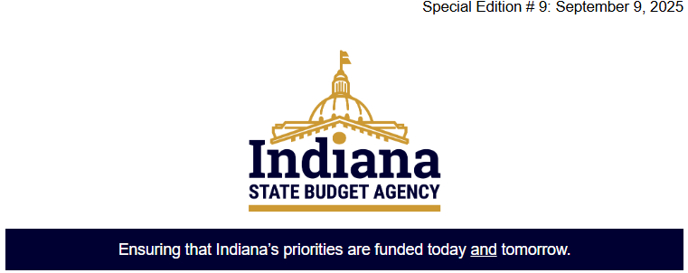
The Euna Grants Update:
We've Listened. Change Is Coming
Important Upgrade Coming by June 30, 2026
The SBA Grants Management Team is excited to announce a strategic upgrade to
Euna Grants that reflects your feedback, streamlines processes, and
strengthens our statewide grants infrastructure ahead of FFY26.
We’ve Listened to You
Over the past two years, your input has shaped this transition. From system functionality to form creation and integration needs, we heard you—and we’re acting on it.

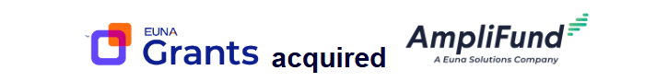
What’s Changing?
- Euna Solutions, the parent company of Euna Grants, has acquired AmpliFund.
As a result: Indiana State Agencies serving as Grant Makers (formerly “Grantors”) will transition to Euna Grants powered by AmpliFund by June 30, 2026.
- Grant Seekers (“Grantees”) will not be affected by this change.
- Why Euna Grants powered by Amplifund?
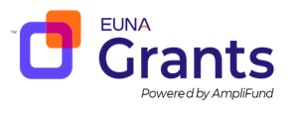

AmpliFund offers enhanced capabilities that better serve the State’s needs:
- 📝 Custom Form Creation for more tailored grant workflows
- 🔍 Greater Detail from Subrecipients, improving transparency and reporting
- 🔗 Built-in Integrations not available in Euna Grants
This upgrade is designed to support more robust grant management across agencies.

Learn More. Join us for a Live Webinar
Tuesday, September 23, 2025 Virtual Webinar
- 1:30 – 2:00pm eastern
- Join via the Teams Meeting information included, below.
- We’ll walk through the upgrade, what it means for your agency, and answer your questions.

Tuesday, Sept. 23 1:30-2p est Teams Meeting Join Link
Meeting ID: 298 088 839 012 4
Passcode: rx3nd6X3

