Special Edition # 10: October 14, 2025

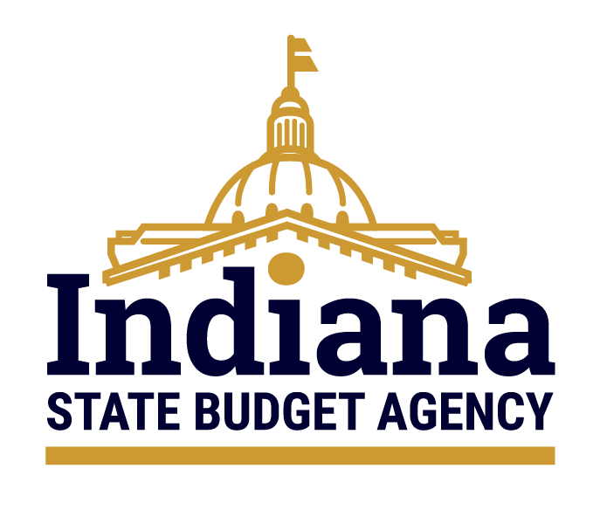

Ensuring that Indiana’s priorities are funded today and tomorrow.

The Euna Grants Update:
The Plan​​

Grant Seeker vs. Grant Maker
- By June 30, 2026, Indiana State Agencies that serve as Grant Makers (formerly “Grantors”) will transition to a new platform: Euna Grants powered by AmpliFund.
- Grant Seekers (“Grantees”) will not be impacted by this transition. Users will continue to manage both state and federal grants through Euna Grants - using the same login credentials, interface, and processes as before. No action is required on your part.

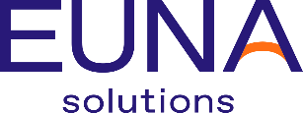acquired 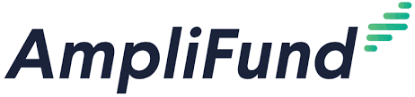

What to Expect Next
The transition to Euna Grants powered by AmpliFund will roll out in phases, with a focus on collaboration, standardization, and readiness. Here's how the plan unfolds:
Fall 2025: Discovery & Standardization
- INDOT, ICJI, and IDHS will partner with Euna Solutions for a discovery process to:
  - Map or update their existing grantmaking processes.
  - Identify opportunities to standardize workflows, forms, and templates across the state.
- These efforts will help define statewide standards that all agencies can adopt, ensuring consistency and efficiency.
Parallel Planning for Existing Programs in Euna Grants
- Once standards are finalized, SBA will begin onboarding Euna Grant users into the AmpliFund module.
- Agencies with programs already operating in Euna Grants will follow a parallel transition timeline.
2026: Statewide Launch & Training
- Euna Solutions will work with INDOT, ICJI, IDHS, and the remaining agencies currently not in Euna Grants to develop their solicitations in AmpliFund, targeting readiness by June 30, 2026.
- The transition will kick off with a “Big Bang” statewide training event, introducing users to the new platform.
- Before current Euna Grants users are added to the new system, SBA will pre-build your existing programs in AmpliFund - ready to copy forward for your next solicitation cycle.
Support for New Programs
- For agencies trained in Euna Grants but not yet published: SBA is ready and available to assist. If your agency has completed training but has not yet published a solicitation in Euna Grants, we’re here to support you through the next steps of the process.

Thanks for attending the September 23 Webinar.

- AmpliFund Implementation Updates & FAQs
  - The SBA Grants Management Team has compiled all questions from the webinar into a centralized AmpliFund FAQ document. This resource will continue to grow and evolve throughout the transition to ensure agencies have the support and clarity they need.
- 2025.09.23 Euna Grants Update Webinar Recording

Questions? Need help? Contact the Grants Management Team.

This email was sent by: State Budget Agency
200 W. Washington St, Indianapolis, IN, 46204 US
Privacy Notice
Manage Preferences Unsubscribe

