Special Edition # 12: December 17, 2025



Ensuring that Indiana’s priorities are funded today and tomorrow.

The Euna Grants Update:
AmpliFund Implementation Timeline

The acquisition of AmpliFund by Euna Solutions requires State of Indiana agencies
that provide funding to Subrecipients to transition to AmpliFund's Grant Maker tools.

When will my agency be in AmpliFund?

AmpliFund Implementation
Indiana State Agencies serving as Grant Makers will transition to AmpliFund with a goal of
ALL subrecipient programs being published in AmpliFund beginning July 1, 2026.
Stage 1: Kickoff and Demos, Grants Management Discovery, Design, Configuration, & Testing
Stage 2: Training & Deployment (by grant program)
Stage 1 Timeline*, as of December 17, 2025
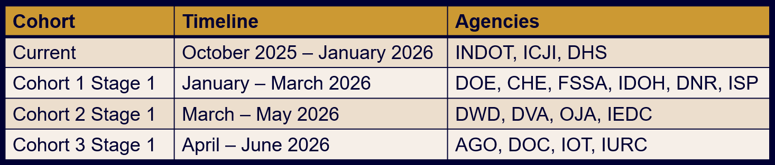
*Don’t see your agency? More info is coming soon!

How can my team prepare?

Discovery Process Preparation
The Indiana SBA Grants Team has been gathering information about subrecipient funding programs and reaching out to agency Division Directors and Grants Management staff. In the discovery process, scheduled agencies and the SBA team will meet with Euna Solutions to perform a fit-gap analysis to state standards, evaluating agency workflows (program and finance), user roles, report requirements, etc.
Here are ways that Indiana State Agencies can prepare:
- Develop an inventory of grants and awards
  - Assess current workflows
  - Establish a calendar of activities (solicitation release dates, application periods, etc.)
  - Assess who from your agency needs to be involved (finance and program staff)
- Compile all SOP (Standard Operating Procedure) documents your agency has created describing the grant making process/ lifecycle.
  - Update these to align with current practices, including Euna Grants implementation, PeopleSoft Financials, & the SCM (Supplier Contracts Management) module.
  - Ensure all stakeholders are involved in its creation & review.
Please discuss your role in this process with agency leadership.

Resources for State Agencies/ Training Materials

Want to see more about Euna Grants, Powered by AmpliFund?
- AmpliFund Grant Maker Demonstration Video
- Grant Maker Updates on the SBA Grants Management page
- Euna Grants Support Page for Euna Grants, Powered by AmpliFund

New to Euna Grants, or haven’t visited the SBA Grants page, recently?
- Resources for State Agencies houses all Training Materials
- You may also request ad hoc training 24/7 via the Contact Grants Management Team page.

Questions? Need help? Contact the Grants Management Team.

This email was sent by: State Budget Agency
200 W. Washington St, Indianapolis, IN, 46204 US
Privacy Notice
Manage Preferences Unsubscribe

