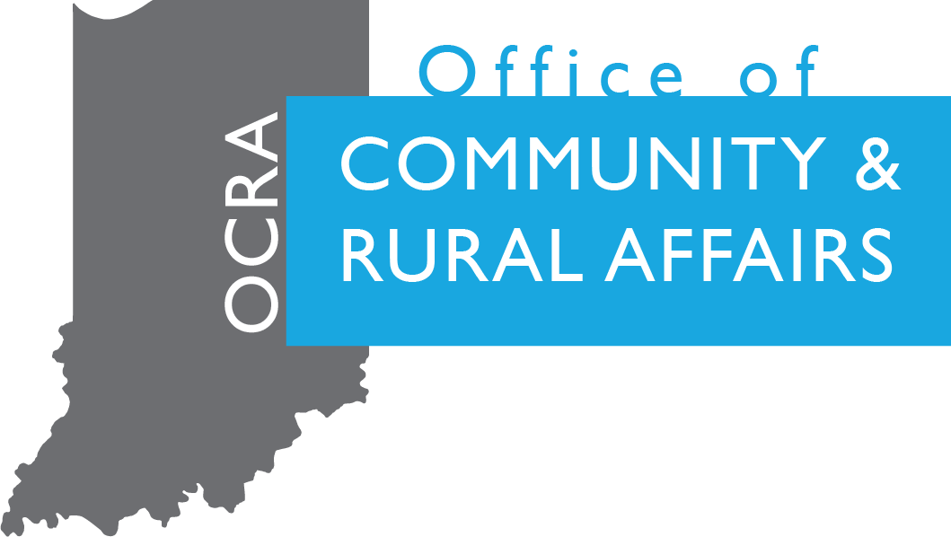

BUIDLING SOCIALLY CONNECTED COMMUNITES GRANT PROGRAM
Application

Indiana Office of Community and Rural Affairs
One North Capitol, Suite 600
Indianapolis, Indiana 46204
(317) 233-3762, (800) 824-2476

May 2024

Indiana Office of Community and Rural Affairs
Community Affairs Division
One North Capitol, Suite 600
Indianapolis, Indiana 46204
(800) 824-2476

APPLICATION COMPLETION CHECKLIST

For proper staff consideration, the grant proposal MUST include ALL of the following parts, forms, and documentation.

Cover Sheet
Is Local Match at least 50% of the Total Eligible Project Cost?
All fields completed

Project Summary

Project Narrative, all questions answered

Project implementation schedule/timeline for the project with key milestones (use provided template)

Project Budget, NOTE: The grant award is considered taxable income in the year that it is used. Awardees should consult with their legal counsel or accountant for more information.

Scope of Work (be as detailed as possible)
Line Item Budget (be as detailed as possible)
Description of Matching Funds
Estimates for all work to be completed (estimates must be from a qualified professional on their letterhead)

Attachments:

Attachments should be submitted as separate attachments in an email with clear and appropriate naming conventions.
Attachments should follow the naming convention: BSCC_CommunityName_AttachmentName (example: BSCC_Indianapolis_Map)

Budget using the provided Excel template.
Maps
State map with community location.
Project location with key demographic locations
Letters of Support from impacted community organizations or residents (optional)
Proof of available local match funds (i.e. bank letter – do not provide bank account information)
Memorandum of Understanding with project/community partners.
Key Impact data – Census demographics

BUILDING SOCIALLY CONNECTED COMMUNITIES GRANT APPLICATION
(COVER SHEET)

GRANTEE:
CONTACT ADDRESS:
CITY: COUNTY:
ZIP+4:
PHONE: FAX:
E-MAIL:

PRIMARY POINT OF CONTACT, IF DIFFERENT THAN GRANTEE (NAME):
CONTACT ADDRESS:
CITY: COUNTY:
ZIP+4:
PHONE: FAX:
E-MAIL:

PROPERTY OWNER (IF APPLICABLE):
PROPERTY OWNER ADDRESS:
CITY: COUNTY:
ZIP+4:
PHONE: FAX:
E-MAIL:
FEDERAL I.D. /TAX NUMBER:

PROJECT FUNDING SUMMARY (Ensure lead applicant match equals 50% of overall eligible costs.)
All grant request amounts need to be rounded to the nearest dollar.
Amount
Grant Request
Lead Applicant Match
Other Private Sources
List sources:
TOTAL MATCH
TOTAL PROJECT COST
In what Indiana Senate District(s) does this project fall under?
State Senator(s) representing this district:
In what Indiana House of Representatives District(s) does this project fall under?
State Representative(s) representing this district:
In what US Congressional District(s) does this project fall under?
*In anticipation of increased demand, there may be revisions made to the distribution of these funds.

PROJECT SUMMARY

Please enter a brief description of your project. This description will be used in print materials and press releases. The description should be no more than 250 words describing the overall project and what specifically the grant funding will be used to purchase.

PROJECT NARRATIVE (1000 word count)

Community Background

- Tell the review committee about your community. Be sure to include demographics and your organization’s experience with community-based projects and grants.

- Please describe the unique challenges that you are trying to address or solve through this grant.

Project Description

- Please explain the project you are applying for and how it aligns with the program’s focus areas. Focus areas can be found in the project overview. Be sure to include:
  - A clear, easy to understand description of all proposed activities that will be completed as part of the scope of the work.
  - The geographic services area and the population(s) that will be served.

- How will you reach those experiencing loneliness.
  - Include a detailed outreach plan for engaging community members who are isolated or lonely and how you will strengthen community-wide relationships.

Project Outcomes

- Please provide clear, measurable goals the organization hopes to achieve with this grant and explain how the organization plans to measure the success of those goals.
  - Please provide a minimum of three measurable goals in bullet point form.

Community Support and Connections

- What social assets does your community have that your project will collaborate with or build upon. Consider gathering places, local businesses, groups working towards similar goals, or regional organizations.
  - In addition, please give a detailed description of the collaboration and upload detail memorandum of understanding as an attachment.

Innovation

- How does this project address loneliness and unique community need through innovative ideas and creative partnerships?
  - Example: Need: Things for individuals to do after 5:00 pm. Partnership: Local small businesses. Uniqueness: The local coffee shop that typically closes at 2:00 pm stays open after 5:00 one night a week so that community bookclubs, knitting classes, dance classes, or game nights can be hosted in the space.

PROJECT COMPLETION TIMELINE

Beginning with the application submission date, outline a reasonable timeline for project completion. Include all significant milestones, emphasizing those related to grant award, drawdown of funds, final plans submission and completion. (All projects awarded funding must be completed within 24 months of contract execution.) See example below, then delete table to create your own:

PROJECT BUDGET

BSCC applicants should complete and submit the Building Socially Connected Communities Grant Program Budget Table separately.

DESCRIPTION OF MATCHING FUNDS

In order to be considered for this grant, the applicant must provide a letter or statement confirming adequate funds to cover their portion of the budget OR include a letter of commitment from an external source (grant, community match, in-kind etc.) This letter must be on official letterhead. Confirmation must be, at a minimum, the total of the local match funds. Please do not include bank account number.

Please include a description of where local match funds are coming from for the project with corresponding documentation.

Applicant

I certify to the best of my knowledge and belief that the information presented in this application are true, complete and accurate. I am aware that any false, fictitious or fraudulent information or the omission of any material fact may subject me to penalties under applicable law(s).

_______________________________
Typed Name and Title Signature

Date: , 20

