What does my septic tank do?
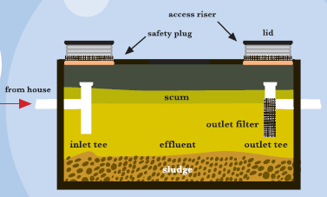
Septic tanks can have either one or two compartments. The septic tank provides primary treatment for wastewater through physical separation by density. Solids are heavy and fall to the bottom of the tank as sludge. Fats, oils, and greases are light and will float to the top and form a scum layer. Sludge and scum remain in the tank so they cannot harm the soil absorption field. The middle liquid portion, effluent, flows out of the tank and enters the soil absorption field for final treatment.

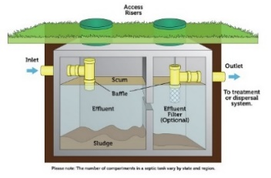
Single Compartment Septic Tank

Two Compartment Septic Tank

What can I do to make my On-site System last?
Proper design and installation, and maintenance are key to system longevity. Your drains should not be used as a trash can; fats, oils, and greases should not be poured down the drain, and trash such as feminine products, cigarette butts, and food waste should be thrown in the trash, not down the drain. Wipes, even if they say they are septic-safe should not be disposed of down the drain. Your system is designed to be able to handle a set flow (called a design daily flow). This is the maximum peak flow your system should see on any one day. Usage at or above design daily flow on a regular basis can lead to hydraulic overload of the system and cause system failure. Hydraulic overload is simply using more water than what the system was designed to be able to treat. When you live on an on-site sewage system, use of water needs to be regulated so that hydraulic overload does not occur.


See our Septic Tank Outlet Filter Brochure for further information on outlet filters and their maintenance.

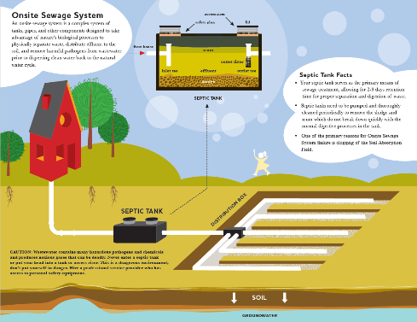


Who regulates On-site Sewage Systems in Indiana?
The Indiana Department of Health writes state-wide rules for residential and commercial on-site systems. The local health department has authority for administering the rules.
The Residential Rule is 410 IAC 6-8.3. The Commercial Rule is 410 IAC 6-10.1.
For Additional Information…
Wayne County Health Department
www.co.wayne.in.us

Indiana Department of Health http://www.onsite.isdh.in.gov
Indiana Onsite Wastewater Professionals Association (IOWPA) http://iowpa.org
Purdue University https://mdc.itap.purdue.edu/
Environmental Protection Agency Septic Smart Program http://www.epa.gov/septic

On-Site Sewage Systems
On-Site Sewage Systems
A Guide to Your Private Wastewater Treatment Plant


Indiana Environmental Health Association Wastewater Management Committee


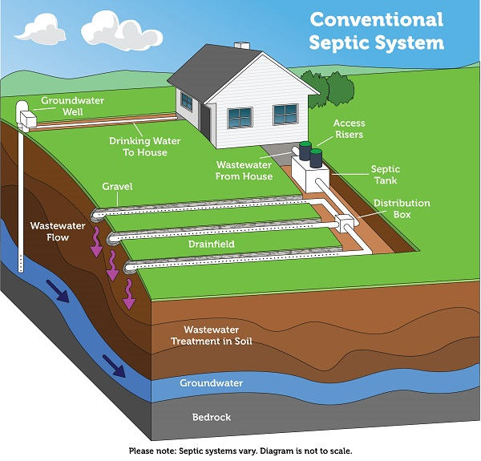
What other components could my On-site Sewage System have?
Many on-site sewage systems have components other than just a septic tank and a soil absorption field. Some components often found in an on-site sewage system include:
- An outlet filter,
- A dosing tank and effluent pump,
- Controls and/or alarms,
- Subsurface and surface drainage,
- A secondary treatment unit, such as an aerobic treatment unit.
Please consult with your local health department for a copy of your permit file and to answer specific questions about your system. The Wayne County Health Department has limited files on systems installed prior to 1990.

What is an On-site Sewage System Failure?
A system failure is defined by one or more of the following:
- Interference with home plumbing (e.g. back-up, slow drains, gurgling)
- Sewage surfacing to the ground surface or to surface waters,
- Contamination of potable, ground, or surface water sources.
A failing on-site sewage system creates a public health hazard.

Does My On-site Sewage Systems Need Maintenance?
Yes, every on-site sewage system needs regular maintenance. Maintenance includes pumping and cleaning of the septic tank and other tanks in the system as well as cleaning of filters, and checking the system for signs of failure. In general, a septic tank should be cleaned every 3-5 years, depending upon usage. Consult a septic professional for a personalized maintenance plan for your system.

What is an On-site Sewage System?
In Indiana, an on-site sewage system (also commonly called a septic system) consists of at least a septic tank and a soil absorption field that has not failed. There may be other components in the system, but minimally, the system has to have a septic tank for primary treatment of the wastewater and a soil absorption field for final treatment of the wastewater.
Residential On-site Sewage System
Distribution Box
Septic Tank
Minimum 50’ Separation
Soil Absorption
Field

