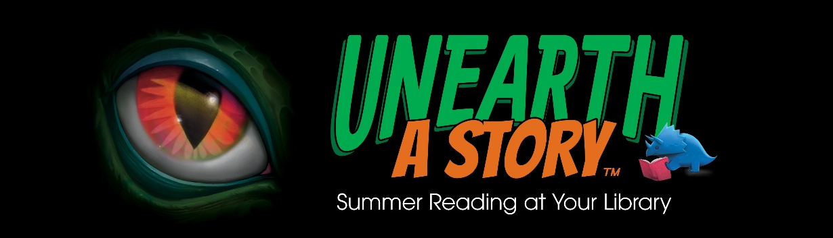

Join the ALL AGES Summer Reading Program!
June 1st to July 31st

Sponsored by the Indiana Talking Book & Braille Library

Join the Indiana Talking Book and Braille Library’s ALL AGES (toddler to adult) Summer Reading Program for “Unearth a Story”. Books are available to borrow from the library in braille, large print, and digital audio formats; participants can also download digital audio books and braille files from BARD at nlsbard.loc.gov, or use the BARD Mobile app available from the iTunes app store, the Google Play store, or the Amazon App Store.

Note that only books borrowed or downloaded from the library within the timeframe will count towards a reader’s total.

After enrolling, you will be sent a ‘gameboard’ of summer activities to do. Checkmark each activity beginning June 1st on your sheet and return it to Abby by August 7th for fun prizes!

I will be sending out materials throughout the program including prizes, activity packets, crafts, and more!

Please complete and return the application to enroll. Simply fold the application in half, tape it shut, and put it in the mail. If your application is late getting to us, you are still eligible to be a summer reader.

Questions about this program can be directed to Abby Chumin, Librarian by phone at 317-232-3684/ 1- 800-622-4970 or by email at tbbl@library.in.gov.

