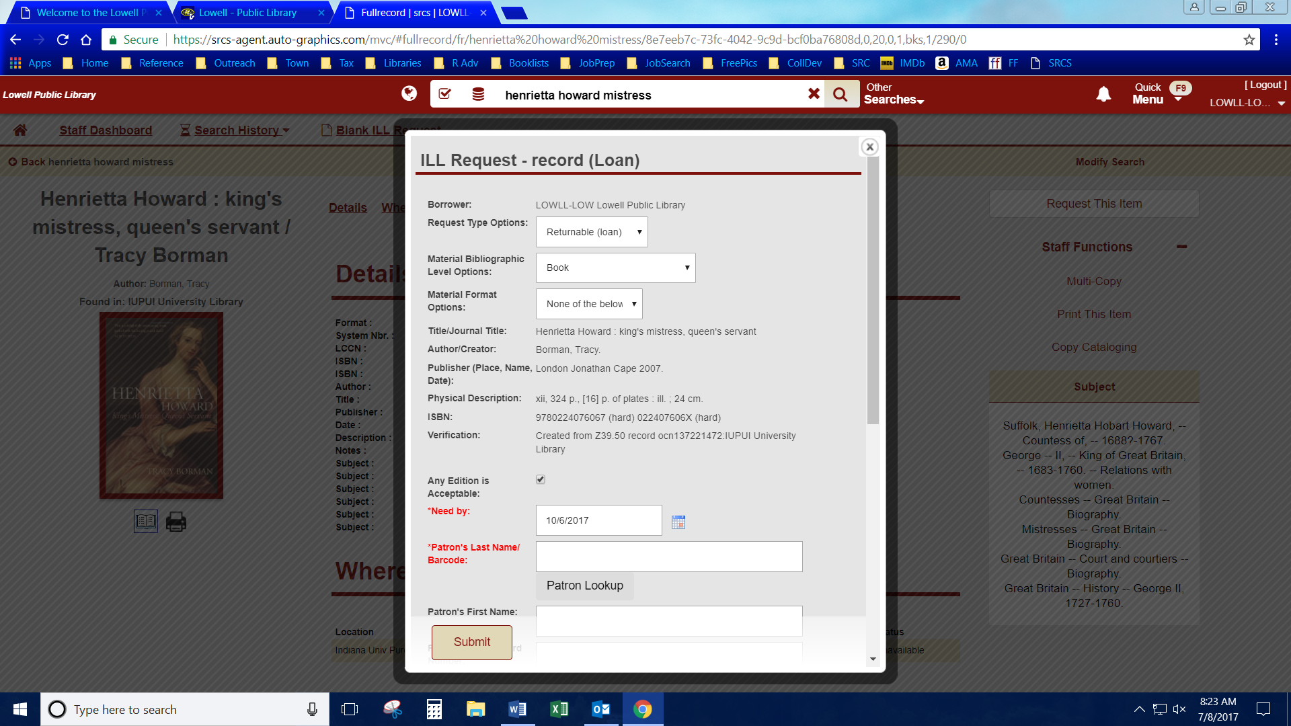

Type in either & hit Patron Lookup.

Choose the correct patron.

It will AUTO-FILL all the Patron information fields

AUTO-FILLED

**BOOK EXAMPLE**

Verify the default for these options are correct.

If LARGE PRINT **only** is requested, choose that option here.

AUTO-FILLED

INFORMATION

**IF LEFT CHECKED** paperbacks can fill hardback requests (and vice versa), & different print editions can be used (2012 vs 2016) & a large print can fill a regular request (and vice versa)

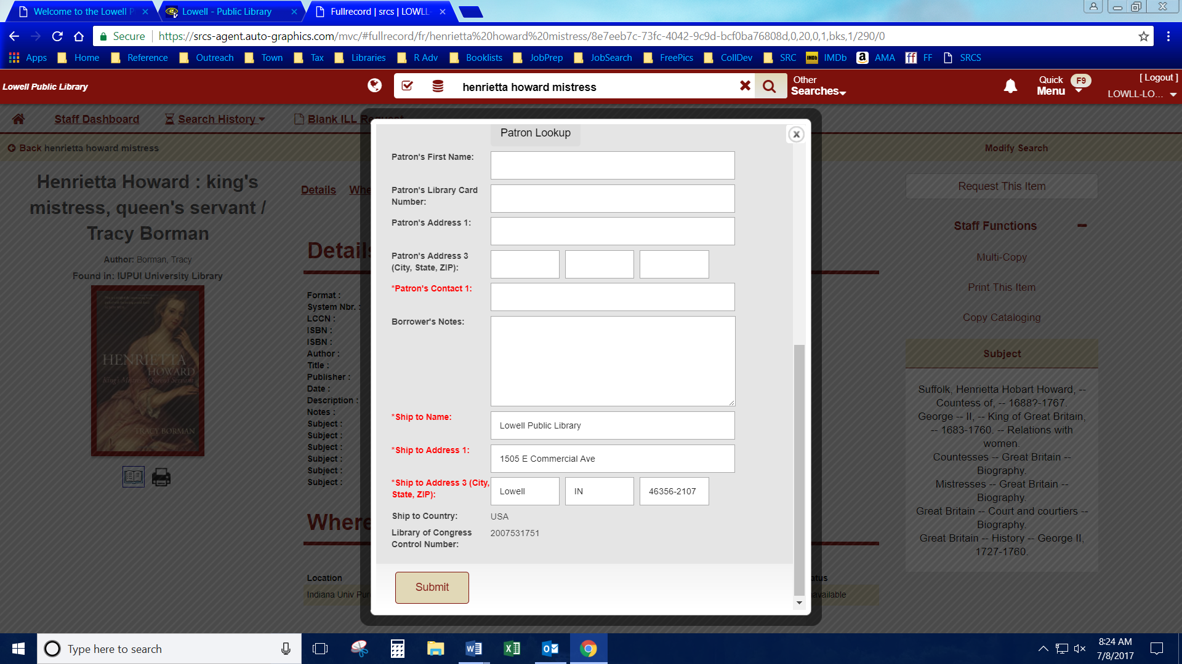

**REVIEW EVERYTHING**

Then hit Submit, Print out form & Highlight title

**TYPE IN**

Regular or Large Print

Any special information

AUTO-FILLED

INFORMATION

AUTO-FILLED after finding through Patron Lookup.

Can be manually entered if patron not found.

Verify or add phone number.