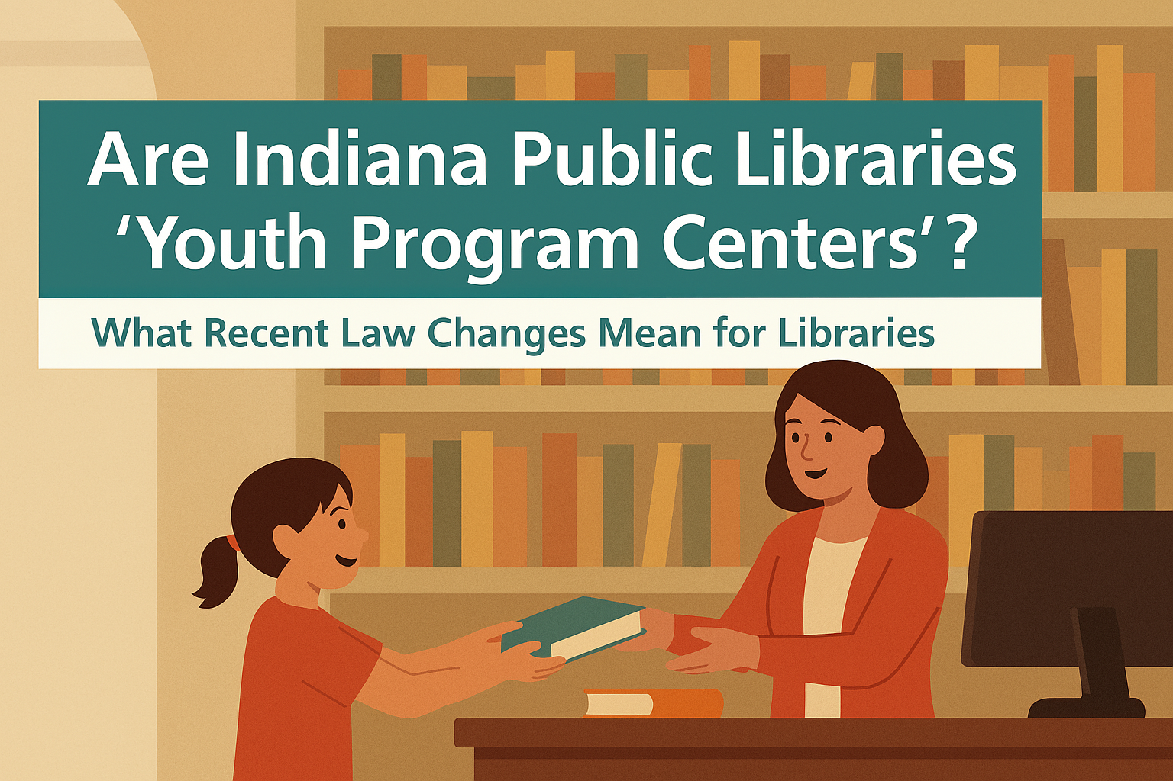
Are Indiana Public Libraries “Youth Program Centers”? What Recent Law Changes Mean for Libraries
Indiana libraries are increasingly asking whether they qualify as “youth program centers” under state law, and what that means for library operations. Even though libraries aren’t named directly in the statute, several parts of Indiana law suggest they likely fall into this category.
Indiana Code defines a youth program center as any place that regularly provides programs or services for people under 18. Public libraries routinely offer story times, teen events, summer reading programs, and other youth activities. Because of this, they likely meet the definition. This matters because certain laws apply to these locations. Offenders convicted of crimes against children generally cannot live within 1,000 feet of a public library. Sexually violent predators and offenders against children cannot work or volunteer in a public library. An Indiana Court of Appeals case, Sewell v. State (2012), supports this interpretation. The court held that a church was a youth program center simply because it held weekly youth activities.
What Senate Bill 119 Changes
Senate Bill 119, recently passed by the Indiana General Assembly, adds two new rules related to where certain sex offenders may be present. The bill makes it a felony for certain offenders to work or volunteer at facilities or events directed primarily at children. For libraries, this change has little practical impact because existing laws already restrict who may work or volunteer in a library. A more notable change is that serious sex offenders cannot knowingly enter a facility where children’s programming is happening. This means entering a library during a children’s event could be a felony if the person knows the event is in progress. The law does not create new obligations for libraries. The responsibility remains with the individual offender.
Optional Steps Libraries May Consider
While not required, libraries may choose to post a temporary sign on the door that says something to the effect of: “Children’s programming in progress” during events. Library staff may also contact law enforcement if staff become aware that a sex offender is present during children’s programming. Enforcement decisions remain with law enforcement, not library staff.
Could These Rules Be Challenged?
A federal case from the 10th Circuit, Doe v. City of Albuquerque, ruled that a total ban on sex offenders in libraries violates the First Amendment because it is too broad. However, Indiana’s law is narrower. It limits access only during children’s events, meaning other access remains available. Because of this, it is more likely to withstand constitutional scrutiny.
Bottom Line
Indiana law likely treats public libraries as youth program centers based on existing definitions and court decisions. Senate Bill 119 adds new limits for serious sex offenders during children’s programming but does not add new duties for libraries. Libraries can continue their mission of serving the whole community while staying informed about how state law affects their operations.

