Can I Help You with That?
Understanding the Role of Librarians in Legal Information Services

Each day, patrons visit the library seeking guidance on a wide range of topics, including legal matters. Whether it’s locating a rental agreement form, understanding divorce proceedings, or researching local ordinances, public libraries are often the first stop for individuals facing legal challenges. "Law books on a shelf." by umjanedoan is licensed under CC BY 2.0.
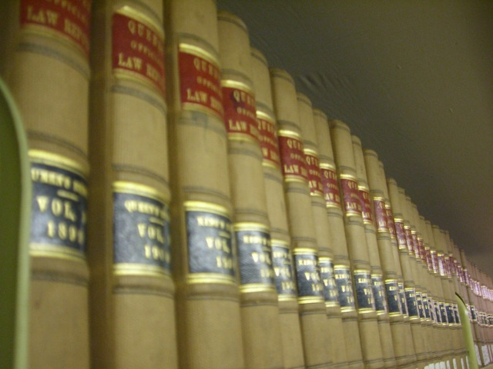
Given that libraries have a longstanding reputation as a trusted source of information, it is only natural that members of the public turn to librarians for help in navigating the complex world of law. However, while librarians are well-equipped to assist with legal research and information access, there are strict ethical and legal boundaries that govern how far that assistance can go.
It is helpful for patrons to understand what librarians can and cannot do in terms of legal reference assistance in the library in order to minimize frustration and maximize a positive outcome. While librarians are not attorneys and do not offer legal advice, they can provide a wide range of support within the scope of their professional role. Librarians can help patrons locate relevant laws, regulations, ordinances, and court opinions. Whether its federal, state, or local law, librarians can direct users to authoritative sources, both in print and online. Library staff can also demonstrate how to use legal research tools such as Westlaw, Lexus Nexus, as well as secondary sources like legal encyclopedias and self-help guides. Some of these resources require subscriptions so the resources available could be limited based on what databases or services the library pays for. Librarians can point patrons to trusted sources of free information including legal aid websites, government portals, and non-commercial databases that provide reliable up to date content. This is particularly important in an era where misinformation is easily encountered online. Libraries sometimes even collaborate with legal aid organizations and community partners to host clinics, workshops, and informational events. Librarians can inform patrons about upcoming programs, eligibility requirements, and how to schedule appointments with qualified legal professionals.
While library staff play an important role in facilitating access to legal information, there are clear ethical and legal limits designed to protect both the patron and the librarian. These restrictions are in place to prevent the unauthorized practice of law. Librarians are not authorized to analyze how a particular law may apply to an individual specific situation. They can provide access to legal texts but they cannot offer interpretations or recommended courses of action. While librarians may assist patrons in locating the appropriate legal forms they patron may need, the librarian cannot help the patron complete the form or provide suggestions about what to include in any particular section. Doing so would constitute legal advice. If a patron asks if they should “plead guilty,” “file a motion,” or “appeal a case,” these types of questions fall squarely within the realm of legal advocacy and must be directed to a licensed attorney.
Patrons need to understand that the limitations placed on librarians are not a reflection of unwillingness to help but are grounded in the professional and legal standards that protect all parties. Librarians are trained to provide neutral and objective assistance. By observing the boundary between legal information and legal advice, librarians ensure that patrons are not misled or inadvertently harmed by well-meaning but unauthorized guidance. Maintaining these boundaries also upholds the library’s reputation as a trustworthy and unbiased institution. When legal issues arise, patrons can rely on the Library as a starting point for research and resource navigation and they can be confident that any further recommendations will be directed to qualified professionals. The law can be intimidating for individuals who are unfamiliar with legal systems, terminology, and procedures. Libraries help lower the barrier to legal access by offering free resources, research support, and community connections.

