IOT Billing Dashboard Documentation

Purpose:

Prior to the launch of the IOT Billing Dashboard, there was some effort required to retrieve, understand and analyze ones bill. IOT’s billing software (Pinnacle) does offer reporting, but that reporting was relatively slow and required some expertise to execute properly. The dashboard has been created to offer a simple set of graphic and tabular representations of an agency’s billed services with the capability of filtering and outputting the underlying data.

Access:

The dashboard is published online and does not require special software to view it (although Google Chrome is the preferred browser). Any Security Coordinator can obtain access for a state employee by contacting the IOT Help Desk. At the time of request, the name of the new user and his agency must be provided.

Permissions are updated upon request, but the dashboard imports new permissions overnight. That means a user might have to wait until the next day to actually access the dashboard. If there is any difficulty after 24 hours, submit a ticket through the IOT Help Desk. If a person leaves his agency or state employment, all permissions are cleared. If access is required later, submit a new request.

Navigation:

Following the link below will open a page with multiple projects. Click on the project called, “IOT – Final Workbooks” and then select the workbook, “IOT Billing,” to see the pages available.

https://dataviz.in.gov/#/site/IOT/projects/

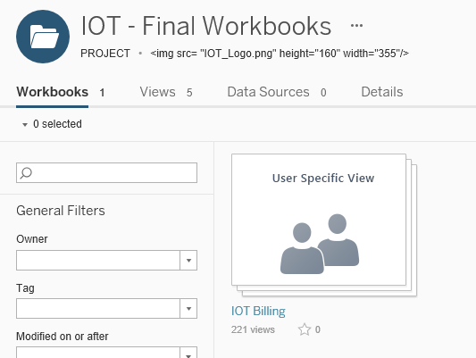
Pages:

A “page” on the dashboard contains visualization elements (like charts and graphs) that describe an agency’s billing history from a particular viewpoint. Click on one of these pages to navigate to it.

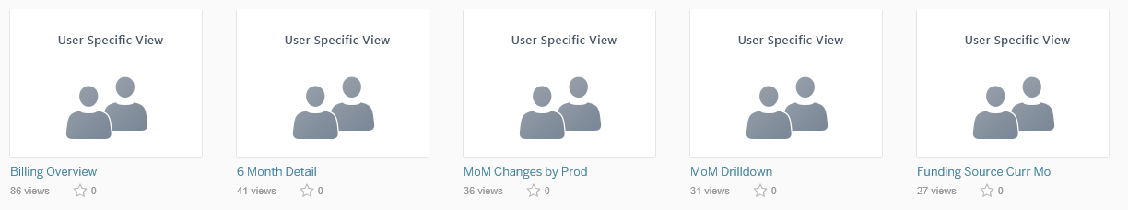

Here are the available pages with a description of what each contains.

Billing Overview: Provides high level billing history. It includes a 3-year trend of total spending by month and FYTD spending by product, by month.

MoM* Changes by Prod: Compares the expense by product in the current month to the prior month. The percentage change between current and prior month is also called out.

6 Month Detail: Offers six months of billing detail down to the transaction level. Detail can be filtered by department and/or fund.

Funding Source Curr Mo: Shows spending for the most recent month by chartfield code. This helps to identify active codes that should be inactive. It also shows the relative size of various funds, departments, programs, etc.

MoM* Drilldown: Provides a means to very quickly identify departments and programs whose IOT expense has increased or decreased significantly. It also assists in identifying the IOT products that drove the variances.

YoY** Change by Product: Allows the user to see how a specific product, or set of products, is impacting total spend compared to the same month in the prior year.

* MoM stands for month over month.
*YoY stands for year over year.

Interactivity:

Before going into the use of each page, it should be noted that each page is designed to be interactive. That means that clicking on a portion of a chart or table filters all of the data on the page. For instance, if there is a pie chart of spending by department, clicking on a specific department in the chart will restrict all data on the page to that department. There will be visual cues to indicate this has happened. A filter thus initiated can be removed by either clicking again on the chart element that was just selected or by clicking in the chart area outside of where the data are represented. An example is shown below. Note that multiple sections can be made simultaneously by holding down the Ctrl button and clicking on chart elements.

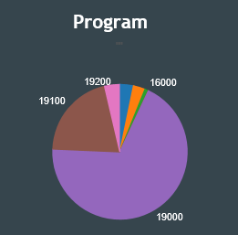
Click to remove filter.
Click to filter.

The Dashboard Menu:

There are some features common to every page in the dashboard. The functions of the most important ones are explained below.

3
9
8
7
6
5
4
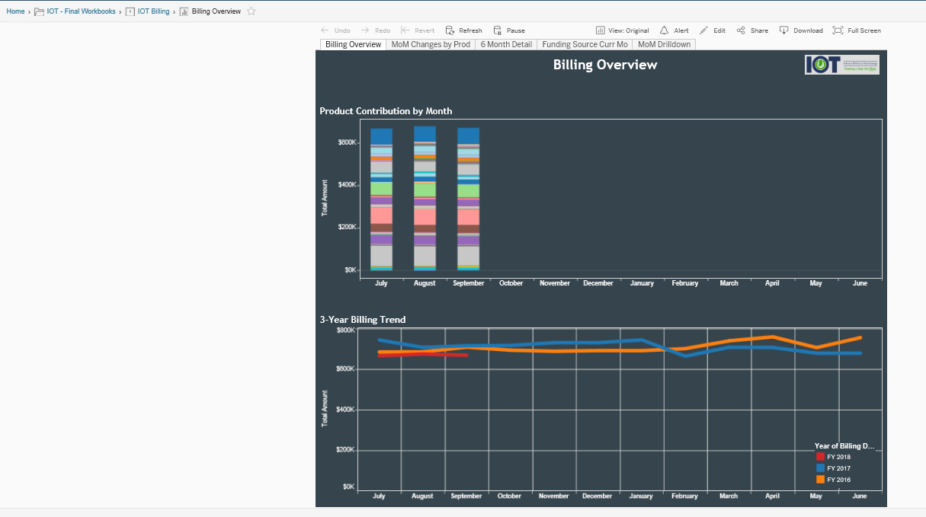
2
1

1. Navigation Bar

The navigation bar identifies the current page being viewed (Billing Overview page in the above) and allows navigation to a higher level view by clicking on the one desired. In this example, the user can move directly to the home view, to IOT’s Final Workbooks or to the IOT Billing workbook specifically.

2. Workbook Tabs

The IOT Billing workbook currently has five pages, and those pages are instantly accessible by clicking the tab of the desired page.

3. a. Undo
Remove the most recently applied filter.

b. Redo
Reapply the filtering most recently removed by using Undo.

c. Revert
Remove all filtering and bring the page back to its original state.

d.Pause/Refresh Data

For data sources that are “live” and change frequently, it might be useful to Refresh the data currently displayed and bring it current. It also could be useful to Pause the data, so that they are not queried each time the visualization is changed. That may cause the dashboard to populate more quickly. The data source for the IOT Billing Dashboard is not live, and these features are not necessary. Billing data are updated monthly and remain static until the following month.

4. View

This feature should allow the user to create pre-saved filters to a page, but it has not been successfully tested at this time. Do not use it until advised otherwise.

5. Alert

Alerts allow the user to have an e-mail sent to himself should a metric reach a certain level. This feature is not particularly useful with the kind of static data provided in the IOT Billing Dashboard, and it has not been tested for functionality.

6. Edit

The edit function allows a dashboard administrator make changes to it online. Users are not able to make and save edits.

7. Share

Using Share allows the user to send someone a link to the dashboard via e-mail. Click on the share icon (above), and a dialog box will display with a link to the dashboard. Click “Email Link” to send the link to another user via e-mail. Because it is sent through e-mail, a written comment can accompany the link to call out the issue requiring attention.

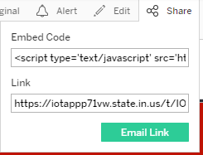

It should be noted that any person receiving this link who does not have access to the dashboard will not see anything when clicking the link. If the receiver has permissions for a different agency or agencies than the sender, the dashboard will build according to the receiver’s permissions.

8. Download

The Download icon is used to output to Excel or Access the data used to build a visualization. This is extremely useful if a user wants to do analysis on a particular set of data rather than just seeing it represented by a chart or table.

To output data underlying an element on a page, click on an un-filterable section of the dashboard element.
Unfilterable Section (click)

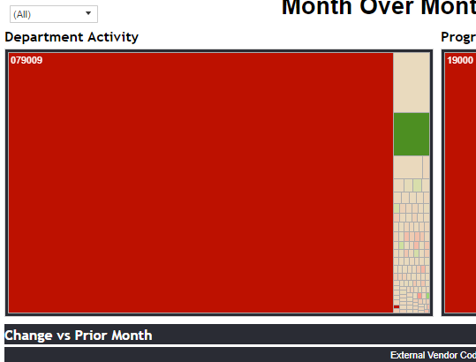

Once a single element of a page is selected, click on the download icon, and a pop-up menu will appear showing options for the type of outputs that are possible.

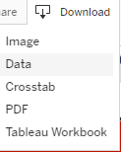

Image – This will allow the user to save the page element as a jpg image.
Data – This will open a display page with the underlying data from the selected page element. There are two tabs on the display page: Summary and Full Data. The Summary tab shows data that is what the dashboard actually uses to render the visualization. The Full Data option shows all data used even if it was only used as a filter.

The user can choose to view the data in the display page or output it to Excel as a .csv file by clicking the link “Downlad all rows as a text file.”

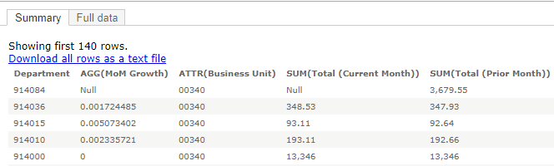

When selecting the Full Data option, the user can also select a check box that says, “Show all columns.” When this box is selected, all possible data fields will display whether or not those fields were used in any way as a filter or as data populating the page. For instance, there is a data field called, “Address Line 1.” It is not used for anything on the dashboard, but the field will show when selecting Show all columns.

Crosstab – This option creates a .csv file that opens in Excel. Instead of showing as a flat data file, it presents in crosstab format. This is generally a much easier format for most people to read, as it presents data in a customary row/column format with values in the body. Simply click on “Crosstab” and click the “Download” button that pops up.

PDF – This option saves the entire page as an image in a .pdf file. It is very similar to the Image download. Clicking the PDF menu item will open another dialog box that allows the user to select various options regarding the presentation of the dashboard image.

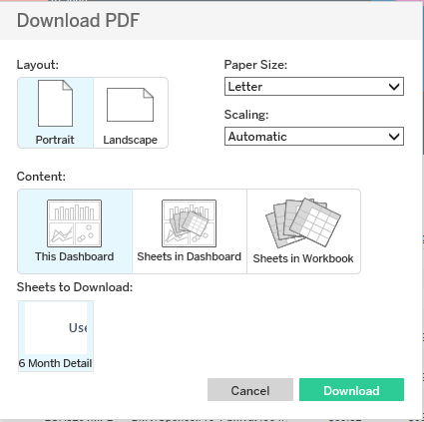

The layout orientation, paper size, scaling (how it fits on the page) and range of pages to print can all be selected from the dialog box.

When selecting options under “Content:,”
- “This Dashboard” refers to the currently selected page.
- “Sheets in Dashboard” allows the user to create a pdf image with specific page elements. Just highlight one or more of the elements in the section “Sheets to Download.”

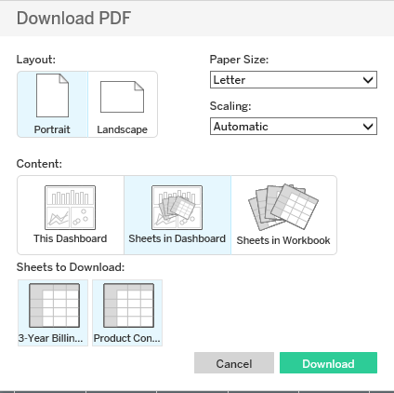

- “Sheets in Workbook” allows the user to print specific pages from the current workbook to a pdf file. The pages to be printed can be selected in the section “Sheets to Download” (see below).

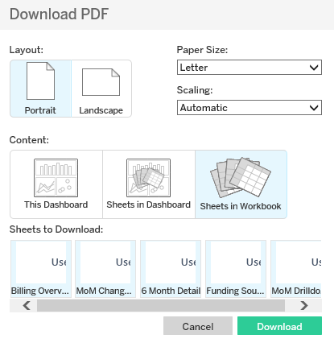

Tableau Workbook – This option takes the dashboard and opens it as a Tableau workbook. This option will not work for any users other than the dashboard administrators. It should not be selected.

9. Full Screen

Using the Full Screen option takes the dashboard and displays it using the full range of the current monitor. In normal viewing mode, only a portion of each page can be displayed due to space being used for the dashboard and browser menu items.

To exit full screen mode, press the <Esc> key.

Using Dashboard Pages:

Instructions were provided above to navigate to the billing dashboard workbook and the individual pages therein. This section explanations the content of each individual page, including the data it contains, how it is organized and how to use it to best advantage.

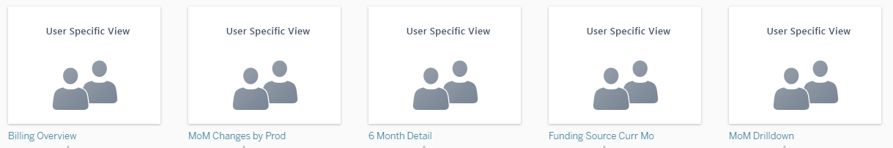

Billing Overview

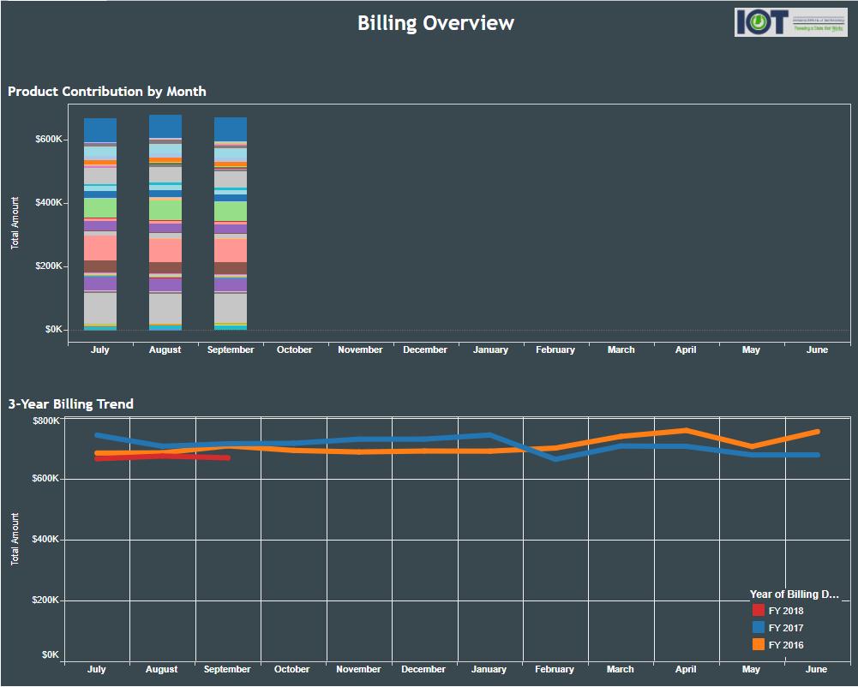

The Billing Overview page is a high level view of billing designed to provide very general information about billing history and expense drivers. On the lower half is a three-year billing trend by month. On the upper half is a stacked bar chart that shows the total expense by month for the current fiscal year with segments for each product. This is useful to see what is driving IOT expenses.

In each segment of the page, additional detail is available by hovering the mouse over a plotted point or segment. For the Three-Year Billing Trend, this includes the month name, fiscal year number and billed amount. The Product Contribution by Month chart returns the month name, product number, product name and amount billed. See below for examples.

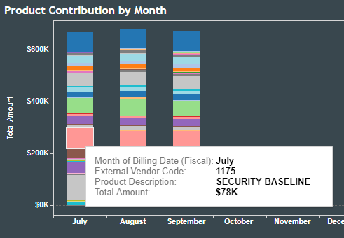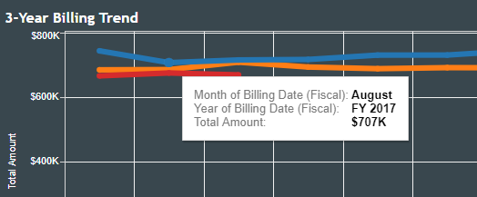

MoM Changes by Prod

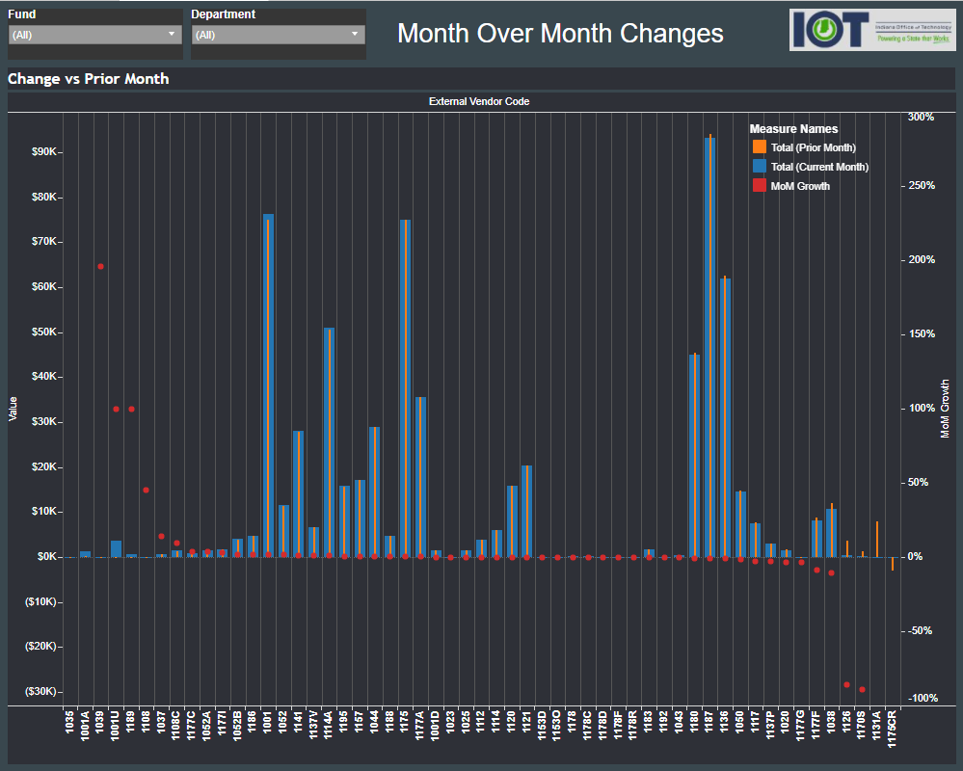

The Month-Over-Month Changes by Product page displays critical information necessary to quickly understand how the use of IOT services has changed from the prior month to the current month. The idea is to spot outliers each month and address those variances. Each product that has had billing activity within the last two months will be listed along the x-axis. For each product, three pieces of graphical information will appear in the body:

- Red dots indicate the percent change in a product’s expense this month compared to the prior month. (e.g. July = $1,000 and August = $1,100 then % change = 10%). Red dots correspond to the vertical axis on the right side of the chart.
- Slim gold bars show the amount billed in the prior month. The gold bar corresponds to the vertical axis on the left side of the chart.
- Broad blue bars show the amount billed in the current month. The blue bar corresponds to the vertical axis on the left side of the chart.

Products on the x-axis are sorted from left to right based on the percentage change (red dots) in descending order. This means that products where expenses increased over the prior month will be found on the left side of the chart. Products that showed decreases in spending month-over-month will be found on the right. This is helpful in identifying aberrations and addressing them with IOT before they begin to appear customary.

When hovering the mouse over any chart element (dot/bar), a tool tip will show the corresponding product code, product name, current month dollars, prior month dollars and the month over month change. This helps the user identify the details driving the visual cues in the chart.

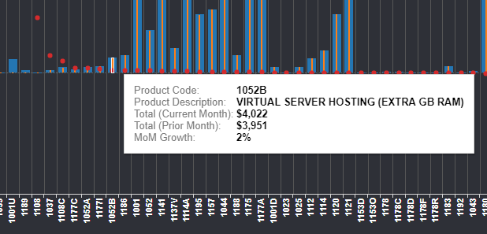

At the top left of the page, there are two dropdown filters. One is for Fund, and the other is for Department. The user can use these filters to narrow the number of funds and/or departments included in the chart. For instance, if the user selects only department 123456, the chart below will display billing data only relevant to that department.

Note that filtering out certain funds will limit the departments available for filtering – and vice versa. If all department 123456 activity falls in fund 54321, filtering out fund 54321 will remove department 123456 from the list of department filtering options. If a user finds that a desired department or fund is missing from the list, assure that there is nothing limiting that option from being presented.

MoM Drilldown

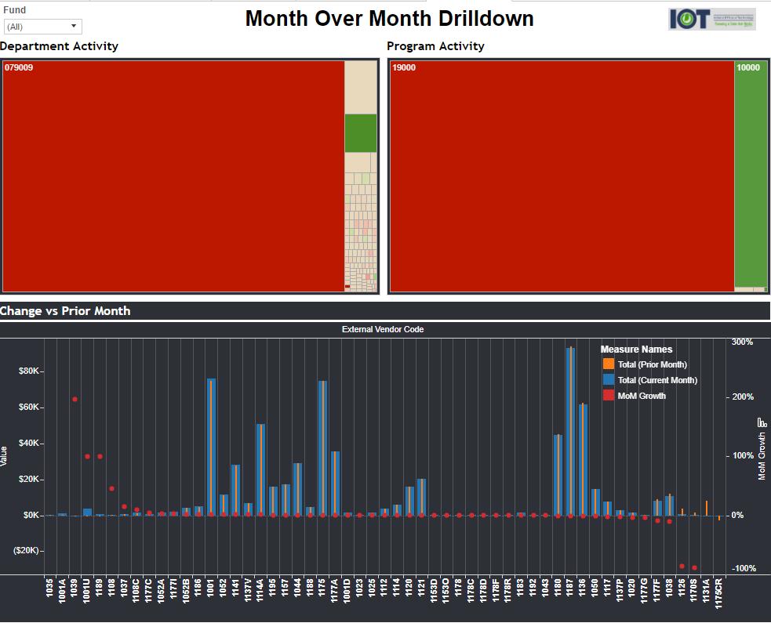

The Month-Over-Month Drilldown page is an outstanding tool for identifying specific funds, departments and programs that are driving changes in an agency’s IOT bill. The lower portion of the page is identical to the MoM Changes by Prod page described above, but the filtering of departments and programs is highly targeted through the use of two tree maps in the top half of the page.

The tree maps have two attributes: size of sectors and sector color. The size of a sector correlates to the dollar amount of the most recent month’s bill. The color indicates the current month’s rate of increase over the prior month - red indicating an increase, and green indicating a decrease. Taken together, the user can tell which departments or programs have experienced large increases in their IOT bill and whether those increases are meaningful in dollar terms.

While hovering the mouse over a sector of a tree map, the tool tip will display the business unit number, department number, current month expense, prior month expense and the month-over-month growth rate.

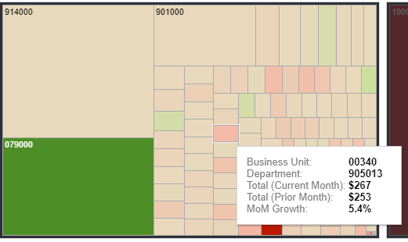

By clicking on a sector of concern, the user can filter the entire page to identify specific products that are driving expenses. The detail showing which products are driving expenses will be found below in the Change vs Prior Month chart.

As noted elsewhere, filtering a page will limit additional filtering options on the same page. For instance, filtering by program might limit the departments that display to those that have activity within the selected program. Be mindful of filters and the effect they have on available options. If a desired filter appears to be missing, check to make sure applied filters are removed.

Funding Source Curr Mo

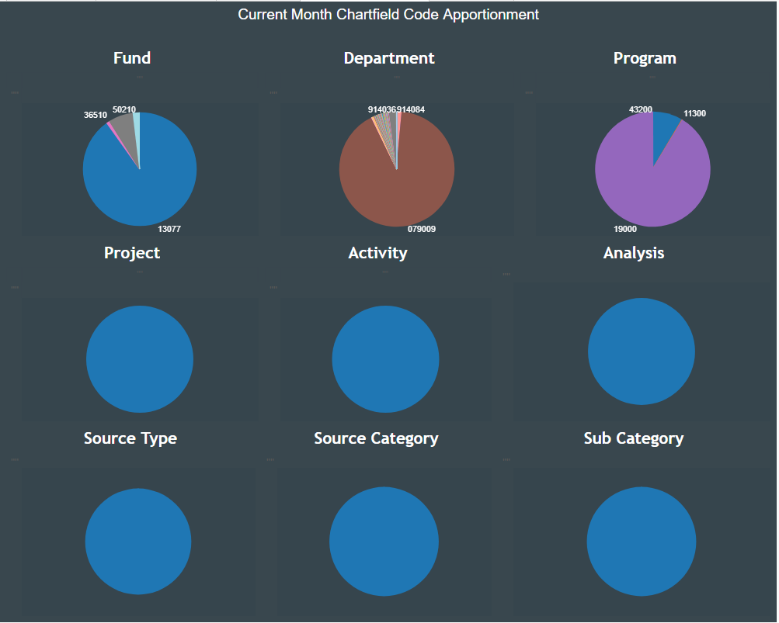

For each fund, department, program, project, activity, etc, the funding source page shows the proportion of IOT spending in the current month driven by the members in those chartfield sections. This page primarily exists to help identify chartfield sections that are incurring expenses but should be inactive.

By hovering over any slice of any pie chart, a tool tip popup will identify the chartfield section number and the total amount of IOT expense incurred under the selected fund, department, etc.

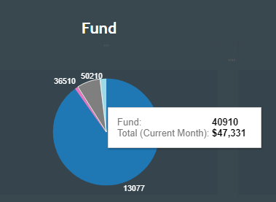

Click on any slice of a pie chart, and the entire page will filter based on what was selected. This gives the user an opportunity to limit returned codes and spot chartfield codes that should not be associated with what was selected.

6 Month Detail

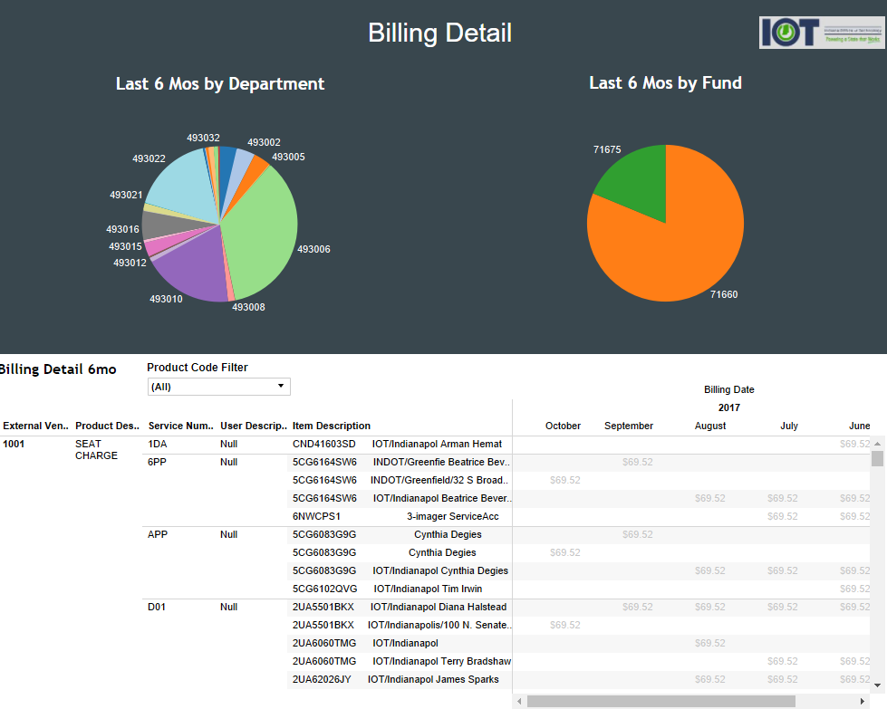

The Six Month Detail page displays six months of very granular billing detail – including transaction-level detail. For instance, specific computer users are called out under Seat charges, and specific telephone numbers are identified under telecom products. This detailed report is presented on the lower half of the page.

The upper half of the page shows pie charts of IOT expenses by department on the left side and fund on the right. Hovering over a wedge of one of the pies shows the department or fund number along with the aggregate of the most recent six months of billing.

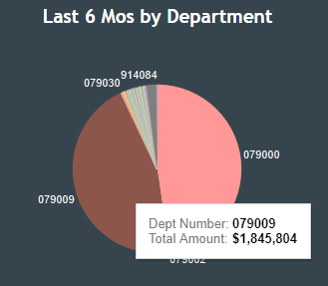

When clicking on one of these wedges, the entire page filters results so that they will display only results related to the department(s) or fund(s) selected. Doing this is helpful for two reasons:

- It reduces the sheer volume of billing detail.
- It allows managers of only a segment of agency expenses to review their portion of the IOT bill.

In addition to targeting the billing detail of specific departments or funds, a user can also limit billing detail results by selecting one or more IOT products from a dropdown in the detail section.

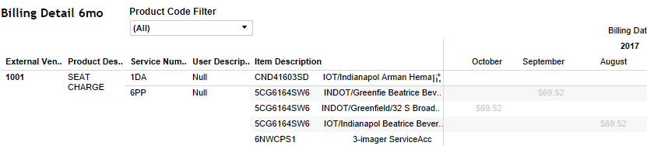

Note that selecting a set of products will cause the pie charts above to filter based on what is selected. This can be helpful, because it will identify which departments and funds actually used the selected product(s). Any products and funds that did not use the selected product(s) will be filtered out.

Once results are filtered (if desired), it is often most useful to download the data in the billing detail section of the page. See the explanation above for how to output the billing detail to Excel or Access. As a quick reminder, click on the portion of the billing detail highlighted below and click on the Download icon at the top of the dashboard. The user should click on an unused portion of the chart or table so as to not trigger a filter.
Click here.

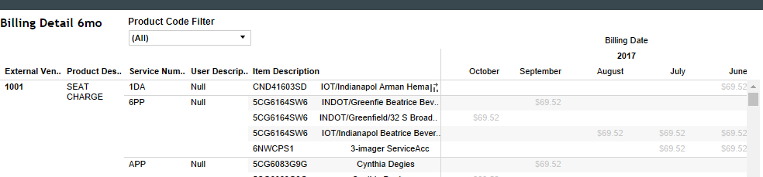

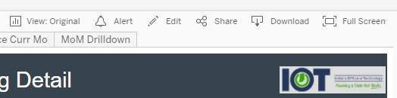

YoY Change by Product

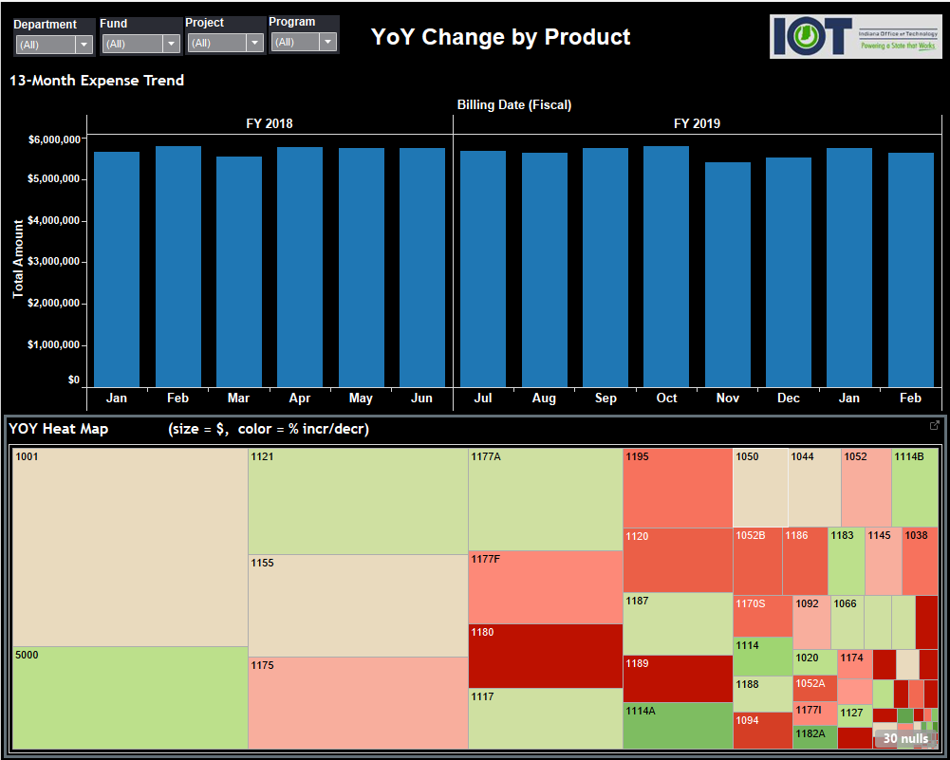

This dashboard page is designed to call attention to products whose expense is large and has grown compared to the same month in the prior year.

It is split into two graphic images. The top section shows the monthly expense of whatever products are included in the current filter. This will be all products if none is specifically selected.

The bottom section shows two metrics simultaneously:

1) The relative expense of each product as represented by the size of each square.
2) The percentage growth rate for each product compared to the same month in the prior year. This is represented by the color that scales between red for large increases to green for large decreases.

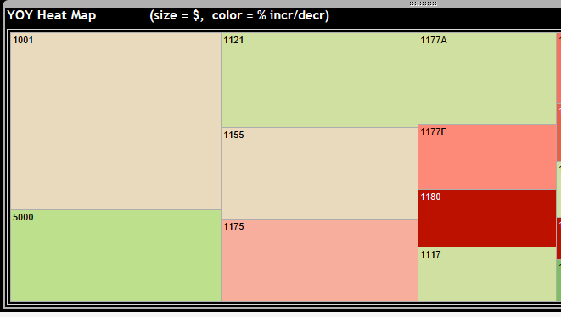
Large Decrease
Large Increase
Large Spend

The page is designed for the user to identify products driving year over year growth in the lower section. By clicking on a product of interest, the page will filter, and the monthly spend for the most recent 13 months will show in the upper section.

This process will quickly identify products that are driving costs up (or down) on a year over year basis and show when exactly the increase occurred. By knowing when the trend changed, the user can look for additional detail regarding what specifically caused the change.

