1977 POLICE OFFICERS’ AND FIREFIGHTERS’
PENSION AND DISABILITY FUND (1977 FUND)
Summary of Plan Provisions

Effective May 1, 2015

TABLE OF CONTENTS

ARTICLE I. DEFINITIONS 4

ARTICLE II. MEMBERSHIP IN THE FUND 6
Section 2.1 Eligibility for Membership
Section 2.2 Participation by Units
Section 2.3 Exclusions from Membership
Section 2.4 Reinstatement of Membership

ARTICLE III. CREDITABLE SERVICE 8
Section 3.1 Creditable Service
Section 3.2 Prior Service
Section 3.3 Service Transfers with Other Funds
Section 3.4 Leaves of Absence
Section 3.5 Credit for Qualified Military Service
Section 3.6 Purchase of Prior Creditable Service

ARTICLE IV. CONTRIBUTIONS 12
Section 4.1 Member Contributions
Section 4.2 Rollover Contributions
Section 4.3 Trustee-to-Trustee Transfers
Section 4.4 Employer Contributions
Section 4.5 Irrevocability of Contributions
Section 4.6 Adjustment for Gains

ARTICLE V. RETIREMENT ELIGIBILITY AND BENEFITS 13
Section 5.1 Eligibility for Normal Retirement
Section 5.2 Amount of Normal Retirement
Section 5.3 Eligibility for Early Retirement
Section 5.4 Amount of Early Retirement
Section 5.5 Eligibility for Vested Retirement
Section 5.6 Amount of Vested Retirement
Section 5.7 Eligibility for Disability Retirement
Section 5.8 Amount of Disability Retirement
Section 5.9 Review of Disability Retirement
Section 5.10 Refund of Contributions
Section 5.11 Cost-of-Living Increases

ARTICLE VI. DEFERRED RETIREMENT OPTION PLAN
AND DIRECT ROLLOVERS 18
Section 6.1 Eligibility for Deferred Retirement Option Plan (DROP)
Section 6.2 Amount of DROP Benefits
Section 6.3 Disability While in DROP
Section 6.4 Survivor Benefit Under DROP
Section 6.5 Direct Rollovers
ARTICLE VII. SURVIVOR BENEFITS 21
Section 7.1 Survivor Benefits
Section 7.2 Designation of Beneficiary
Section 7.3 Refund of Contributions Death Benefit
Section 7.4 Duration of Benefits

ARTICLE VIII. BENEFIT APPLICATION AND LIMITATIONS 23
Section 8.1 Benefit Application
Section 8.2 Distribution Limitations
Section 8.3 Reemployment After Retirement
Section 8.4 Limitations on Benefits

ARTICLE IX. TRUST FUND AND BOARD OF TRUSTEES 25
Section 9.1 1977 Fund
Section 9.2 Board of Trustees
Section 9.3 Board Duties
Section 9.4 Board Powers
Section 9.5 Investment of the Fund
Section 9.6 Custodian Agreements
Section 9.7 Claims and Appeals Procedures

ARTICLE X. AMENDMENT AND TERMINATION 28
Section 10.1 Amendment
Section 10.2 Termination
Section 10.3 Assets in Excess of Liabilities
Section 10.4 Mergers

ARTICLE XI. GENERAL PROVISIONS 29
Section 11.1 Employment Not Guaranteed
Section 11.2 Correction of Benefit Payments
Section 11.3 Nonalienation of Benefits
Section 11.4 Minors and Incompetent Persons
Section 11.5 Confidentiality of Records
Section 11.6 Severability
Section 11.7 Nondiscriminatory Action
Section 11.8 Gender/Number
Section 11.9 Applicable Laws

APPENDIX – EXCLUSION RECOVERY CHART 31

1977 POLICE OFFICERS’ AND FIREFIGHTERS’

PENSION AND DISABILITY FUND

INTRODUCTION

The 1977 Police Officers’ and Firefighters’ Pension and Disability Fund (“1977 Fund” or the “Plan”) was established to pay pension, disability and survivor benefits to eligible public safety employees of local political subdivisions and their survivors. Benefits are paid by the 1977 Fund from the contributions of public employers and members and returns on investment of assets.

Effective July 1, 2011, the Indiana Public Retirement System (“INPRS”) was established under Indiana law. The INPRS administers and manages the Public Employees’ Pension Fund (“PERF”), the State Teachers’ Retirement Fund, the Prosecuting Attorneys’ Retirement Fund, the 1977 Police Officers’ and Firefighters’ Pension and Disability Fund, the Legislators’ Retirement System, the Judges’ Retirement System and the State Excise Police, Gaming Agent, Gaming Control Officer and Conservation Enforcement Officers’ Retirement Plan. Each of these retirement plans are separately administered by the nine-member board of trustees of INPRS.

This document is intended to be a summary of the provisions of the governing documents of the Plan, including applicable State statutes and administrative code provisions, and shall not be construed in any way to modify the governing terms of the Plan as set forth in such documents. This summary of plan provisions applies only to employees who are members of the 1977 Police Officers’ and Firefighters’ Pension and Disability Fund. The rights and obligations with respect to members of the 1977 Fund who retired, died, transferred, or terminated employment prior to May 1, 2015 shall be determined under the terms and conditions of the plan in effect at the time of the earlier of retirement, death, transfer or termination unless otherwise specifically provided for in the Plan’s governing documents.

The purpose of this Plan is to provide retirement income for the exclusive benefit of eligible employees of participating employers and their designated beneficiaries subject to the conditions set forth herein. This Fund is intended to be a tax-exempt qualified trust under sections 401(a) and 501 of the Internal Revenue Code as sponsored by a governmental agency.

ARTICLE I - DEFINITIONS

1.1 Actuarial Equivalent means two benefits of equivalent present value based on actuarial factors adopted by the Board.

1.2 Base Salary means, for purposes of determining a pension, disability or survivor benefit under this Plan, the monthly salary of a first class patrolman or firefighter (including longevity increases for service of 20 years or less, if applicable) in the year the Member terminates active service with a participating Employer, as such salary is certified annually by each participating Employer for the calendar year.

In addition to other applicable limitations set forth in the Plan, and notwithstanding any other provision of the Plan to the contrary, the annual compensation limitation of each Member taken into account in determining benefit accruals in any calendar year shall not exceed $200,000 in accordance with Code section 401(a)(17). For this purpose, annual compensation means compensation during the calendar year or such other consecutive twelve-month period over which compensation is determined under the Plan (the “determination period”). The $200,000 limit on annual compensation shall be adjusted for cost-of-living increases in accordance with Code section 401(a)(17)(B). The cost-of-living adjustment in effect for a calendar year applies to annual compensation for the determination period that begins with or within such calendar year.

For Members who participated in the Fund prior to July 1, 1996, the annual compensation limit under Code section 401(a)(17) shall not apply to the extent the application of such limit would reduce the amount of annual compensation that is allowed to be taken into account under the Fund in effect on July 1, 1993.

Notwithstanding the foregoing, a Member’s compensation for purposes of the limitations under Code sections 415 and 401(a)(17) shall include any elective deferral, as defined in Code section 402(g)(3), and any amount that is contributed or deferred by the Employer at the election of an employee and which, by reason of Code section 125, 132(f)(4), 402(e)(3), 402(h) or 457, is not includible in the gross income of the employee.

1.3 Beneficiary means the person(s) or entities receiving or entitled to receive benefits from the Plan, if any, after the death of a Member, because of written designation by the Member or because of the terms of the Plan.

1.4 Board means the board of trustees of the Indiana Public Retirement System.

1.5 Code means the Internal Revenue Code of 1986, as amended.

1.6 Creditable Service means each period of continuous employment in an eligible position with a participating Employer under this Plan, as described in Article III.

1.7 Employer means:

(a) a municipality that established a police pension fund (1925 fund or 1953 fund) or that participates in the 1977 Fund; or

(b) a Unit that established a firefighter pension fund (1937 fund) or that participates in the 1977 Fund; or

(c) a consolidated city that consolidated the fire departments of a 1937 fund or participated in the 1977 Fund before the Units’ consolidation into the fire department of a consolidated city established under State statutes; or

(d) a consolidated city that establishes a consolidated law enforcement department under State statutes.

1.8 Fund means the 1977 Police Officers’ and Firefighters’ Pension and Disability Fund (1977 Fund) established to pay pension, disability and survivor benefits to eligible public safety officers and their survivors in accordance with the terms of the Plan. The Fund is a trust administered by the Board.

1.9 Local Board means the board of trustees for a municipal police pension fund (“1925 fund”), or a firefighter Unit pension fund (“1937 fund”) or a consolidated city’s police pension fund (“1953 fund”) that are established pursuant to applicable State statutes.

1.10 Member means a public safety employee enrolled in the Fund.

1.11 Plan means the plan of benefits for the 1977 Fund, as described herein and as amended from time to time.

1.12 Retirement Effective Date means the first day of the first period for which an amount is payable as a monthly pension under this Plan, which can be no earlier than the first day of the month following the Member’s termination of employment.

1.13 State means the State of Indiana.

1.14 Unit means a political subdivision in the State that established a police department or fire department.

1.15 Vested means the status of having 20 years of Creditable Service under the 1977 Fund.

1.16 Other Terms. Additional terms may be defined in other Sections of this Plan and thereafter shall have the meaning set forth in such Section of the Plan.

ARTICLE II – MEMBERSHIP IN THE FUND

2.1 Eligibility for Membership. Any individual who is hired or rehired after April 30, 1977 as a full-time, fully-paid police officer, firefighter or public safety officer by a participating Employer becomes a Member of the Plan on the date the individual’s employment begins, so long as the individual is less than 36 years of age at date of hire or rehire and passes the required statewide baseline physical and the Local Board’s mental examinations, as set forth under State law. For purposes of this Section 2.1, “public safety officer” means an employee of a participating Employer who performs the functions of a police officer and firefighter for a single Employer.

The following employees shall also be Members of the Fund, subject to the specific rules set forth in State statutes:

(a) A firefighter for a Unit who is a participating Employer in the Fund that was employed as an emergency medical technician within the jurisdiction of such Unit’s fire department and was a member of PERF, but ceased employment as an emergency medical technician and was hired by the Unit’s fire department due to reorganization of emergency medical services within the department’s jurisdiction;

(b) A police matron hired or rehired after April 30, 1977 and before July 1, 1996 who is a member of a police department in a second or third class city under State statutes on March 31, 1996; and

(c) A park ranger who graduated from a State law enforcement academy or comparable law enforcement academy in another state and is employed by the parks department of a city with a population of more than 110,000 but less than 150,000;

Police officers and firefighters whose employment with a participating Employer is changed due to consolidation of a law enforcement department or fire department of a consolidated city under State statutes, shall be Members of the Fund without meeting the age and physical and mental examination requirements described in this Section 2.1. In addition, a police officer or firefighter who separates employment with a participating Employer and is employed as a full-time police officer or firefighter with a new participating Employer not later than 180 days after separation, shall be a Member of the Fund without meeting the age and physical and mental examination requirements described in this Section 2.1. Such 180-day restriction does not apply to a Member of the 1977 Fund who is eligible for reinstatement following a period of layoff under Indiana Code Section 38-8-4-11.

2.2 Participation by Units.

(a) If a town establishes a board of metropolitan police commissioners, or if a town becomes a city, the municipality shall participate in the 1977 Fund and its police officers and former marshals shall be Members of the Fund without meeting the age requirement set forth in Section 2.1 so long as they meet the physical and mental examination requirements established by the Local Board. However, such police officers and former marshals who are members of the Public Employees’ Retirement Fund (PERF) may elect to continue as members of PERF instead of the 1977 Fund.

(b) If a Unit did not establish a 1937 fund for its firefighters, the Unit may participate in PERF or the 1977 Fund as a participating Employer. If a Unit has not established a pension fund for its firefighters and is participating in PERF, such Unit may participate in the 1977 Fund as a participating Employer upon approval by the Unit’s fiscal body. However, such firefighters who are members of PERF may elect to continue as members of PERF instead of the 1977 Fund.

2.3 Exclusions from Membership. The following individuals are excluded from membership in the Fund:

(a) A police officer or firefighter hired before May 1, 1977 who earns 20 years of service with an employer but does not convert benefits to the 1977 Fund under State statutes (as described in Section 3.3(c)) and is rehired after April 30, 1977 with the same employer;

(b) A police officer or firefighter hired before May 1, 1977 but does not convert benefits to the 1977 Fund under State statutes (as described in Section 3.3(c)) and is rehired after April 30, 1977 but before February 1, 1979 and becomes a member of a 1925 fund, 1937 fund or 1953 fund;

(c) A police officer or firefighter hired by a police or fire department of a Unit before May 1, 1977 but does not convert benefits to the 1977 Fund under State statutes (as described in Section 3.3(c)) and is hired by another such Unit after December 31, 1981 and is made by the fiscal body of such Unit a member of a 1925 fund, 1937 fund or 1953 fund; and

(d) A police officer or firefighter appointed as a fire chief or police chief where the requirements for prior service in the department were waived, unless the executive of the participating Employer requests membership in the Fund and the individual was previously a Member of the Fund.

2.4 Reinstatement of Membership. Upon terminating employment and receiving a refund of contributions under Section 5.10 of the Plan, then returning to covered service in an eligible position with a participating Employer, a Member may resume membership in the Fund and may claim Creditable Service for the period of employment prior to termination and receipt of the refund, but only to the extent the reinstated Member repays the refund of contributions with interest at a rate specified by the Board from the date of the refund.
ARTICLE III - CREDITABLE SERVICE

3.1 Creditable Service. Creditable Service under the 1977 Fund shall be granted to a Member for each continuous period of employment after April 30, 1977 in an eligible position for any participating Employer. In addition, Creditable Service includes the period a Member is receiving disability benefits under Section 5.7, up to a maximum of 20 years of Creditable Service during such period. Notwithstanding any provision to the contrary, Creditable Service shall not be granted for any period of employment if such grant of service credit would result in a Member receiving more than one year of Creditable Service for the same calendar year.

Except as otherwise provided for in this Plan, all Creditable Service earned under the terms of this Article III shall be counted for purposes of vesting, retirement eligibility and calculation of retirement pension benefits. Creditable Service shall be granted to a Member as provided for in this Article III, as well as for other service credited pursuant to applicable State statutes or administrative code.

  - Prior Service. A Member who has service as a police officer (including as a town marshal or deputy town marshal) or a firefighter with a Unit that becomes a participating Employer in the 1977 Fund shall be granted Creditable Service for the period prior to the Employer’s participation in the Fund if the Employer contributes the amount necessary to amortize prior service liability over a period not to exceed 40 years (Pursuant to SEA 283, 2015, effective July 1, 2015 the period is not to exceed 30 years) (as determined by the Board) and the Member makes the contributions he or she would have paid while a Member of the Fund during such period of prior service. The Member may pay such contributions from a rollover contribution (as set forth in Section 4.2) a trustee-to-trustee transfer (as set forth in Section 4.3), a lump sum payment, or installment payments (as determined by the Board).

A Member with service prior to May 1, 1977 as a police officer or firefighter who is hired or rehired after April 30, 1977 shall be granted Creditable Service for the period prior to membership in the Fund if the Employer who rehires the Member contributes the amount necessary to amortize entire prior service liability over a period not to exceed 40 years (Pursuant to SEA 283, 2015, effective July 1, 2015 the period is not to exceed 30 years) (as determined by the Board). Where the Employer contributes such amount, the Member shall be granted Creditable Service for prior period of employment without making additional contributions, so long as the period of prior service does not count toward a benefit in another public pension plan.
Additional Creditable Service for service prior to membership in the Fund may be also granted to a Member pursuant to special rules for designated groups as set forth in applicable State statutes.

3.3 Service Transfers with Other Funds.

(a) Transfer from PERF. If a Unit becomes a participating Employer in the Fund and such Unit previously covered police officers, firefighters and emergency medical technicians in PERF, or if employees of such Unit become Members of the Fund under Section 2.1(a), and the employees of such Unit transfer from PERF to the 1977 Fund, a minimum benefit applies as a result of such transfer for members who do not become vested in the 1977 Fund. Such minimum benefit, payable at 52 years of age, equals the Actuarial Equivalent of the vested retirement benefit payable to the Member upon normal retirement age under PERF based solely on creditable service, average annual compensation and the Member’s annuity savings account under PERF on the date before transferring benefits to the 1977 Fund. The Board shall transfer from PERF to the 1977 Fund the amount in the Member’s annuity savings account under PERF and the present value of the retirement benefits payable at 65 years of age attributable to such transferring Member. The amount the Employer and Member must contribute to the 1977 Fund for such prior service (as described in Section 3.2) shall be reduced by the amount transferred from PERF. After such transfer, all service credit as a police officer, firefighter or emergency medical technician in PERF is waived and payable only from this Fund. All service credit under PERF other than as a police officer, firefighter or emergency medical technician remains in PERF and is not payable from this Fund.

(b) Transfer to PERF. An individual who becomes a Member as described in Section 2.3(d) where the Member is not eligible for a pension benefit from the 1977 Fund at the time their appointment as fire chief or police chief ends, may elect to receive a refund of the Member contributions to the Fund under Section 5.10 or to transfer the Member’s Creditable Service to PERF for all service under the Fund as a police chief or fire chief. If the Member elects to transfer Creditable Service to PERF, the Fund shall transfer the Member’s contributions and the present value of unreduced benefits attributable to the Member under this Fund to PERF. After such transfer, all Creditable Service in this Fund as a police chief or fire chief is discharged and payable only from PERF.

3.4 Leaves of Absence. Members will receive Creditable Service for any periods of paid leave of absence. During paid FMLA leave which the Employer continues to make contributions to the Fund, the Member has the option to make contributions for a paid leave. However, no Creditable Service will be granted for accrued but unused sick leave, whether or not the Member received compensation for such unused sick leave.

Members on a leave of absence that qualifies for benefits and protections afforded by the Family and Medical Leave Act or “FMLA” (29 U.S.C. 2601 et. seq.) will receive Creditable Service for purposes of vesting and eligibility for retirement to the extent required by this Act, including periods during which the Member is receiving disability benefits while on leave under FMLA, but will not receive Creditable Service for purposes of calculating retirement benefits during such period(s) of leave of absence, except as otherwise described under this Section 3.4.
3.5 Credit for Qualified Military Service. Notwithstanding any provision of this Plan to the contrary, contributions and Creditable Service with respect to qualified military service shall be provided to Members for purposes of vesting, retirement eligibility and calculation of retirement benefits in accordance with the Uniformed Services Employment and Reemployment Rights Act or “USERRA” (38 U.S.C. 4301 et. seq.) and Code section 414(u). For this purpose, “qualified military service” means service in the uniformed services, as defined in 20 C.F.R. Part 1002.
If a Member dies while performing qualified military service (as defined in Code section 414(u)(5)), the deceased Member’s Beneficiaries shall be entitled to any additional benefits to the extent required by Code section 401(a)(37), such as accelerated vesting or survivor benefits that are contingent on the Member’s death while employed, that would have been provided under this Plan if the Member had resumed covered employment under the Fund and then terminated employment on account of death. To the extent required under Code sections 3401(h) and 414(u)(12), an individual receiving military differential wage payments from an Employer while the individual is performing qualified military service shall be treated as employed by such Employer, and the differential wage payments shall be treated as earned compensation.
If a Member dies or becomes disabled while performing qualified military service (as defined in Code section 414(u)(5)), the Member or the deceased Member’s Beneficiaries shall be entitled to any additional benefits, including Creditable Service for purposes of vesting, retirement eligibility and calculation of retirement benefits during the period of qualified military service, that would have been provided under this Plan if the Member had resumed covered employment under the Fund and then terminated employment on account of death or disability.

3.6 Purchase of Prior Creditable Service. A Member who has at least one year of Creditable Service in this Plan may purchase Creditable Service in one month increments based on prior employment with another governmental entity that is not creditable service under a retirement plan of such governmental entity, as set forth in this Section 3.6. To purchase prior Creditable Service a Member must pay the full actuarial cost of such service, as determined based on the age and Base Salary of the Member at the time of purchase, as well as the months of Creditable Service the Member intends to purchase. Prior Creditable Service may not be purchased to the extent the purchase would cause the Member’s total Creditable Service with the Fund to exceed 32 years of Creditable Service.

Purchase of Creditable Service may be made from a rollover contribution (as set forth in Section 4.2) a trustee-to-trustee transfer (as set forth in Section 4.3), a lump sum payment, annual installments for a period not to exceed five years (including interest at a rate determined by the Board), or any combination thereof. Creditable Service purchased via annual installments must be for a minimum of one year of service. If a purchase of Creditable Service is not completed due to default on installment payments or termination of employment, partial Creditable Service will be credited in monthly increments based on partial payments made. In such event, a Member is not eligible to make any further payments towards purchase of Creditable Service. If Creditable Service is purchased via rollover or transfer, the rollover or transfer must be made in an amount not to exceed the amount of the required purchase payment.

Creditable Service purchased under the terms of this Section 3.6 shall be counted for purposes of retirement eligibility and calculation of retirement benefits but not Vested status. Therefore, if a Member terminates employment prior to attaining Vested status or eligibility for a disability benefit, the Member may withdraw their purchase amount plus accumulated interest by submitting to the Fund a completed application for a refund.

Members may purchase the following types of prior Creditable Service by providing verification of such prior service with another governmental entity that is not creditable service under the retirement plan of such entity:

(a) Out-of-state service with another state in a comparable position that would be creditable service under the 1977 Fund if performed in this State.

(b) In-state service for prior service in one or more of the following public retirement funds: the Public Employees’ Retirement Fund (PERF), the Indiana State Teachers’ Retirement Fund, the State Police Pension Trust, the Sheriff’s Pension Trust, and the State Excise Police, Gaming Agent, Gaming Control Officer and Conservation Enforcement Officers’ Retirement Plan; so long as the Member has not attained vested status and is not an active member in any such funds. For in- state prior service, a Member’s Employer may pay all or part of the cost of purchasing such Creditable Service via lump sum payment only.

(c) Military service of up to two years performed by a Member who was honorably discharged from the United States armed forces after at least six months of military service. The Member must be active in the Fund at the time of purchase. Such purchased military service credit is in addition to any Creditable Service provided under Section 3.5.

The Board may deny any application for the purchase of Creditable Service, if such purchase would exceed the limitations under Code section 415.

ARTICLE IV - CONTRIBUTIONS
4.1 Member Contributions. Members of the Fund shall, as a condition of employment, be required to contribute six percent (6%) of their Base Salary to the Fund until the Member earns at least 32 years of Creditable Service under the Fund. An Employer may elect to pay all or a part of such mandatory employee contribution or to pick up mandatory employee contributions deducted from the Member’s Base Salary each pay period in accordance with Code section 414(h)(2). Any mandatory employee contribution paid by the Employer or picked up by the Employer is considered to be made to the Fund on a pre-tax basis in accordance with Code section 414(h)(2). Any mandatory employee contribution amounts neither paid by the Employer nor picked up by the Employer under Code section 414(h)(2) shall be deducted from the Member’s Base Salary each pay period and made to the Fund on an after-tax basis.
4.2 Rollover Contributions. The Fund may accept all or part of an Eligible Rollover Distribution (as defined in Section 6.5(a)) from an Eligible Retirement Plan (as defined in Section 6.5(b)) in the form of a Direct Rollover (as defined in Section 6.5(d)) on behalf of a Member for the purpose of purchasing Creditable Service under Section 3.6. A rollover contribution may contain only tax-deferred contributions and earnings on the contributions, and may not include any after-tax contributions. The Board may require, as a condition to accepting a rollover contribution, such documentation from the distributing plan as it deems necessary to effectuate the rollover in accordance with Code section 402 and to confirm that the distributing plan is an eligible retirement plan within the meaning of Code section 402(c)(8).
4.3 Trustee-to-Trustee Transfers. The Plan may accept a direct trustee-to-trustee transfer from either a deferred compensation plan under Code section 457(b) or from a tax-sheltered annuity under Code section 403(b) that is an Eligible Retirement Plan under Section 6.5(b) for the purpose of purchasing Creditable Service under Section 3.6. The Board may require, as a condition to accepting a transfer, such documentation from the distributing plan as it deems necessary to effectuate the transfer and reasonable releases or indemnifications from the Member against any and all liabilities that may be connected with the transfer.
4.4 Employer Contributions. The Employers in the Plan shall make contributions to the Fund at such times and in such amounts as may be actuarially determined to fund the benefits provided under this Plan and as directed by the Board.
4.5 Irrevocability of Contributions. All contributions made by an Employer shall be irrevocable and shall be allocated to the trust fund governed by the Board in accordance with Article IX. In the case of contributions made by an Employer that are made by a mistake of fact, such contributions shall be returned to the respective Employer within one year of the date the contribution was made.
4.6 Adjustment for Gains. Actuarial gains, including forfeitures, to the extent that they exceed accumulated actuarial losses, may be used to reduce future contributions to the Plan by Employers. However, pursuant to Code section 401(a)(8), no forfeitures shall be applied to increase the benefits any Member would otherwise receive under the Plan.
ARTICLE V - RETIREMENT ELIGIBILITY AND BENEFITS
5.1 Eligibility for Normal Retirement. A Member is eligible for an unreduced Normal Retirement benefit upon retirement if the Member is at least 52 years of age and has earned at least 20 years of Creditable Service.
5.2 Amount of Normal Retirement. Normal Retirement benefits under this Plan shall be a monthly pension equal to 50% of the Member’s Base Salary in the year the Member’s active service ended plus one percent (1%) of Base Salary for each six months of Creditable Service over 20 years, to a maximum of twelve additional years of service. Therefore, the maximum Normal Retirement benefit is 74% of Base Salary.
5.3 Eligibility for Early Retirement. A Member is eligible for a reduced Early Retirement benefit upon retirement if the Member is at least 50 years of age and has earned at least 20 years of Creditable Service.

5.4 Amount of Early Retirement. Early Retirement benefits under this Plan shall be an amount equal to the pension payable at Normal Retirement based on the Member’s Base Salary as of the year the Member’s active serviced ended and Creditable Service at the Retirement Effective Date, actuarially reduced for each month the Member is younger than 52 years of age on the Retirement Effective Date. The actuarial reduction is currently seven percent (7%) at 51 years of age and 14% at 50 years of age with appropriate interpolation for months of age between whole years of age.

5.5 Eligibility for Vested Retirement. A Member whose employment terminated for any reason other than retirement is eligible for a Vested Retirement benefit if at termination the Member has attained Vested status. Vested Retirement benefits may be payable on or after age 50 but no later than the Member’s Required Beginning Date (as defined in Section 8.2), as of the Retirement Effective Date elected by the Member upon application for retirement benefits.
5.6 Amount of Vested Retirement. Vested Retirement benefits under this Plan shall be an amount as determined under Section 5.2 or 5.4, whichever is applicable, based on the Member's Base Salary and Creditable Service at the Member’s termination of employment.
5.7 Eligibility for Disability Retirement. A Member is eligible for Disability Retirement benefits if the Member has a covered impairment that causes the Member to be permanently or temporarily unable to perform the essential function of the Member’s employment duties and all suitable and available work for the appropriate department for which the Member is or may be capable of becoming qualified, considering reasonable accommodation to the extent required by the Americans with Disabilities Act. A covered impairment does not include any impairment resulting from an intentionally self-inflicted injury or attempted suicide, any impairment resulting from the Member’s commission or attempted commission of a felony, any impairment resulting from current engagement in the use of a controlled substance or unlawful use of prescription drugs, or any impairment which begins within two years after a Member’s entry or reentry into active service with the department and which was caused or contributed to by a mental or physical condition which manifested itself before the Member entered or reentered active service.

Upon petition from a Member or the safety board of the appropriate police or fire department, the Local Board shall conduct a hearing to determine whether a covered impairment of the Member exists and shall also either determine whether the Member’s impairment is a Class 1, Class 2 or Class 3 impairment, or for Members first hired prior January 1, 1990 who did not choose to be covered by class impairments under (a), (b) and (c) below, determine whether or not the Member’s covered impairment was incurred in the line of duty. All such determinations of the Local Board shall be reviewed by the Board and the INPRS medical authority and may be approved or modified by the Board. The INPRS medical authority shall determine the degree of impairment of the Member. The impairment standards contained in the American Medical Association Guidelines of Disability Ratings in effect at the time the application for disability benefits is filed with the Board shall be used to determine the degree of impairment. Determinations regarding disability impairments shall be subject to the claims and appeals procedures described in Section 9.7.

The class of impairment of a Member, other than Members first hired prior to January 1, 1990 who did not choose to be covered by class impairments, shall be determined as follows:

(a) A Class 1 impairment is a covered impairment that is the direct result of:
(1) a personal injury that occurs while the Member is on duty; or
(2) a personal injury that occurs while the Member is off duty and responding to an offense or an emergency or a reported offense or emergency; or
(3) an occupational disease as determined under applicable State law; or
(4) a health condition caused by an exposure risk disease that results in a presumption of death or disability incurred in the line of duty as determined under applicable State law.

(b) A Class 2 impairment is a covered impairment that is:
(1) a duty related disease which arose out of the Member’s employment where there is a connection between the conditions under which the Member’s duties are performed and the disease, the disease follows as a natural result of exposure occasioned by the nature of the Member’s duties, and the disease can be traced to the Member’s employment as the proximate cause; or
(2) a health condition caused by an exposure related heart or lung disease or an exposure related cancer or exposure related Parkinson’s disease that results in a presumption of disability incurred in the line of duty as determined under applicable State law.
(c) A Class 3 impairment is a covered impairment that is not a Class 1 or Class 2 impairment. If a Member is hired with a pre-existing excludable medical condition (as determined under applicable State law), such Member is not eligible for a Class 3 disability benefit if the impairment is related in any manner to the excludable condition. Where the Member’s Class 3 impairment is not related to such pre-existing excludable medical condition, Member shall not be eligible to receive a Class 3 disability benefit for a period of four years after the Member’s date of hire or rehire, unless the Class 3 impairment is attributed to an accidental injury.
(d) For Members first hired prior January 1, 1990 who did not choose to be covered by class impairments under (a), (b) and (c) above, eligibility for a Disability Retirement benefit will be determine as described in this Section 5.7 and in accordance with applicable State statutes, including whether or not the Member’s disability was incurred in the line of duty. Such Member’s disability will be considered to be incurred in the line of duty if the disability is a direct result of:
(1) a personal injury that occurs while the Member is on duty; or
(2) a personal injury that occurs while the Member is off duty and responding to an offense or an emergency or a reported offense or emergency; or
(3) an occupational disease as determined under applicable State law; or
(4) is a duty related disease which arose out of the Member’s employment where there is a connection between the conditions under which the Member’s duties are performed and the disease, the disease follows as a natural result of exposure occasioned by the nature of the Member’s duties, and the disease can be traced to the Member’s employment as the proximate cause; or
(5) is a disability otherwise presumed incurred in the line of duty under applicable State statutes.
Once a Member files an application for Disability Retirement benefits, such benefits will be payable as of the later of the Member’s disability effective date, as determined by the Board or the date all paid leave has been exhausted by the Member.
5.8 Amount of Disability Retirement.
(a) Class 1 Disability Retirement. The Disability Retirement benefit for a Member determined to have a Class 1 impairment shall be a monthly amount equal to 45% of the Member’s Base Salary in the year of the Local Board’s determination of impairment; plus an additional monthly benefit based on degree of impairment, as described in subsection (d) below. Class 1 disability benefits shall be payable for the life of the Member and are not subject to federal income taxes. Upon attainment of 52 years of age, the Member shall be eligible to receive a Normal Retirement benefit equal to the benefit determine under Section 6.2 based on the greater of 20 years of Creditable Service or the Member’s earned years of Creditable Service under the Plan and the annual Base Salary for the year in which the Member attains age 52.
(b) Class 2 Disability Retirement. The Disability Retirement benefit for a Member determined to have a Class 2 impairment shall be a monthly amount equal to 22% of the Member’s Base Salary in the year of the Local Board’s determination of impairment plus one-half of one percent (0.5%) of Base Salary for each year of Creditable Service earned by the Member, up to a maximum of 30 years of Creditable Service; plus an additional monthly benefit based on degree of impairment, as described in subsection (d) below. Class 2 disability benefits shall be payable for a period equal to the member’s years of Creditable Service if the Member’s Class 2 disability benefit is less than 30% of Base Salary and the Member has less than four years of Creditable Service. If the Member’s Class 2 disability benefit is at least 30% of Base Salary or the Member has earned at least four years of Creditable Service, Class 2 disability benefits shall be payable for the life of the Member. Class 2 disability benefits are not subject to federal income taxes, except for the amount based on years of Creditable Service. Upon attainment of 52 years of age, the Member shall be eligible to receive a Normal Retirement benefit equal to the benefit determine under Section 6.2 based on the greater of 20 years of Creditable Service or the Member’s earned years of Creditable Service under the Plan and the annual Base Salary for the year in which the Member attains age 52.
(c) Class 3 Disability Retirement. The Disability Retirement benefit for a Member determined to have a Class 3 impairment shall be a monthly amount equal to one percent (1%) of the Member’s Base Salary in the year of the Local Board’s determination of impairment multiplied by the Member’s years of Creditable Service, up to a maximum of 30 years of Creditable Service; plus an additional monthly benefit based on degree of impairment, as described in subsection (d) below. Class 3 disability benefits shall be payable for a period equal to the member’s years of Creditable Service if the Member’s Class 3 disability benefit is less than 30% of Base Salary and the Member has less than four years of Creditable Service. If the Member’s Class 3 disability benefit is at least 30% of Base Salary or the Member has earned at least four years of Creditable Service, Class 3 disability benefits shall be payable until the Member attains 52 years of age. Class 3 disability benefits are subject to federal income taxes. Upon attainment of 52 years of age, the Member’s disability benefit will be converted to a retirement benefit equal to the benefit as determined under this subsection (c) and any additional benefits under subsection (d) below.
(d) Additional Disability Benefits. In addition to the Disability Retirement benefits payable to a Member under subsection (a), (b) or (c) above, as applicable, the Member shall receive an additional monthly amount that is at least ten percent (10%) but not more than 45% of the Member’s Base Salary in the year of the Local Board’s determination of impairment based on the Member’s degree of impairment, as determined by the INPRS medical authority, up to a maximum total Disability Retirement benefit of 90% of the Member’s Base Salary for a Class 1 impairment with a 100% degree of impairment.
(e) Pre-1990 Disability Benefits. For Members first hired prior January 1, 1990 who did not choose to be covered by class impairments under (a), (b) and (c) above, the Disability Retirement benefit shall be a monthly amount equal to the greater of the retirement benefit the Member would have received if the Member had retired on the disability effective date, or the retirement benefit the Member would have received if the Member was age 52 and had earned 20 years of Creditable Service at such date. If the Member’s disability was determined to have been incurred in the line of duty under Section 5.7(d), the portion of Member’s Disability Retirement Benefit based on 20 years of Creditable Service will be considered a nontaxable benefit.
5.9 Review of Disability Retirement. No more than once every twelve months after a Member’s final disability determination under Section 5.7, the Member, the Board, the Local Board or the safety board of the appropriate police or fire department may petition for a review of the Member’s impairment, including whether a covered impairment continues to exist and whether the Member’s degree of impairment has changed.

5.10 Refund of Contributions. A Member who terminates employment other than by death or disability prior to attaining Vested status may elect to receive a lump sum refund of all Member contributions credited to the 1977 Fund plus accumulated interest thereon. Such rate of interest shall be determined by the Board from time to time. After separation from service under the Fund, a Member’s contributions will earn interest for a period of five years, or if the Member continues employment in a position not covered by the Fund the Member’s contributions will earn interest until termination of employment.

A Member who elects a refund of contributions forfeits all Creditable Service in this Plan. If such individual is reemployed in an eligible position and again becomes a Member of the Fund, the Member must repay the entire refund amount with interest at a rate specified by the Board from the date of the refund in order to reinstate the Member’s prior Credible Service under the Plan.
5.11 Cost-of-Living Increases. The Fund shall pay a cost-of-living increase to retired Members and surviving Beneficiaries based on annual increases to the United States city average consumer price index prepared by the United States Department of Labor. Such cost-of-living increase may not exceed three percent (3%) annually and shall not be payable until July of the year following the year of the first benefit payment to the Member or Beneficiary.

ARTICLE VI - DEFERRED RETIREMENT OPTION PLAN
AND DIRECT ROLLOVERS

6.1 Eligibility for Deferred Retirement Option Plan (DROP). A Member who would be eligible for a Normal Retirement benefit under Section 5.1 of this Plan upon termination of employment may elect to enter DROP by executing an irrevocable election to retire on the DROP retirement date selected by the Member and agreeing to remain in active service until that date. The Member shall select a DROP retirement date not less than twelve months and not more than 36 months after the Member’s DROP entry date. A Member may make an election to enter the DROP only once in the Member’s lifetime.
All Member and Employer contributions provided under Article III will continue for a Member while the Member is in the DROP until the Member earns at least 32 years of Creditable Service under the Fund.
A Member shall exit the DROP on the earliest of the following:
(a) the Member’s elected DROP retirement date.
(b) 36 months after the Member’s DROP entry became effective.
(c) the Member reaches the mandatory retirement age under the applicable Unit’s rules, if any.
(d) the date the Member retires because of a disability under Section 5.7.
6.2 Amount of DROP Benefits. A Member who retires after exiting the DROP in accordance with Section 6.1 may elect to receive either a monthly retirement benefit equal to the Normal Retirement amount as determined under Section 5.2 as if the Member had never entered DROP, or a monthly benefit equal to the DROP frozen benefit plus an additional amount, paid as the Member elects under this Section 6.2, determined by multiplying the DROP frozen benefit by the number of months the Member was in the DROP. For purposes of this Section 6.2, the “DROP frozen benefit” means the Member’s Normal Retirement benefit calculated under Section 6.2 by using the Member’s Base Salary and Creditable Service as of the date the Member’s entry into the DROP became effective. A Member who does not terminate employment and retire after exiting the DROP shall only be eligible to receive retirement benefit equal to the Normal Retirement amount as determined under Section 5.2 as if the Member had never entered DROP and shall not be eligible for any benefits under the DROP.
The Member shall elect to receive the additional amount calculated in accordance with the preceding paragraph as a lump sum paid on the date the Member exits the DROP or in three equal annual payments commencing on the date the Member exits the DROP and thereafter the anniversary of such date without any interest thereon.
Cost-of-living increases determined under Section 5.11 do not apply to the additional amount calculated under this Section 6.2 and no cost-of-living increase is applied to a DROP frozen benefit while the Member is in the DROP. After the Member exits the DROP and retires, cost-of-living increases described under Section 5.11 of this Plan apply to the Member’s monthly benefit payable under this Section 6.2.
6.3 Disability While in the DROP. If a Member is determined to be disabled while in the DROP, the Member’s monthly benefit is computed as follows:
(a) If the Member retires because of a disability less than twelve months after the date the Member enters the DROP, the Member’s monthly benefit is calculated as of the Member had never entered the DROP.
(b) If the Member retires because of a disability at least twelve months after the date the Member enters the DROP, the Member’s monthly benefits are calculated under Section 6.2 and the Member’s retirement date is the date the Member retires because of a disability rather than the Member’s DROP retirement date.
6.4 Survivor Benefit Under DROP. If a Member who is in the DROP dies prior to commencement of a pension under the Plan, survivor benefits will be determined under Section 7.1 as if the Member had never entered DROP.

6.5 Direct Rollovers. Notwithstanding any provision of the Plan to the contrary, a Distributee may elect, at the time and manner prescribed by the Board, to have any portion of an Eligible Rollover Distribution paid directly to an Eligible Retirement Plan specified by the Distributee in a Direct Rollover. For purposes of applying this Section 6.5, the following definitions shall apply:

(a) Eligible Rollover Distribution. An Eligible Rollover Distribution is any distribution of all or any portion of the balance of a Member's retirement benefit to the credit of the Distributee except that an Eligible Rollover Distribution does not include:

(1) any distribution that is one of a series of substantially equal periodic payments (not less frequently than annually) made for the life (or life expectancy) of the Distributee or the joint lives (or joint life expectancies) of the Distributee and his or her designated Beneficiary, or for a specified period of ten years or more;

(2) any distribution to the extent such distribution is required under Code section 401(a)(9);

(3) the portion of any distribution that is not includible in a Distributee’s gross income (except for the purposes of a rollover to individual retirement account or individual retirement annuity or a qualified trust that is part of a defined contribution plan that will separately account for taxable and nontaxable portions of a distribution in a direct trustee-to-trustee transfer); and

(4) any distribution which is made upon hardship of the Member.

(b) Eligible Retirement Plan. An Eligible Retirement Plan is an individual retirement account described in Code section 408(a), an individual retirement annuity described in Code section 408(b), an annuity plan described in Code section 403(a), a qualified trust described in Code section 401(a), an annuity contract under Code section 403(b), or an eligible deferred compensation plan under Code section 457(b) that is maintained by a state, a political subdivision of a state, or any agency or instrumentality of a state or political subdivision of a state (so long as the plan agrees to separately account for amounts transferred into such plan).
An Eligible Retirement Plan shall also include a Roth IRA described in Code section 408A, subject to restrictions that currently apply to rollovers from a traditional IRA into a Roth IRA.
For an Eligible Rollover Distribution to a designated Beneficiary other than a spouse, an Eligible Retirement Plan is only an individual retirement account described in Code section 408(a) or an individual retirement annuity described in Code section 408(b) that is treated as an inherited IRA in accordance with the provisions of Code section 402(c)(11).

(c) Distributee. A Distributee includes a Member or former Member. In addition, the Member’s or former Member’s designated Beneficiary and the Member's or former Member's surviving spouse are Distributees.

(d) Direct Rollover. A Direct Rollover is an Eligible Rollover Distribution by the Plan to an Eligible Retirement Plan specified by the Distributee that accepts the Distributee’s Eligible Rollover Distribution.
ARTICLE VII - SURVIVOR BENEFITS
7.1 Survivor Benefits. If a Member dies while in active service or receiving a retirement or disability pension or after attaining Vested status, a survivor benefit will be paid in accordance with this Section.
(a) The Member’s surviving spouse is entitled to a monthly benefit for life equal to 60% of the Member’s Normal Retirement benefit under the Plan based on retirement at 52 years of age and the greater of 20 years of Creditable Service or the Member’s earned years of Creditable Service. However, if a Member in active service dies in the line of duty, the monthly benefit payable to the surviving spouse for life shall instead be equal to 100% of the Member’s Normal Retirement benefit as determined in the preceding sentence. For purpose of this subsection (a), “dies in the line of duty” means a death that occurs as a direct result of personal injury or illness caused by incident, accident or violence that results from any action that the Member is obligated or authorized by rule, regulation or condition of employment or law to perform or that the Member performs in the course of controlling or reducing crime or enforcing criminal laws (as a police officer) or while on the scene of an emergency run, including false alarms, or on the way to or from the scene (as a firefighter).

(b) Each of the Member’s surviving children is entitled to a monthly benefit equal to 20% of the Member’s Normal Retirement benefit under the Plan based on retirement at 52 years of age and the greater of 20 years of Creditable Service or the Member’s earned years of Creditable Service. A monthly survivor benefit to a child shall cease when the child attains the age of 18, or age 23 if the child is enrolled in and regularly attending a secondary school or is a full-time student at an accredited college or university. However, if a child who is at least 18 years of age is determined to be mentally or physically incapacitated, such child is entitled to a monthly benefit equal to the greater of 30% of the Member’s Base Salary or 55% of the monthly retirement benefit the Member was receiving or entitled to receive at his or her death, payable as long as the child’s incapacity continues.
(c) If the Member does not have a surviving spouse or any surviving children eligible for benefits under subsection (b) above, the Member’s surviving parent (or parents) who is determined to be wholly dependent on the Member is entitled to a monthly benefit for life equal to 50% of the Member’s Normal Retirement benefit under the Plan based on retirement at 52 years of age and the greater of 20 years of Creditable Service or the Member’s earned years of Creditable Service, shared jointly by both parents if applicable.

(d) In the event the Member dies with no eligible survivor under subsection (a), (b) or (c) above, no monthly survivor benefit will be payable. In such case, the Board will refund the deceased Members contributions (with accumulated interest) to the Member’s designated Beneficiary in accordance with Section 7.3. If such Member has not designated a Beneficiary, or in the event all Beneficiaries predeceases the Member, such refund of contributions shall be paid by the Board to the estate of the deceased Member.

(e) A lump sum survivor benefit shall be paid to the heirs or estate of a Member who dies while in active service or receiving a retirement or disability pension or after attaining Vested status in an amount equal to $12,000. In addition, if Member in active service dies in the line of duty (as determined by INPRS and described in subsection (a) above), a lump sum survivor benefit equal to $150,000 shall be paid to the Member’s surviving spouse, or if none to the Member’s surviving children (in equal shares), or if the Member has no surviving spouse or surviving children, to the Member’s parent or parents (in equal shares).
7.2 Designation of Beneficiary. Notwithstanding any other provision of the Plan to the contrary, a Member may designate a Beneficiary (or Beneficiaries) to receive survivor benefits under Section 7.3, as described in this Section 7.2. The designated Beneficiary on file with the Plan at the time of the Member’s death supersedes all prior Beneficiary designations. A Beneficiary designation must be made in the manner and form approved by the Board. If a Member fails to designate a Beneficiary or all primary and contingent Beneficiaries predecease the Member, the designated Beneficiary of such Member shall be the Member's estate.

7.3 Refund of Contributions Death Benefit. If a Member dies prior to accumulating 20 years of Creditable Service or other than in the line of duty (as described in Section 7.1(a)), all Member contributions credited to the Fund plus accumulated interest thereon shall be paid by the Board to the Member’s designated Beneficiary. Such rate of interest shall be determined by the Board from time to time. If such Member has not designated a Beneficiary, or in the event all Beneficiaries predeceases the Member, such refund of contributions shall be paid by the Board to the estate of the deceased Member.

7.4 Duration of Benefits. If a Member dies after a distribution of benefits has commenced, the remaining portion of the Member’s interest, if any, shall continue to be distributed at least as rapidly as under the method of distribution being used prior to the Member's death.

If the Member dies before a distribution of benefit commences, the Member's entire interest will be distributed no later than five years after the Member's death except if any portion of the Member's benefit is payable to a designated Beneficiary, distributions may be made in substantially equal installments that shall not exceed the life or life expectancy of the designated Beneficiary commencing no later than the December 31 of the calendar year following the calendar year of the Member's death.

ARTICLE VIII – BENEFIT APPLICATION AND LIMITATIONS

8.1 Benefit Application. A Member shall begin receiving benefit payments as of the date that the Member has fulfilled all the conditions specified in the Plan for entitlement to payment, including terminating employment with his or her Employer and filing an application for retirement benefits which has been approved by the Board. A Member who files an application for benefits must provide all information required on the application form approved by the Board, including the following information, as applicable:

(a) the Member’s election of a Retirement Effective Date; and

(b) the name, address, date of birth and Social Security number of the Member’s spouse, with proof of birth for the spouse , along with proof of birth, death and marriage of the Member, as applicable.

A Member who retires or attains 52 years of age for Normal Retirement or 50 years of age for Early Retirement, as applicable, on a date other than the first of a month will receive retirement benefits for the initial partial month of retirement, payable as of the Retirement Effective Date following retirement or attainment of age 52 or 50, as applicable.

8.2 Distribution Limitations. Notwithstanding any other provision of the Plan, all distributions from this Plan shall comply with Code section 401(a)(9) (as applicable to a governmental plan as defined in Code section 414(d)) and a good faith interpretation of the regulations thereunder, including the incidental death benefit provisions of Code section 401(a)(9)(G). Further, such rules under Code section 401(a)(9) shall override any Plan provision that is inconsistent with Code section 401(a)(9).

Under no circumstances shall payment of benefits begin later than the Member's Required Beginning Date. A Member’s “Required Beginning Date” is April 1 of the calendar year following the later of the calendar year in which the Member attains 70 ½ years of age or the calendar year in which the Member terminates employment. Payment of benefits shall be distributed over the life of the Member or over the lives of the Member and a designated Beneficiary, or over a period not extending beyond the life expectancy of such Member or the life expectancy of such Member and a designated Beneficiary.

Notwithstanding any provision herein to the contrary, where benefit payments to the Member commence before death, such benefit payments to a surviving spouse or other Beneficiary must continue to be made at least as rapidly as the method in effect before the Member’s death.

When a Member dies before distribution of benefits has begun, the Member’s entire vested interest in the Plan, if any, shall be distributed within five years of the Member’s death, unless the Member’s interest is payable to a Beneficiary over the life or life expectancy of such Beneficiary and begins no later than December 31 of the calendar year following the calendar year of the Member’s death.

8.3 Reemployment After Retirement. If a Member receiving pension benefits becomes reemployed in a position covered by the 1977 Fund with a participating Employer, the Member’s pension payments will stop and membership in the Fund will resume. Upon subsequent termination of employment, the Member’s pension benefits will be based on Base Salary and total Creditable Service upon the subsequent termination of employment.

If a Member who upon retirement is at least age 55 and receiving pension payments becomes reemployed with the same Unit that employed the Member in a position covered by the 1977 Fund but in a position not covered by the 1977 Fund the Member’s pension payments shall continue during the Member’s period of reemployment. Upon subsequent termination of employment, the Member is not entitled to any additional benefits from the Fund for the Member’s period of reemployment.

8.4 Limitations on Benefits. For any limitation year the annual benefit paid from the Plan cannot exceed the annual dollar limitation set forth under Code section 415(b) and the regulations thereunder, as such limits are applicable to a governmental plan (as defined in Code section 414(d)), and as such annual dollar limit is indexed in accordance with Code section 415(d), which are hereby incorporated by reference. A limitation as adjusted under Code section 415(d) will apply to calendar years ending with or within the calendar year for which the adjustment applies, but a Member’s benefit shall not reflect the adjusted limit prior to January 1 of such calendar year. This automatic annual adjustment to the defined benefit annual dollar limitation under Code section 415(d) shall apply to Members who have terminated from employment. The limitation year shall be the calendar year.

If this Plan must be aggregated with another plan to determine the effect of Code section 415 on a Member’s annual benefit, and if the benefit must be reduced to comply with Code section 415, then such reduction shall be made pro rata between the two plans, in proportion to the Member’s credited service in each plan.

The above limitations are intended to comply with the provisions of Code section 415, as amended and as such applies to governmental plans, so that the maximum benefits provided by plans of the Employer shall equal the maximum amounts allowed under Code section 415 and regulations thereunder. If there is any discrepancy between the provisions of this Section 8.4 and Code section 415, such discrepancy shall be resolved in such a way as to give full effect to the provisions of Code section 415.

ARTICLE IX – TRUST FUND AND THE BOARD OF TRUSTEES

9.1 1977 Fund. The 1977 Police Officers’ and Firefighters’ Pension and Disability Fund (1977 Fund) was established to pay pension, disability and survivor benefits to eligible public safety employees and their survivors in accordance with the terms of the Plan. The Fund is a trust administered by the Board. This Fund is intended to be a tax-exempt qualified trust under Code sections 401(a) and 501 as sponsored by a governmental agency under Code section 414(d). The Board shall separately account for the Member contributions and Employer contributions for each participating Employer.

The Board shall distribute the corpus and income of the Fund to Members and their Beneficiaries in accordance with applicable State statutes and administrative rules. No part of the corpus or income of the Fund may be used or diverted for any purpose other than the exclusive benefit of the Members and their Beneficiaries.

9.2 Board of Trustees. The Plan shall be administered by the board of trustees of the Indiana Public Retirement System (Board) consisting of nine persons appointed by governor of the State. The Board shall have the general responsibility for administering the Plan and carrying out its provisions, including but not by way of limitation, the power to interpret and construe the Plan, and shall establish rules for such administration. The Board may employ such agent or agents, such as legal counsel and such clerical, medical, accounting, custodial and actuarial services as it may deem advisable to assist in the administration of the Plan. The Board may not engage in a transaction prohibited by Code section 503(b).

9.3 Board Duties. In addition to the duties described in this Plan, the Board shall carry out the duties set forth in applicable State statutes, including:

(a) Appoint and fix the salary of a director;

(b) Employee or contract with employees, auditors, technical experts, legal counsel or other service providers as the Board considers necessary to transact the business of the Plan without approval of any State officer, and fix the compensation of those persons;

(c) Establish a general office for Board meetings and for administrative personnel and provide for the installation of a system of books, accounts (including reserve accounts), and records to give effect to all required duties of the Board and to ensure the proper operation of the Plan;

(d) With the advice of the actuary, adopt actuarial tables and compile data needed for actuarial studies that are necessary for the Plan’s operations;

(e) Act on applications for benefits and claims of errors filed by Members and Beneficiaries;

(f) Have the accounts of the Fund audited annually by the State board of accounts, and if the Board determines that it is advisable, have the operation of the Fund audited by a certified public accountant;

(g) Publish for Members a synopsis of the Fund’s condition;

(h) Adopt an annual budget that is sufficient, as determined by the Board, to perform the Board’s duties and, as appropriate and reasonable, draw upon Fund assets to fund the budget;

(i) Expend money, including from the Fund’s investments, for effectuating the Plan’s purposes;

(j) Establish personnel programs and policies for the employees of the Indiana Public Retirement System;

(k) Submit financial reports as required under State laws;

(l) Provide the necessary forms for administering the Plan; and

(m) Submit to the auditor of State or the treasurer of State vouchers or reports necessary to claim an amount due from the State to the System.

9.4 Board Powers. In addition to the powers described in this Plan, the Board shall have the powers as set forth in State statutes, including:

(a) Establish and amend rules and regulations for the administration and regulation of the Plan and the Board’s affairs and to effectuate the powers and purposes of the Board;

(b) Make contracts and sue and be sued as the Board;

(c) Delegate duties to its employees;

(d) Establish an Employer’s contribution rate for all Employers;

(e) Amortize the prior service liability over a period of 30 years or less;

(f) Recover payments made under false or fraudulent representation;

(g) Give bond for an employee for the Fund’s protection;

(h) Receive the State’s share of the cost of the pension contribution from the federal government, to the extent applicable;

(i) Meet an emergency that may arise in administration of the Board’s trust, and determine other matters regarding the Board’s trust that are not specified herein; and

(j) Exercise all powers necessary, convenient, or appropriate to carry out and effectuate its public and corporate purposes and to conduct its business.

9.5 Investment of the Fund. The Board shall invest the assets of the Fund with the care, skill, prudence, and diligence that a prudent person acting in a like capacity and familiar with such matters would use in the conduct of an enterprise of a like character with like aims. The Board shall also diversify such investments in accordance with prudent investment standards, subject to the limitations and restrictions set forth in applicable State statutes.

The Board may establish investment guidelines and limits on all types of investments (including, but not limited to, stocks and bonds) and take other actions necessary to fulfill its duty as a fiduciary for all assets of the Fund under its control, subject to the limitations and restrictions set forth in applicable State statutes. The Board may commingle or pool assets with the assets of other persons and entities. In the event of such commingling or pooling of assets, the Board shall keep separate detailed records of the assets invested. Any decision to commingle or pool assets is subject to the limitations and restrictions set forth in applicable State statutes. The Board may contract with investment counsel, trust companies, or banks to assist the Board in its investment program.

9.6 Custodian Agreements. The Board may enter into a custodial agreement with a trust company or state or national bank to provide for the custody and servicing of the securities and other investments under the control of the Board. The custodians must be banks or trust companies that are domiciled in the United States and approved by the Board to act in a fiduciary capacity and manage custodial accounts on behalf of the Fund. Securities shall be held for the Fund by banks or trust companies under a custodial agreement. Income, interest, proceeds of sale, materials, redemptions, and all other receipts from securities and other investments which the Board retains for the cash working balance shall be deposited as authorized by the Board.

9.7 Claims and Appeals Procedures. If any Members or Beneficiaries disagree with an action or determination of the Board under this Plan, such party or parties may request review under the Administrative Orders and Procedures Act set forth in Indiana Code Title 4, Article 21.5. A Member may petition the Board to correct an error in the determination of the Member’s Creditable Service or retirement benefit amounts at any time. The Board shall investigate any such claim, and correct any error discovered by the Board. If no error is found, and the Member petitioned the Board to correct the error within six years after the determination of the Member’s Creditable Service or benefit, the Member may appeal the Board’s decision under such Act.

ARTICLE X - AMENDMENT AND TERMINATION

10.1 Amendment. The State reserves the right at any time and from time to time by action of the State legislature to modify or amend in whole or in part any or all of the provisions of this Plan, including any modifications or amendments, additions or deletions to this Plan as to benefits or otherwise and retroactively if necessary and regardless of the effect on the rights of any particular Members that it deems appropriate in order to bring this Plan into conformity with or to satisfy any conditions of any laws or regulations in order to qualify this Plan and the Fund and to keep them qualified under Code section 401(a) and to have the Trust declared exempt from taxation under Code section 501(a).

10.2 Termination. The State reserves the right to terminate this Plan in whole or in part at any time. The rights of all affected Members to their accrued benefits as of the date of termination, to the extent then funded, shall be nonforfeitable.

In the event of termination, the assets then remaining in the Plan after providing for any administrative expenses shall be allocated for the benefit of Members and their Beneficiaries as soon as administratively practicable after termination of the Plan, until all liabilities for accrued benefits have been satisfied.

10.3 Assets in Excess of Liabilities. If, after the satisfaction of all liabilities with respect to Members and their Beneficiaries, there is any balance remaining in the Fund that is due to erroneous actuarial computations, such balance shall be refunded to the State to the extent permitted by law.

10.4 Mergers. In the event of any merger or consolidation of the Plan, or in the event of any proposed transfer in whole or in part of the assets and liabilities of the Plan to another plan or to a fund held under any other plan maintained and to be established for the benefit of all or some of the Members, the assets or liabilities of the Plan applicable thereto shall be merged or consolidated with or transferred to such other plan or fund only if each Member and Beneficiary would (if either this Plan or the other plan then terminated) receive a benefit after the merger or consolidation or transfer that is equal to or greater than the benefit each Member and Beneficiary would have been entitled to receive immediately before the merger, consolidation or transfer (if this Plan had then terminated). The merger or consolidation of this Plan with any other retirement plan whereby assets and liabilities are transferred, shall not result in termination of this Plan or be deemed a termination of employment with respect to any employee.

ARTICLE XI - GENERAL PROVISIONS

11.1 Employment Not Guaranteed. The establishment of this Plan shall not be construed as conferring any legal or other rights upon any employee or any person for a continuation of employment, nor shall it interfere with the rights of Employer to discharge any employee or otherwise act in relation to the employee. Each Employer may take an action (including discharge) with respect to any employee or other person and shall treat the employee without regard to the effect such action or treatment might have upon such employee as a Member of the Fund.

11.2 Correction of Benefit Payments. If the Board determines an overpayment or underpayment has been made to a Member or Beneficiary due to an incorrect statement by the Member or Beneficiary or a mistake of fact, the amount of future benefit payments may be adjusted to correct any errors. If a Member or Beneficiary receives an overpayment of benefits due to an administrative error, failure to inform the Fund of a death, or any other reason, the Member or Beneficiary has an obligation to repay the erroneous payment amount to the Fund.

11.3 Nonalienation of Benefits. All benefits, refunds of contributions, and money in the Fund are exempt from levy, sale, garnishment, attachment, or other legal process. A Member or Beneficiary may not assign, transfer or sell any payment from the Fund except as specifically provided for in State statutes, which does not include assignment relating to a domestic relations order.

11.4 Minors and Incompetent Persons. Benefits payable to minors and other incompetent Members or Beneficiaries are governed by State guardianship law; however, payments may be made to minor beneficiaries pursuant to the State’s Uniform Transfers to Minors Act.

11.5 Confidentiality of Records. The Plan may provide Member information, when legally necessary, to other parties in accordance with State laws and regulations. Otherwise, the records of individual Members in this Plan are confidential, except for the name and years of Creditable Service of the Member.

11.6 Severability. If any provision of this Plan, or any step in administration of the Plan, is held to be illegal for any reason, such illegality or invalidity shall not affect the remaining provisions of the Plan, unless such illegality or invalidity prevents the accomplishment of the purposes and objectives of the Plan. In the event of any such holding, the Board will immediately take action to amend the Plan to remedy the defect.

11.7 Nondiscriminatory Action. Any discretionary acts to be taken under the provisions of this Plan by an Employer or by the Board, in respect to the classification of employees, contributions or benefits, shall be uniform and applicable to all similarly situated.

11.8 Gender/Number. The masculine pronoun wherever used shall include the feminine and a singular shall include a plural, where applicable.

11.9 Applicable Laws. The laws of the State of Indiana shall determine all questions arising with respect to provisions of this Plan, except to the extent superseded by federal law.

This Plan is intended to comply with the requirements for tax qualification under Code section 401(a) and all regulations thereunder, and is to be interpreted and applied consistent with that intent. In addition, this Plan was established and is operated consistent with basic principles as a governmental plan (as defined under Code section 414(d)).

For all purposes under the Plan, the term “spouse” shall include an individual married to a person of the same sex if the individual was lawfully married to a Member under applicable laws, and the term “marriage” shall include such a marriage between individuals of the same sex that was validly entered into in a state whose laws authorize the marriage of two individuals of the same sex regardless of where such individuals are domiciled.

APPENDIX
EXCLUSION RECOVERY CHART

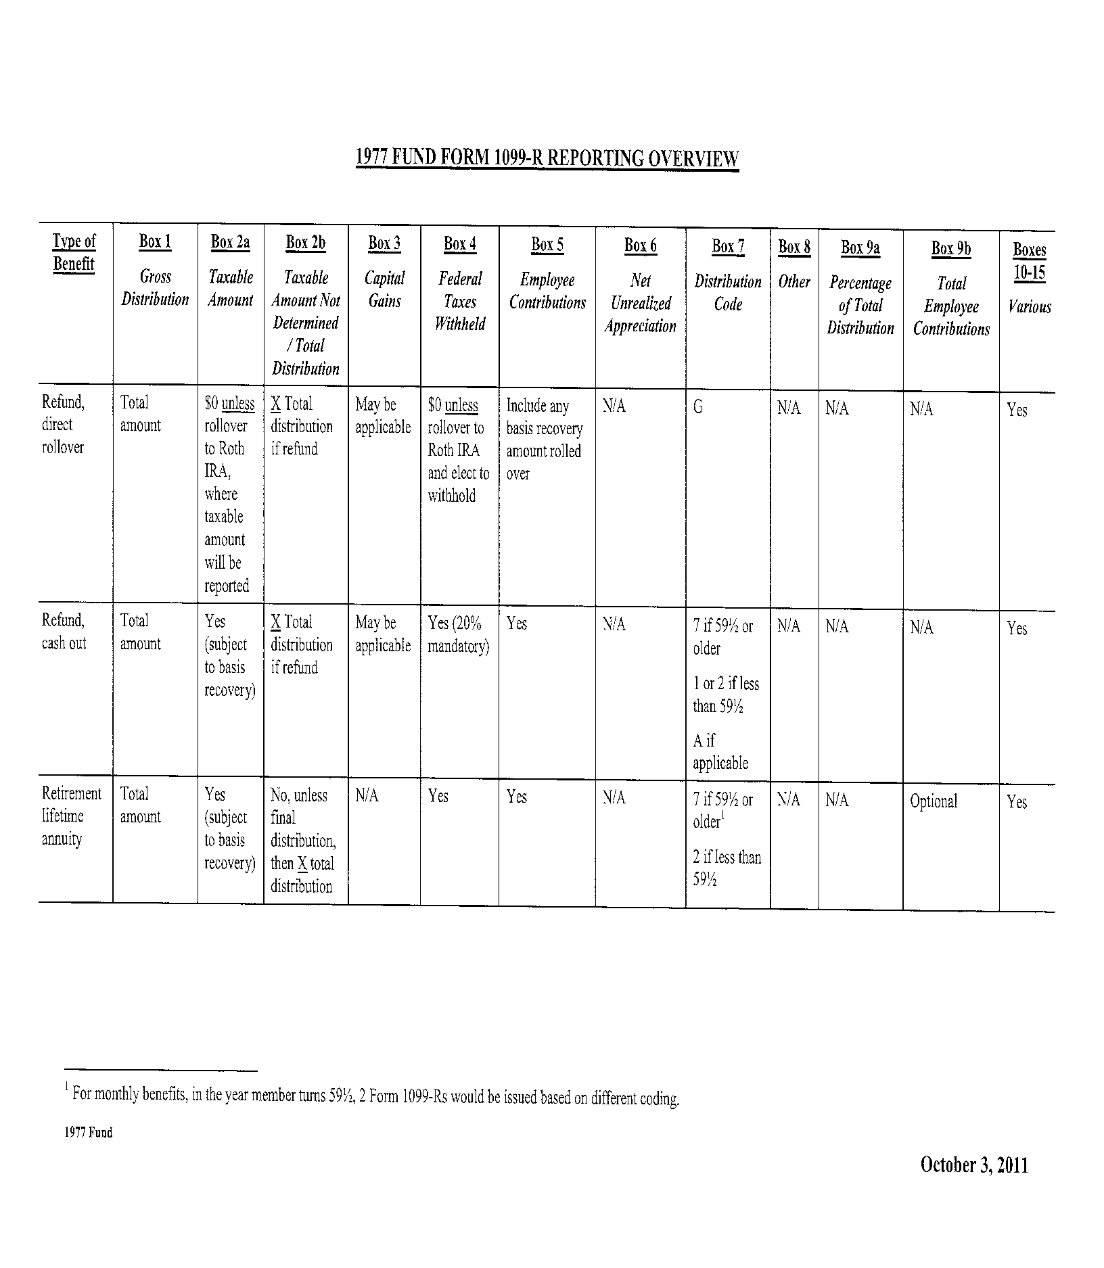

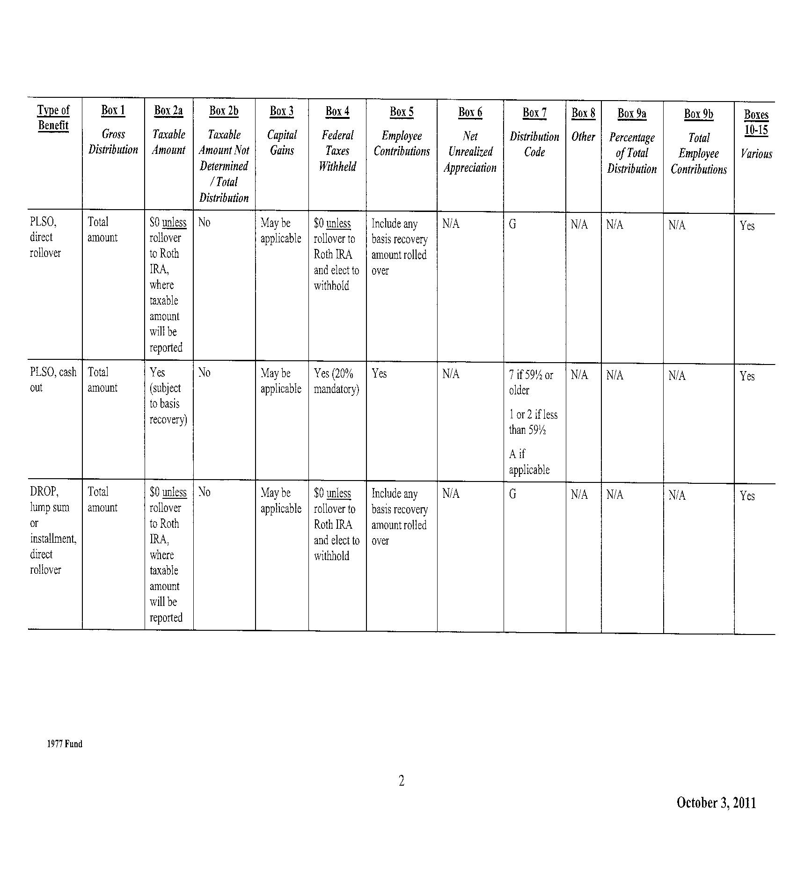

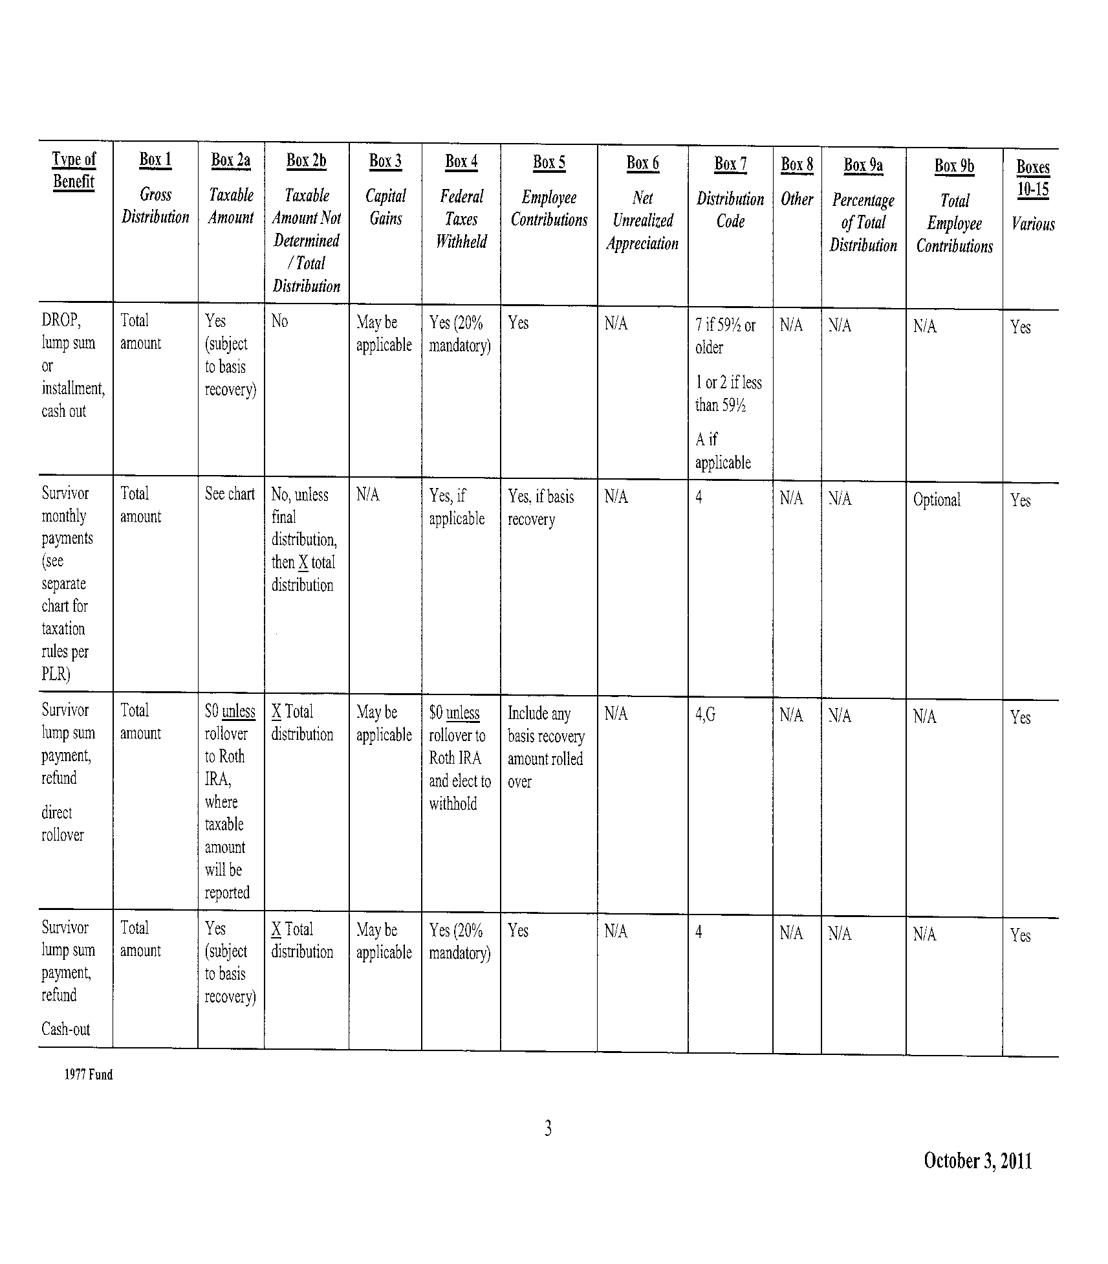

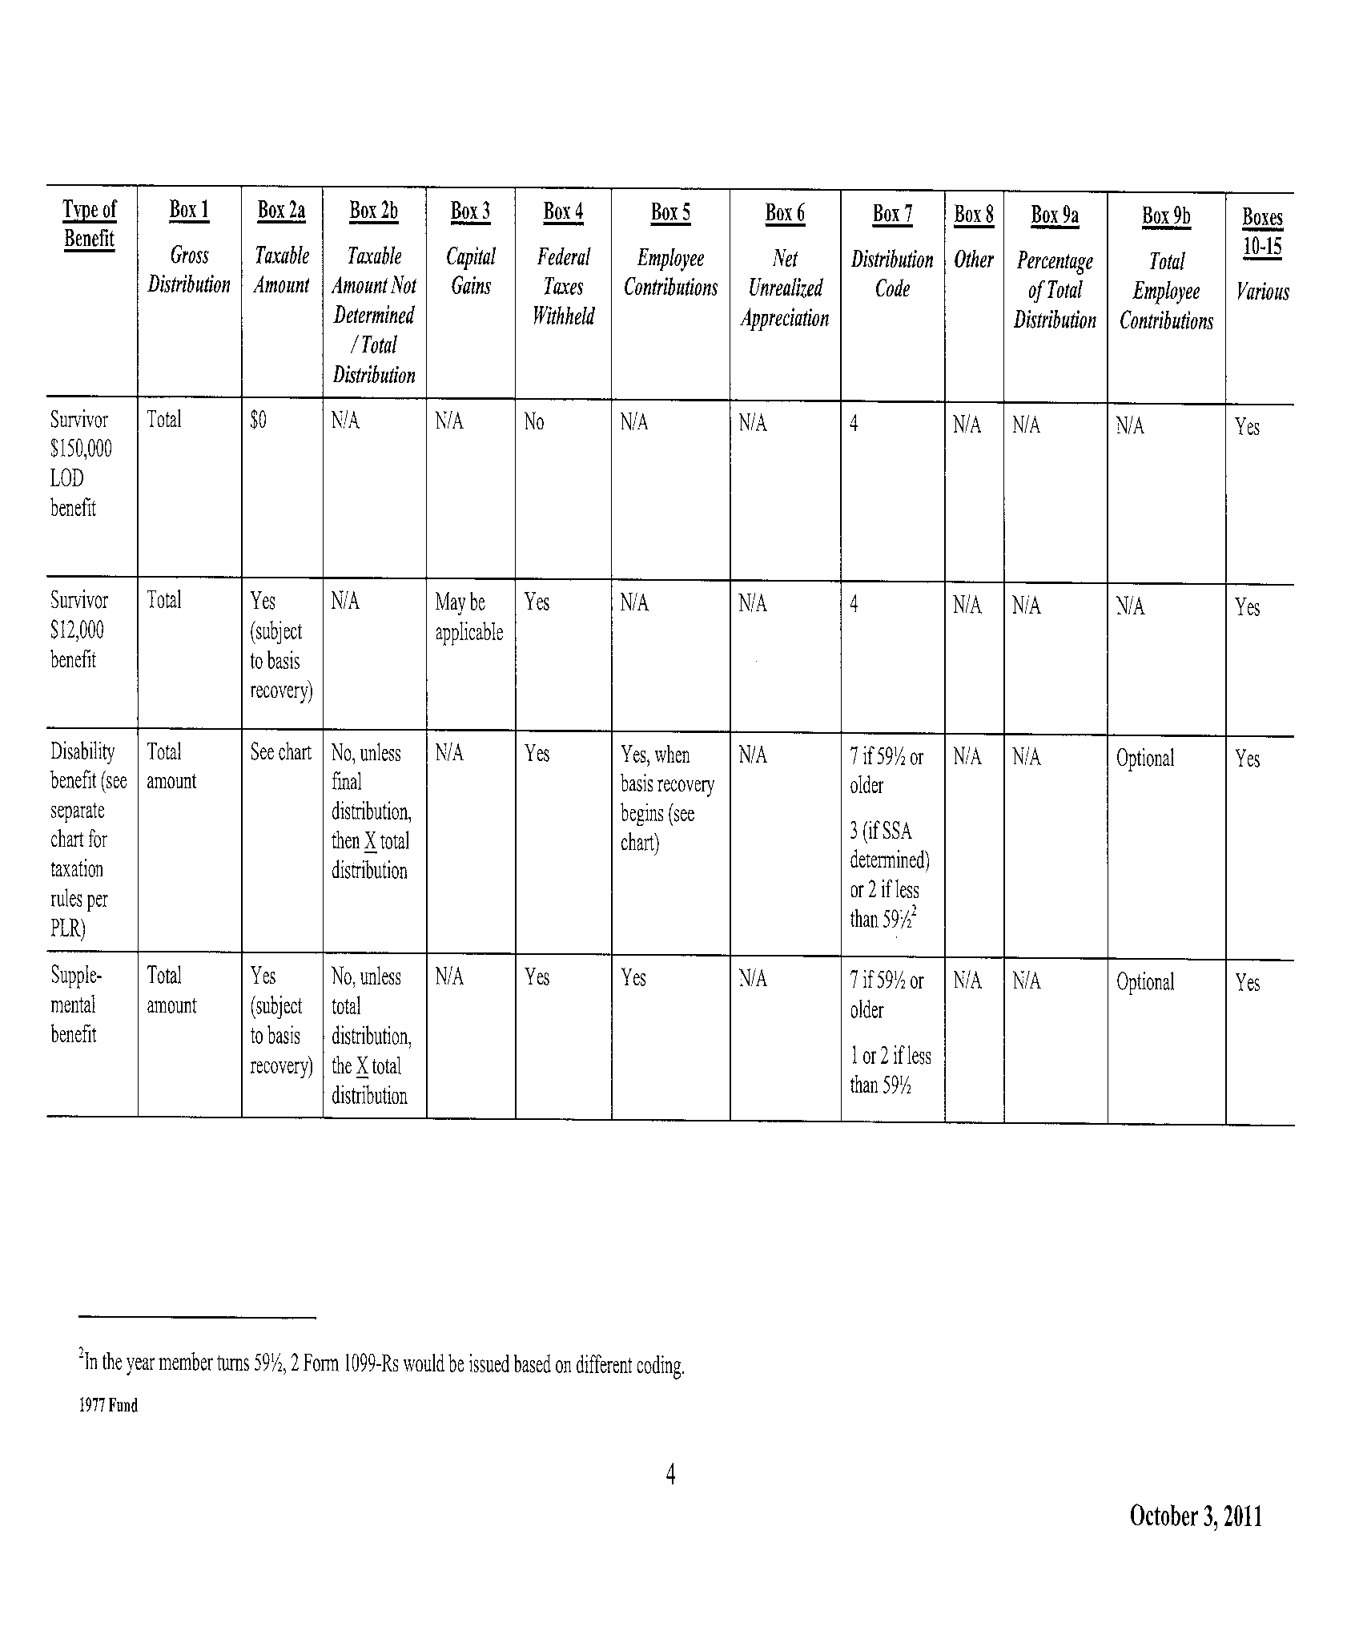

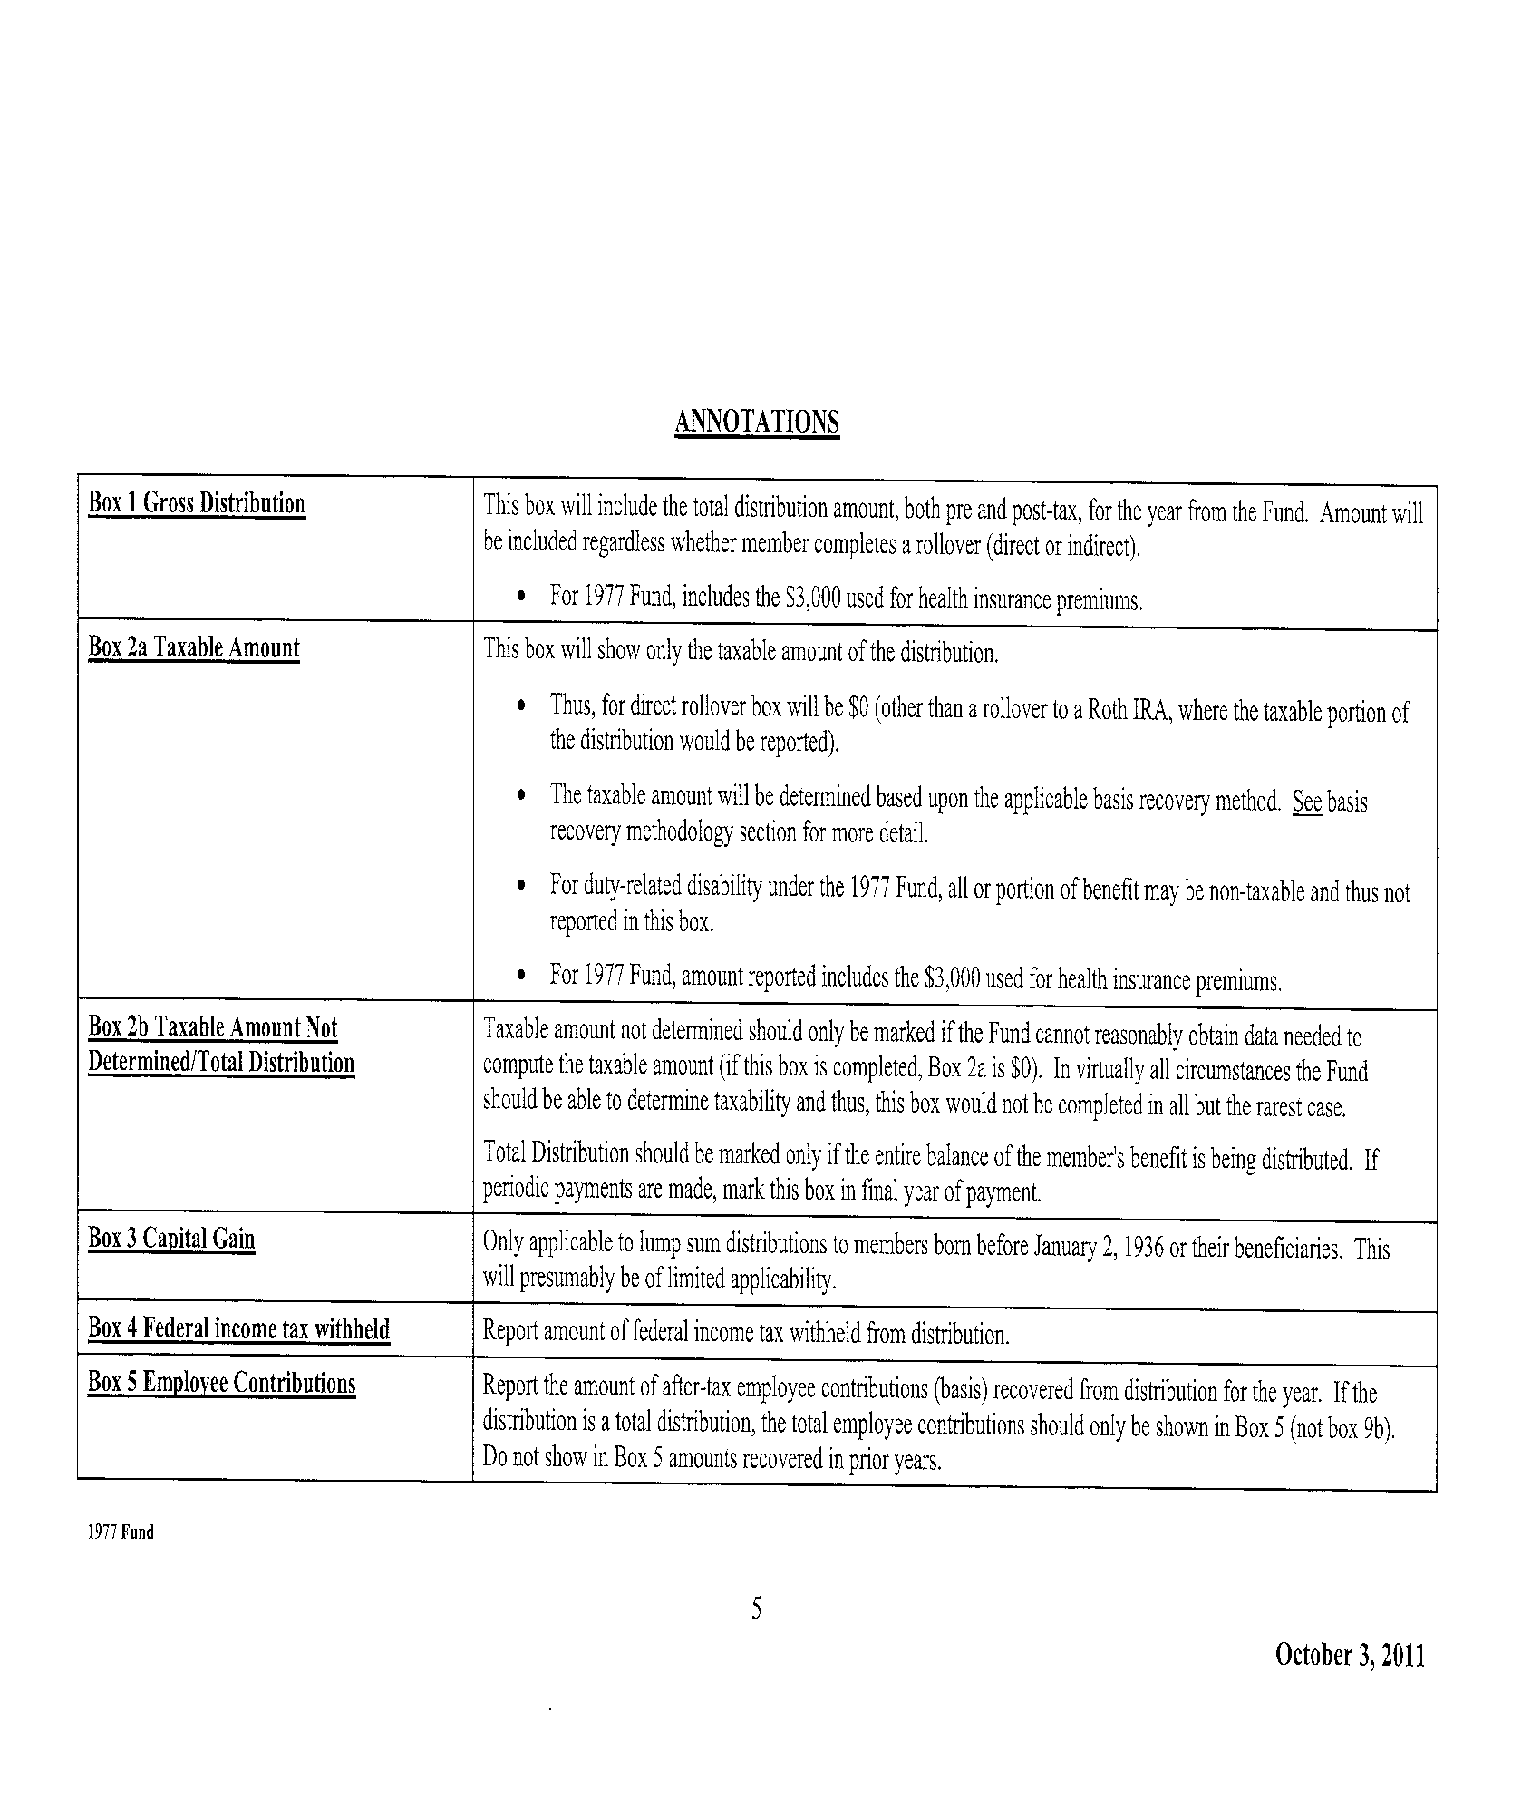

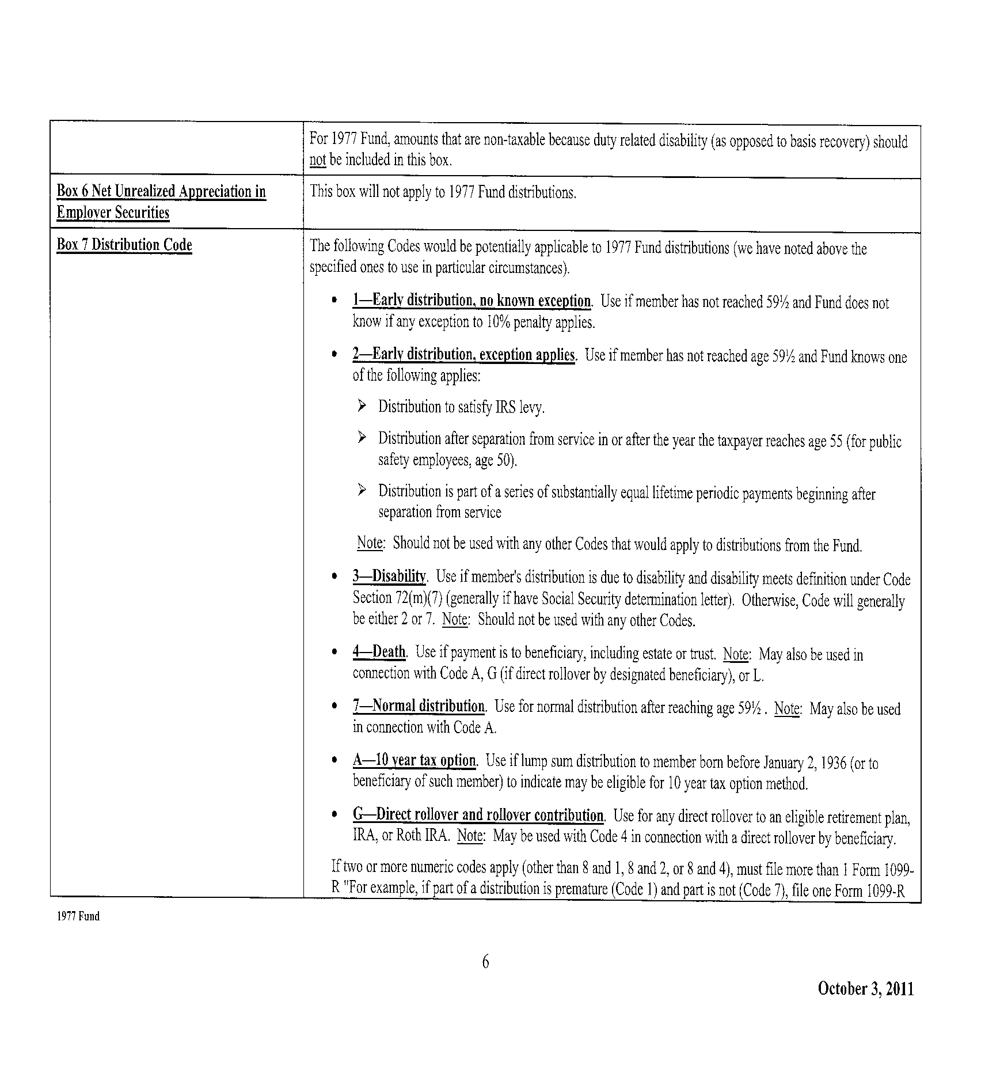

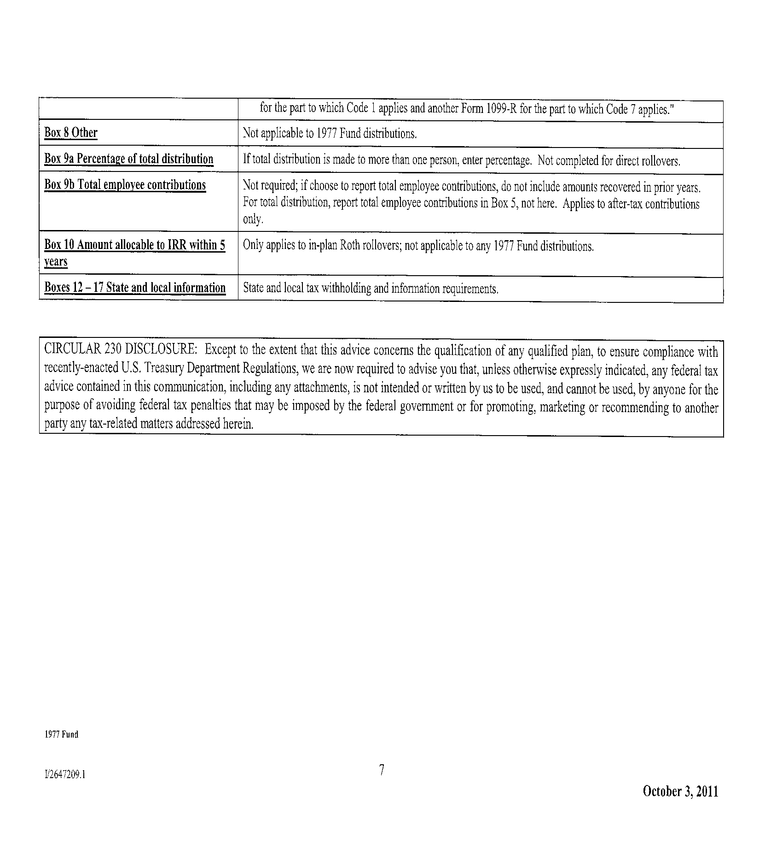

8178903v2/13878.002

