100 North Senate Avenue Room N758-RE

Indianapolis, Indiana 46204

**Eric Holcomb, Governor Michael Smith, Commissioner**

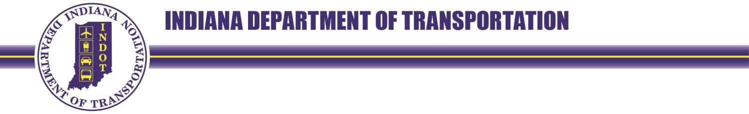

|  |  |  |
| --- | --- | --- |
| Date: |  |  |
| Project: |  |  |
| Code: |  |  |
| Parcel: |  |  |
| County: |  |  |

Property Owner

Address

City, State, Zip

Dear **PROPERTY OWNER**,

The purpose of this notice is to inform you that the Indiana Department of Transportation (INDOT) needs to acquire property that you own, located at: **123 E State Road X, Somewhere, IN 12345**, as part of a nearby transportation improvement project. We will be reaching out to you shortly with more information.

In order to expedite this process, please provide your contact information below and return this page with the included business reply envelope.

|  |  |  |
| --- | --- | --- |
| Preferred Name: |  |  |
| Phone Number: |  |  |
| Email address: |  |  |
| Mailing address: |  |  |
|  |  |  |

Sincerely,

|  |
| --- |
| (Signature)  NAME, TITLE  AGENCY AND ADDRESS  Phone:  Email: |
| Agent of: The Indiana Department of Transportation |