Multimodal Departments Team Up for Crucial Aerial Photos and Video

A typical INDOT project is usually easy to access since it often is located at a roadway intersection or along a section of highway. However, a recent project overseen by the Multimodal Rail Programs Office on behalf of the Federal Railroad Administration (FRA) was located more or less “in the middle of nowhere” in remote Posey County, northwest of Mount Vernon, Ind.

The $20 million project was made possible for the Evansville Western Railway (EVWR) as a result of INDOT being selected for a $10 million TIGER Grant. The project included the removal of 90-year-old timber bridge approaches — totaling more than a half-mile of 228 spans — to the Maunie Railroad Bridge. The bridge approaches were replaced with a 37-span bridge on the Indiana side of the Wabash River and a 40-span bridge on the Illinois side, both constructed with steel and concrete.

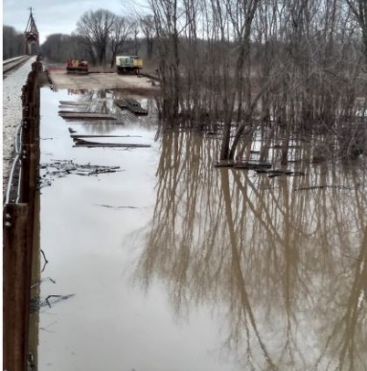
“Because of its self-mandated COVID-19 travel restrictions, the FRA couldn’t accompany INDOT’s Rail Programs personnel onsite for the pre-final inspection,” said INDOT Senior Rail Project Manager Tom Rueschhoff.
The flood plain (right photo) created muddy conditions (middle photo), necessitating the installation of timber mats (bottom photo).

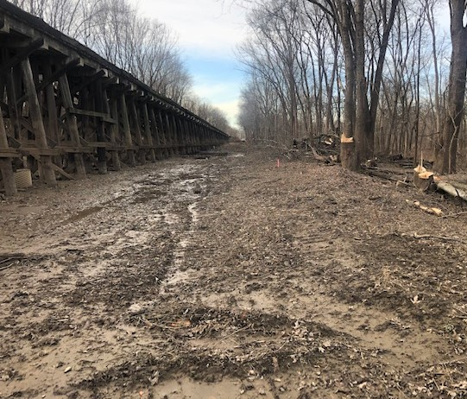
Since the FRA had never visited the project site, Rueschhoff asked if the federal agency would like INDOT to use our drone to fly the entire project. The FRA agreed that a drone would be the preferred inspection method, if possible.

Rueschhoff previously witnessed Aviation Development Specialist James Kinder utilize INDOT’s unmanned aircraft systems (UAS) to produce video sections of I-69. For this rail project, aerial videos in addition to Rueschhoff’s ground photos would help provide a complete visual inspection documentation.

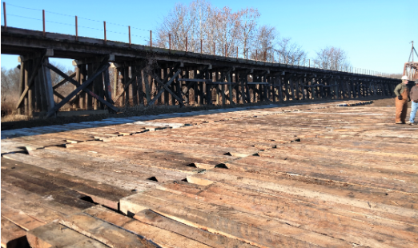
So, in late January, Rueschhoff, Kinder, and INDOT UAS Department Director Dylan Powell trudged out to Posey County to mark the first time that UAS has been used at INDOT for a rail project. Several videos and photographs were taken from all angles via INDOT’s UAS and will provide a complete documentation of the project to be submitted as part of the final performance report to the FRA.

Based on the number of times the railroad had experienced flooding of the Wabash River at the project site in recent years, the EVWR had allowed for a four-year construction schedule for the contractor to work around the anticipated flooding impacts. The project began in November 2019, and the contractor, Sheet Piling Services, was forced off the site after only two months due to flooding for the next four months. It appeared the original project schedule was looking to be likely.
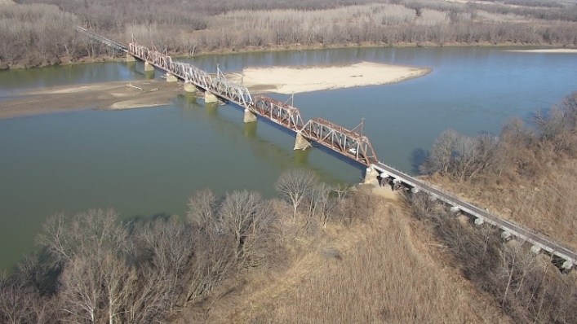
However, over the remainder of 2020, the railroad and contractor doubled the number of crews and amount of equipment to expedite the construction when the waters receded.

“It’s in the middle of nowhere, as you have to drive on dirt farm roads to get to it,” said Rueschhoff. “During the prebid meeting, the railroad had a local farmer drive his large tractor and hay wagon to transport the contractors, EVWR personnel, and INDOT down to the project site so that the contractors could complete their bids.”
INDOT’s aerial footage from January shows the railroad bridge at the foot of the Wabash River (top photo), about a quarter-mile east of the river over a flood plain (middle photo), and crews removing timber crane mats (bottom photo) as demobilization is underway.

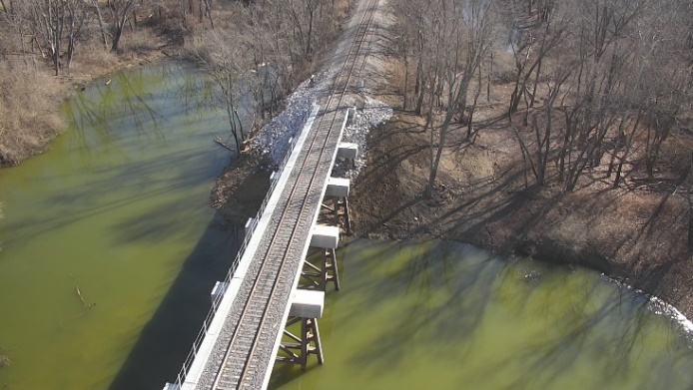
A critical decision was made to spend nearly $1 million in extra charges to install thousands of 12-inch timber crane mats, which would be cabled together and put down to create working platforms on top the mud on both sides of the river. The chained mats were tied off to steel H-pile structural beams to ensure that they would not float away under flooding conditions. With construction now allowed to continue starting in April 2020, the project was able to be finished in 1½ years and not the four years as originally estimated.

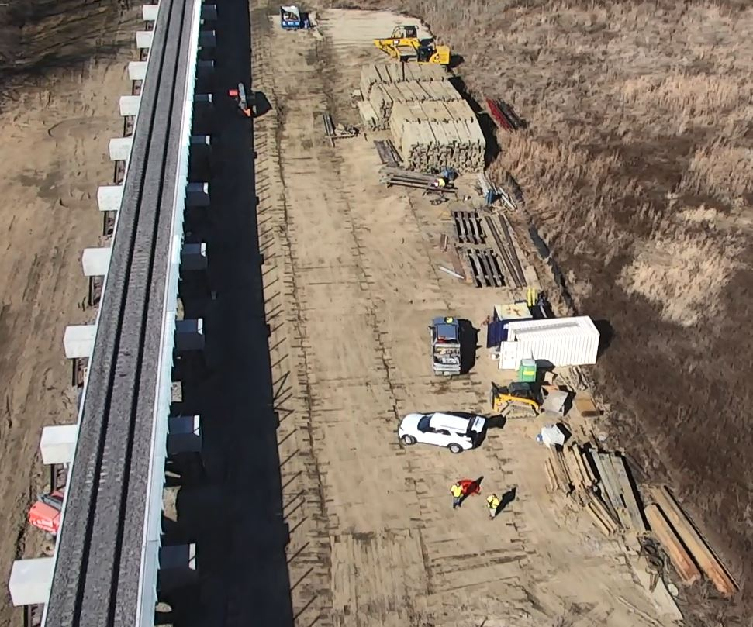
EVWR has hired a separate contractor that is scheduled to remove the old rail from both new bridge approaches plus the bridge over the Wabash River and replace it with continuously welded 136-pound rail from end to end.

Crews are scheduled to install final components in March. This project should keep the tracks operational in those sections for approximately the next 100 years.

To watch an INDOT UAS video that shows the scope of this rail project, click here. (Note: The nine-minute video slowly shows the start of the project on the Indiana side with the new approach bridge, standing water, timber crane mats being dismantled, Wabash River bridge, approach bridge on the Illinois side, timber crane mats being dismantled on the Illinois side, and, finally, a quick flyover back to the Wabash River bridge.)

“Another responsibility of the Rail Programs Office includes inspections of grade crossings throughout the state” said Rueschhoff. “Although we have considered the use of UAS on other facets of our inspections, we currently do not see us utilizing it at this time. However, in the case of the EVWR Wabash River Bridge project over the flood plains, it made perfect sense.”

