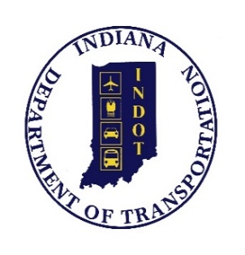
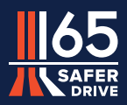

PROJECT NOTICE
REQUEST FOR INFORMATION

REGARDING
SAFER DRIVE 65 PROJECT
FIXED-PRICE PUBLIC-PRIVATE AGREEMENT
(DESIGN-BUILD DELIVERY)

May 23, 2024

Summary:

On May 8, 2024, the Indiana Department of Transportation (INDOT) posted a Request for Qualifications (RFQ) to entities (Proposers) interested in submitting statements of qualifications (SOQs) to design and build the I-65 Added Travel Lanes (ATL) Safer Drive 65 Project (Project) in Clark County, Indiana and Scott County, Indiana, through a “Public-Private Agreement” under IC 8-15.7-5 (hereafter Design-Build Agreement (DBA)) with INDOT. The RFQ is available here: [INDOT: Doing Business with INDOT: Request for Qualifications]. INDOT intends to evaluate SOQs submitted in response to the RFQ to identify prequalified Proposers who will be invited to develop proposals in response to a Request for Proposals for the Project that INDOT is currently developing (RFP). INDOT is soliciting input from prospective the public to assist INDOT in the RFQ process and ongoing development of the RFP. Initially capitalized terms used in this Project Notice (Request for Information) have the meanings assigned such terms in the RFQ.

Request for Information:

Section 2.7 of Part B of the RFQ describes the roles and requirements for Key Personnel positions that INDOT has identified as necessary and appropriate to complete the Project. INDOT solicits input from the public regarding these requirements, specifically with respect to the number of years of experience required for persons filling the Key Personnel positions. Respondents who wish to suggest a change in the requirements should indicate the specific Key Personnel position to which each suggested change applies, and the rationale for the change.

Dates:

Comments are requested by May 28, 2024.

Instructions for Delivery of Responses:

Comments should be titled Response to Request for Information Regarding Safer Drive 65 Project and submitted to Autodesk Construction Cloud. Those that do not have access to ACC please submit a request following the instructions in the RFQ.

Public Record:

Respondents are advised that their responses to this Request for Information are not confidential and will become a part of the public record, regardless of any confidentiality notations that a respondent may include in its submittal.

