|  |  |  |  |
| --- | --- | --- | --- |
| **Letterhead Banner 2**   |  |  |  | | --- | --- | --- | | 100 North Senate Avenue  Room N725  Indianapolis, Indiana 46204 | PHONE: (317) 232-5094  FAX: (317) 233-8862 | **Eric Holcomb, Governor**  **Joe McGuinness, Commissioner** | |
|

**TO: Prequalified Contractors**

**FROM: Prequalification Division**

**DATE: April 6, 2021**

**RE: Frequently Asked Questions- Using the New Contractor Prequalification Application in ITAP**

Construction Partners,

First, thank you all for your partnership in rolling out the new CPQ system. We recognize that the new application will require you to spend some extra time this year learning the platform and converting your information to INDOT’s templates. The information that you provide this year will auto populate when you apply for your next certificate of qualification. We would encourage you to adopt the CPQ templates for storing your company’s prequal information and update the experience and equipment lists in CPQ periodically throughout the year. Instructions for updating data tables are provided on page six (6) of the [CPQ User Guide](https://www.in.gov/indot/files/User%20Guide%20for%20CPQ.pdf) (*see* item number 11). A demonstration of the process is also provided in the [CPQ training video](https://youtu.be/54KZ7KsmX6M).

Based on our experience with CPQ thus far, we have identified the following Frequent Asked Questions and other insights regarding CPQ and the new application process. **

\*\***April 6, 2021 Update*:***Prequalified contractors that have an expiring certificate of qualification should continue working in CPQ and submitting applications for prequalification in the lead up to INDOT’s launch of the new ITAP system (now through April 23, 2021). The launch of the new system will not impact the information you have already entered in CPQ. However, it will require ITAP to go offline starting at 5:00 PM on Friday April 23, 2021, and to remain offline until the morning of April 26, 2021. Applicants will be unable to access CPQ during this time. Otherwise, the launch of the new ITAP system will not have any impact on the contractor prequalification application process.

1. **What type of application should I complete (see CPQ User Guide page 7)?**

There are four (4) application options in CPQ: (1) Over-Height Vehicle Escorts; (2) Non-Prequalified Subcontractors; (3) Haulers; and (4) All Others.

Most firms fall under option four (4)- All Others. This category covers ***all prequalified primes and subcontractors***, regardless of the amount of INDOT work the company plans to complete.

1. **What do I do if I select the wrong option and submit an application as a hauler, escort, or non-prequalified sub (see CPQ User Guide page 6)?**

Click “Past Applications” on your CPQ Dashboard to pull the erroneous application back to draft status and delete it. This action can be completed by all CPQ roles except Certified Public Accounts. If you accidently submit the wrong application type, you will need to pull the erroneous application back to draft status before the system will allow you to start a new application.

1. **How old can my financial statement be?**

INDOT does not accept financial statements that are more than sixteen (16) months old. This is because the expiration date assigned to a certificate of qualification can be no more than sixteen (16) months from the date of the financial statement on which the applicant relied. As such, if a contractor submits an application using a fifteen (15) month old financial statement, the certificate will have a duration of no longer than one (1) month.

**Please note: INDOT will not accept applications based on December 31, 2019 financial statements after April 30, 2021.

1. **What do I do if I have a question or issue using a CPQ template?**

All template related questions should be directed Jose Murillo ([JoMurillo@indot.IN.gov](mailto:JoMurillo@indot.IN.gov)) and Pat Goralski ([PGoralski@indot.IN.gov](mailto:PGoralski@indot.IN.gov)).

1. **Is there is a distinction between new applications and renewals in CPQ?**

No, all applications are considered “new” applications for the purposes of contractor prequalification. Companies with an expiring certificate of qualification will complete the exact same process and application as companies that are entirely new to INDOT. Please note that information entered in CPQ this year will auto populate in the company’s next application.

**How do I change my company’s address and other contact information in ITAP?**

Users can change their own address in ITAP by following these steps:

1. Login to ITAP
2. On the home screen, select USER and click MAINTENANCE in corresponding drop-down menu.
3. The MAINTENANCE menu will show all users and their contact information.
4. To change the address for each user, click the pencil icon in the far-right box.
5. When you click the pencil icon, a box will open containing the users contact information.
6. Edit the information you would like to edit in this box and click SAVE on the bottom of the box.
7. **What should I do if my company’s ITAP account is registered to a previous employee and I cannot access that person’s email inbox?**

In most instances companies can change and re-assign roles, including admin roles, themselves by following these steps- Log into ITAP> Select Business > Select Busines Maintenance> Click User Icon> Select Current Admin> Click Edit Icon> Uncheck Is Business Admin Box

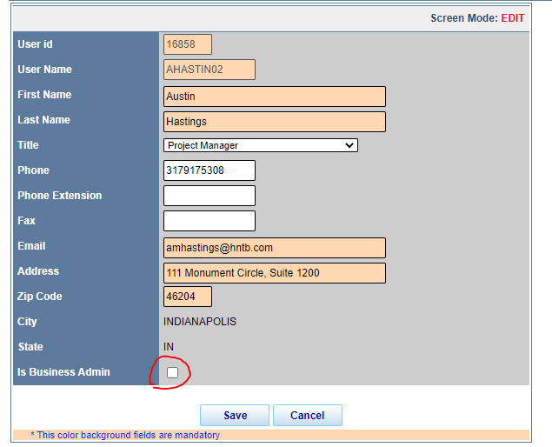If a company is unable to change its admin user following the above steps, please send an email to [sctcrequest@indot.in.gov](mailto:sctcrequest@indot.in.gov) containing the following information: (1) Business Name; (2) Name of Current Admin User; (3) Name and email address of the new admin user.

NOTE: Contractors should only use this method for changing user admin roles when it is not possible for the company to complete the change in ITAP.

1. **What do I do if I get the following error message while attempting to begin an application or complete another action within CPQ?**

Access Denied, please contact application administrator.

If an applicant gets the above error message it means the user does not have the necessary admin permissions assigned in CPQ. To assign admin authority to an existing user click on Business > Business Maintenance > User Icon> Select your user profile>Click Edit Icon>Check the Box at bottom of new window that says, “Is Business Admin”. If a user continues to get the above error or cannot change the roles in CPQ, please email [sctcrequest@indot.in.gov](mailto:sctcrequest@indot.in.gov) for assistance.

1. **What do I need to know about the upcoming ITAP upgrade and system update?**

The new upgraded ITAP platform goes live on April 26, 2021. All new and existing ITAP users must create an Access Indiana account and link their company’s ITAP business registration(s) to their new Access Indiana account. Training materials will be sent to all ITAP users in the coming weeks. Please note that as a result of the new system launch, **ITAP will be offline from 5:00 PM EST on Friday, April 23rd until the morning of Monday, April 26th**. During this time, firms will be unable to edit or create applications for prequalification in CPQ.

Please direct questions regarding ITAP and Access Indiana to Karie Riley (KRiley2@indot.IN.gov) and Vijaya Marakani (VMARAKANI@indot.IN.gov).

1. **What if I have questions about CPQ as I complete my application?**

Please reference the [CPQ User Guide](https://www.in.gov/indot/files/User%20Guide%20for%20CPQ.pdf) and [CPQ training video](https://youtu.be/54KZ7KsmX6M) for an overview and step by step guide to completing the new application process. . If the user guide and video do not answer the question, please send an email to the contractor prequalification team: Chris Serak, Prequal Director ([chserak@indot.in.gov](mailto:chserak@indot.in.gov)); Jose Murillo, Prequal Engineer ([jomurillo@indot.in.gov](mailto:jomurillo@indot.in.gov)); Greg Christoff, Prequal Auditor ([gchristoff@indot.in.gov](mailto:gchristoff@indot.in.gov)); Aggie Wagoner, Prequal Specialist ([awagoner@indot.in.gov](mailto:awagoner@indot.in.gov)); and Pat Goralski, Technical and Performance Manager ([pgoralski@indot.in.gov](mailto:pgoralski@indot.in.gov)).

Emails should include a brief explanation of the issue the applicant is encountering, including screen grabs and other files as needed. Email is the best means of resolving CPQ questions as it allows the team to send links and review files that are giving an applicant trouble. Sending an email to the whole team ensures the person with the right expertise receives each inquiry.

The contractor prequalification team will update this FAQ from time to time as necessary to equip applicants to navigate the CPQ system. The above FAQs are based on the questions we are currently receiving and ask that contractors continue communicating their experience using the new process. The information and feedback we have received from construction partners has been critical to the functionality of the CPQ system.

Respectfully Yours,

*/s/: Chris Serak*___________

Christopher B. Serak,

Prequalification Director

Ethics Officer