How to install iTAMS Mobile Application on an IOS device

This function is located in: Download URL

Description
This “HOW TO” manual describes the way to install the iTAMS Mobile App on an iOS device.

Steps
# | Description
1. | The Mobile App installation is composed of three steps:  - Select the App version.  - Download the application.  - Make the App trusted in your device.
2. | Open the web browser using the link provided by W-BMS Administrator or that is located under External links

4. | Install the Mobile Application.  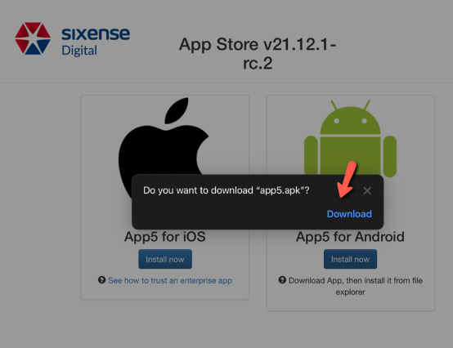
5. | Go to Settings→ General → Device Management: SIXENSE DIGITAL. Then click on Trust “SIXENSE DIGITAL”->Trust.  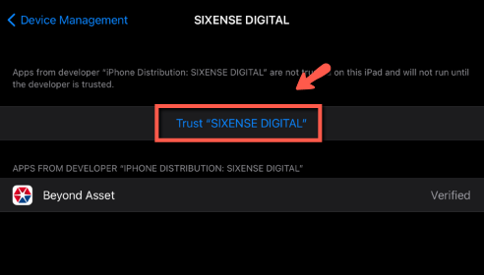
6. | When you login for the very first time, the App prompts users to enter the Code – INDP provided by the W-BMS Administrator.  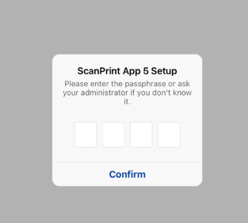  CODE: INDU
7. | Log in to W-BMS with your same user credentials from the web application.  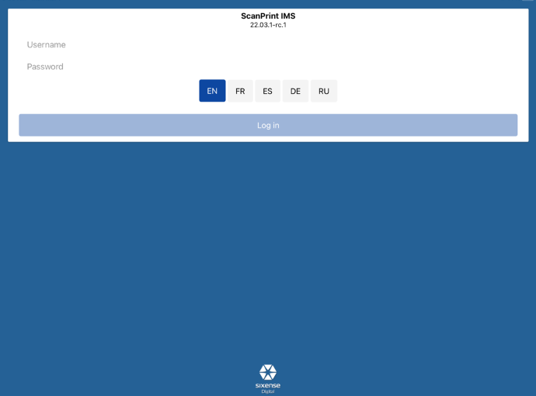
Reference recordings from 3/10/2023 and 3/17/2023 for training guide.

NOTE: To use the mobile app offline; you will need to sign in with your username and paasword with internet connection, first.

