How to Edit Inspection Task Info and Tabs

This function is located under: Tasks->Inspections->Task Info and Chapters

Description
This “HOW TO” manual describes the way to update Inspection Chapters.

Steps
# | Description
1. | - To update an inspection, first select an Asset.  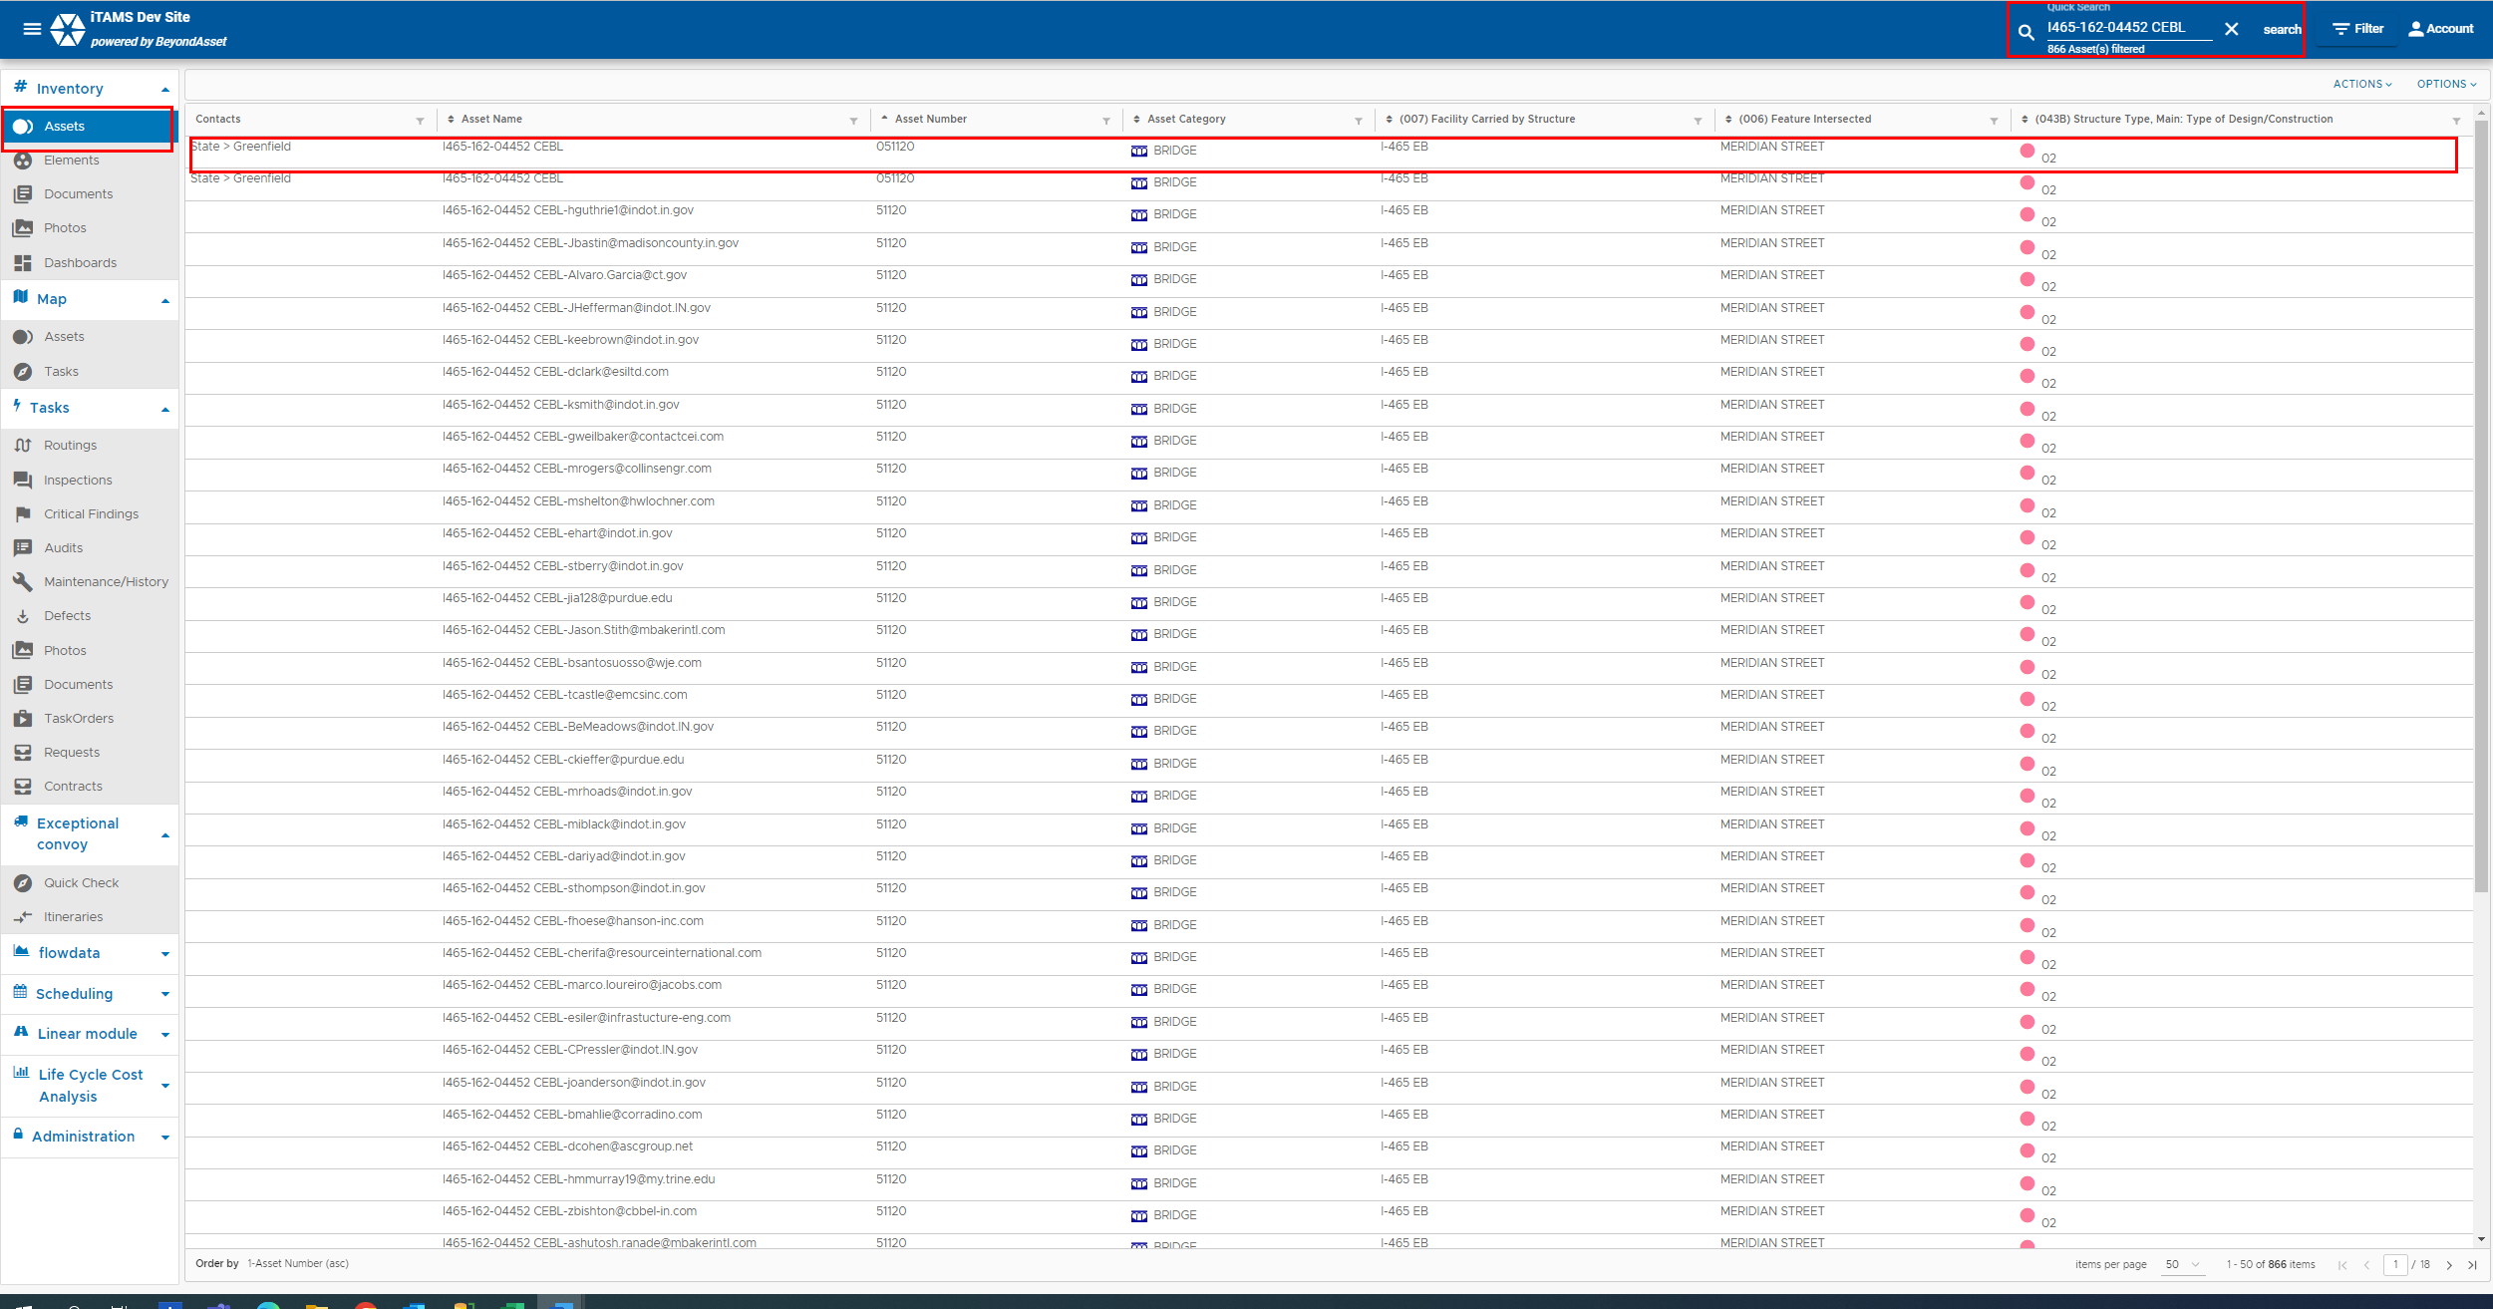

2. | Click on the Inspections tab.  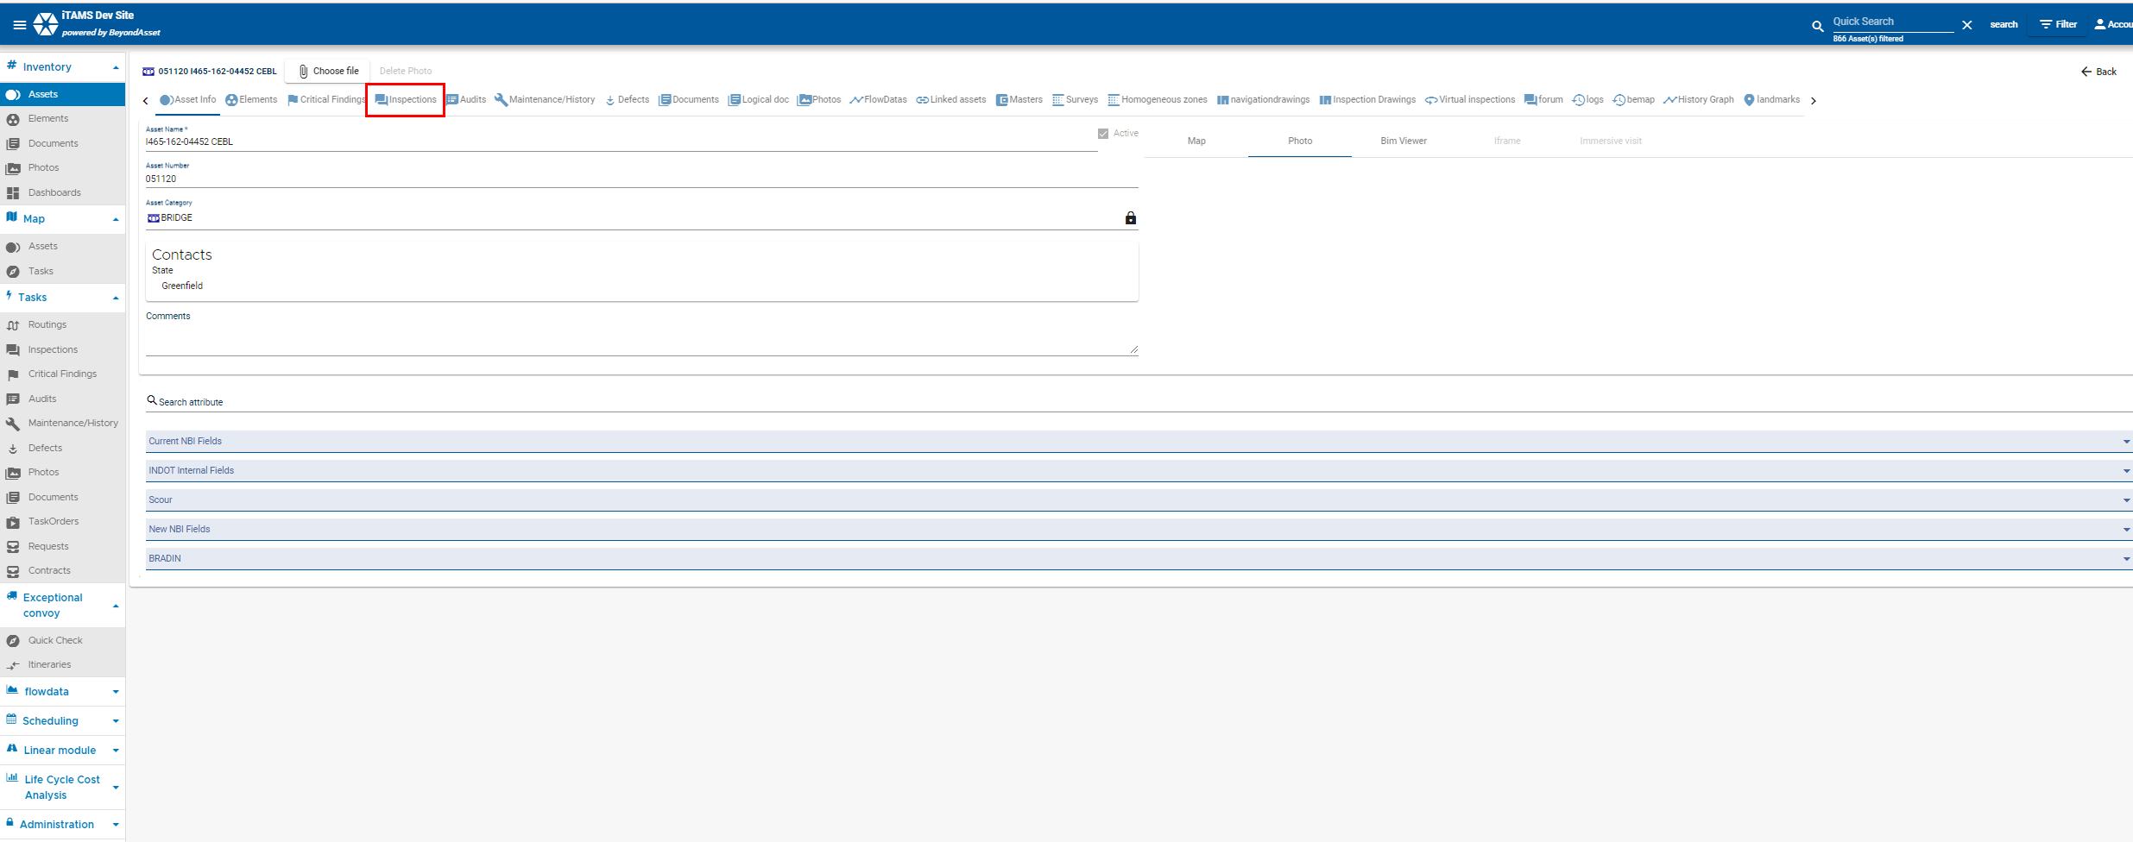
3. | Select the inspection from the list. Please note inspections with the status = approved or inactive will be filteres out from the page list by default. You will have to unfilter to see those records.  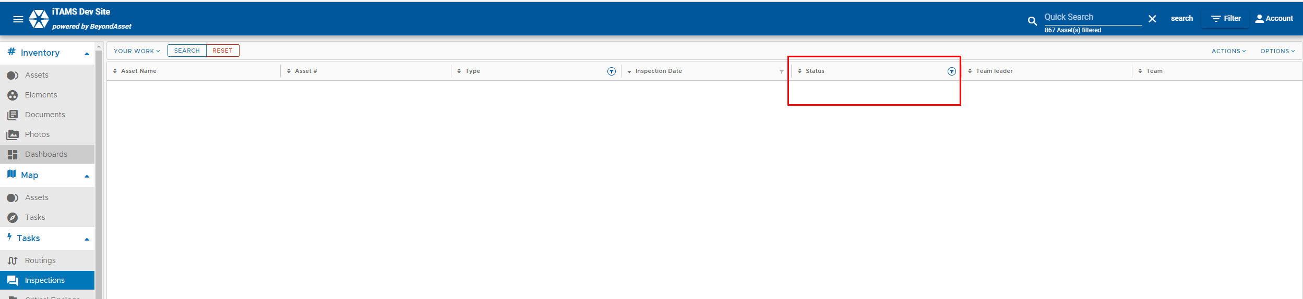  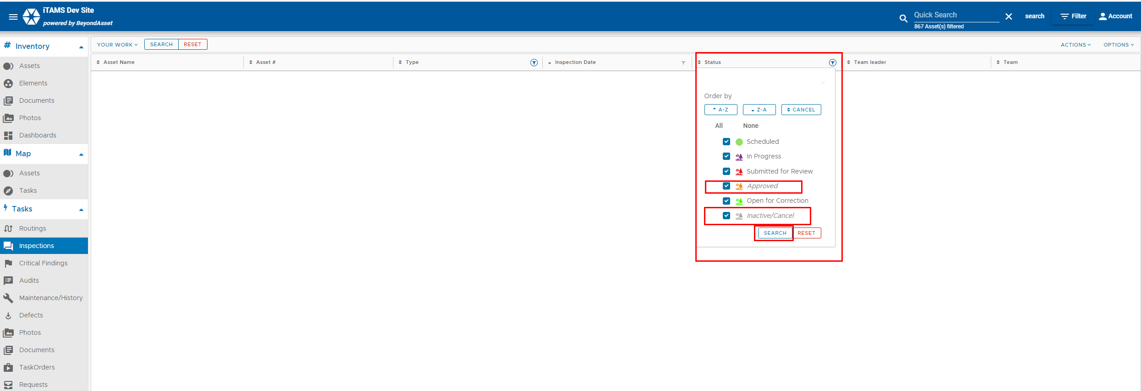  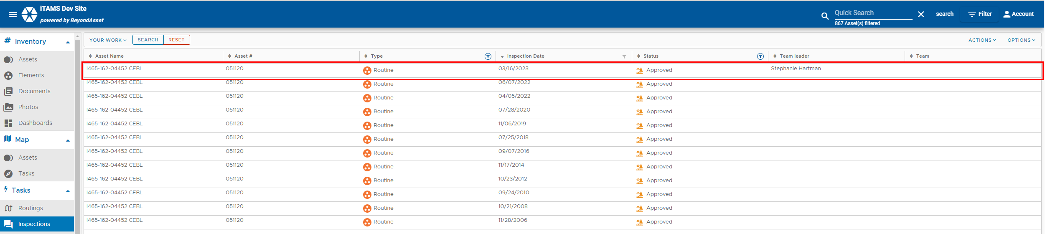

4. | Click on the at the bottom right to edit the inspection. Click on the Chapter you want to edit. Select and populate the fields. Click Save. Once the inspection in in Approved Status, the Inspection Chapter field values will copy over into the Asset chapter field values.  