How to edit Inspections

This function is located under: Tasks->Inspections->Task Info

Description
This “HOW TO” manual describes the way to update a selected Inspection.

Steps
# | Description
1. | - To update an inspection, first select an Asset.  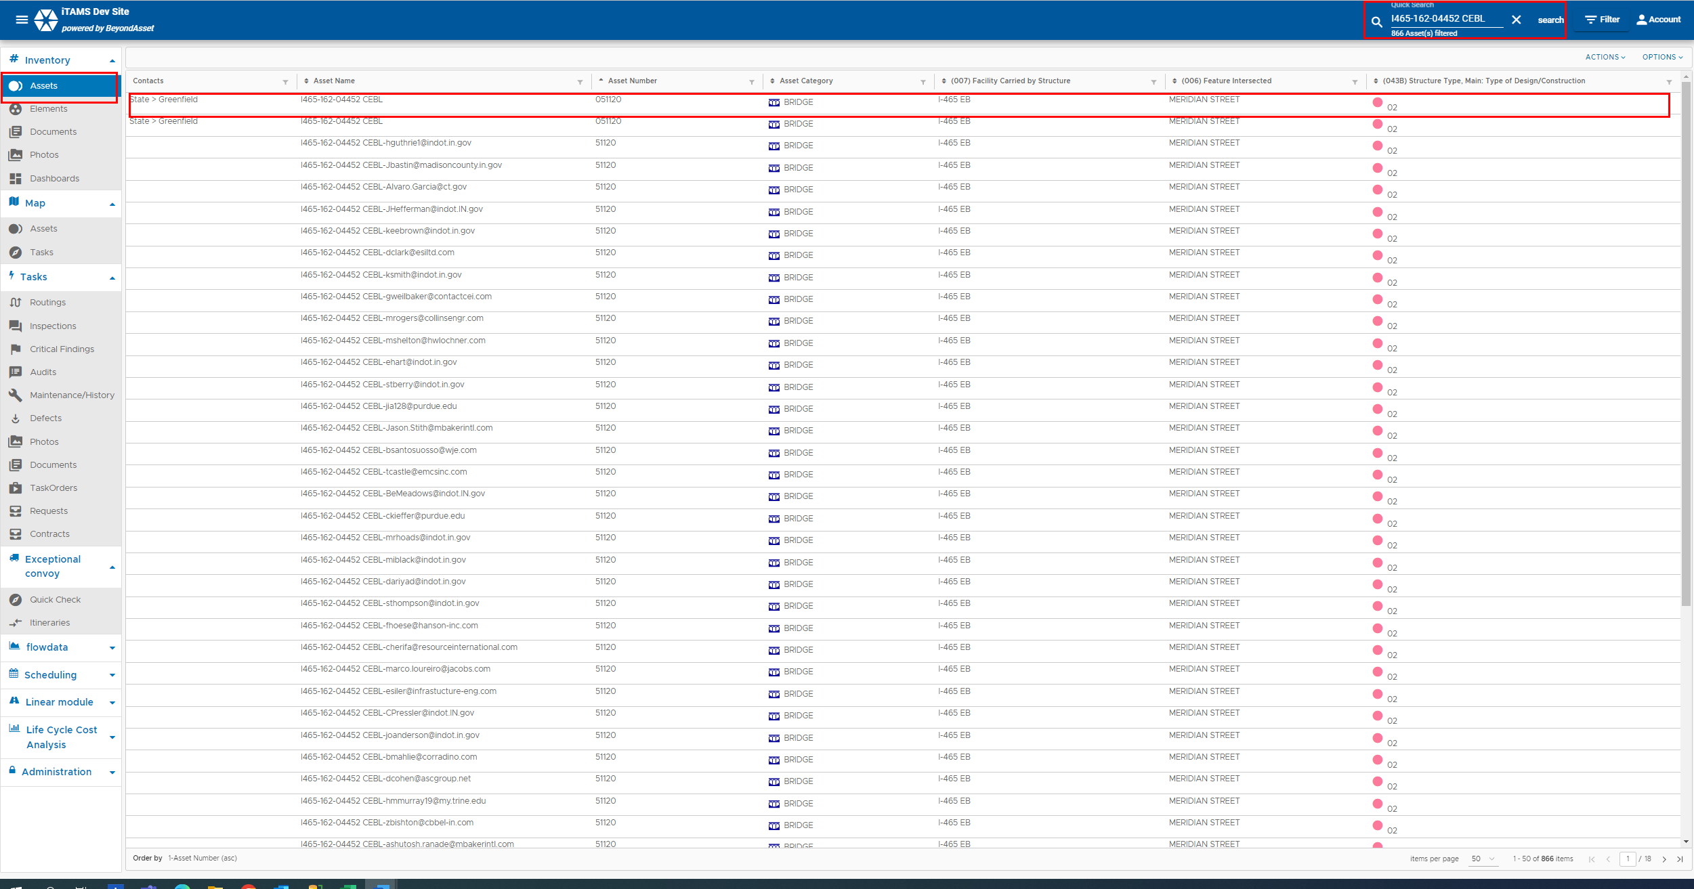

2. | Click on the Inspections tab.  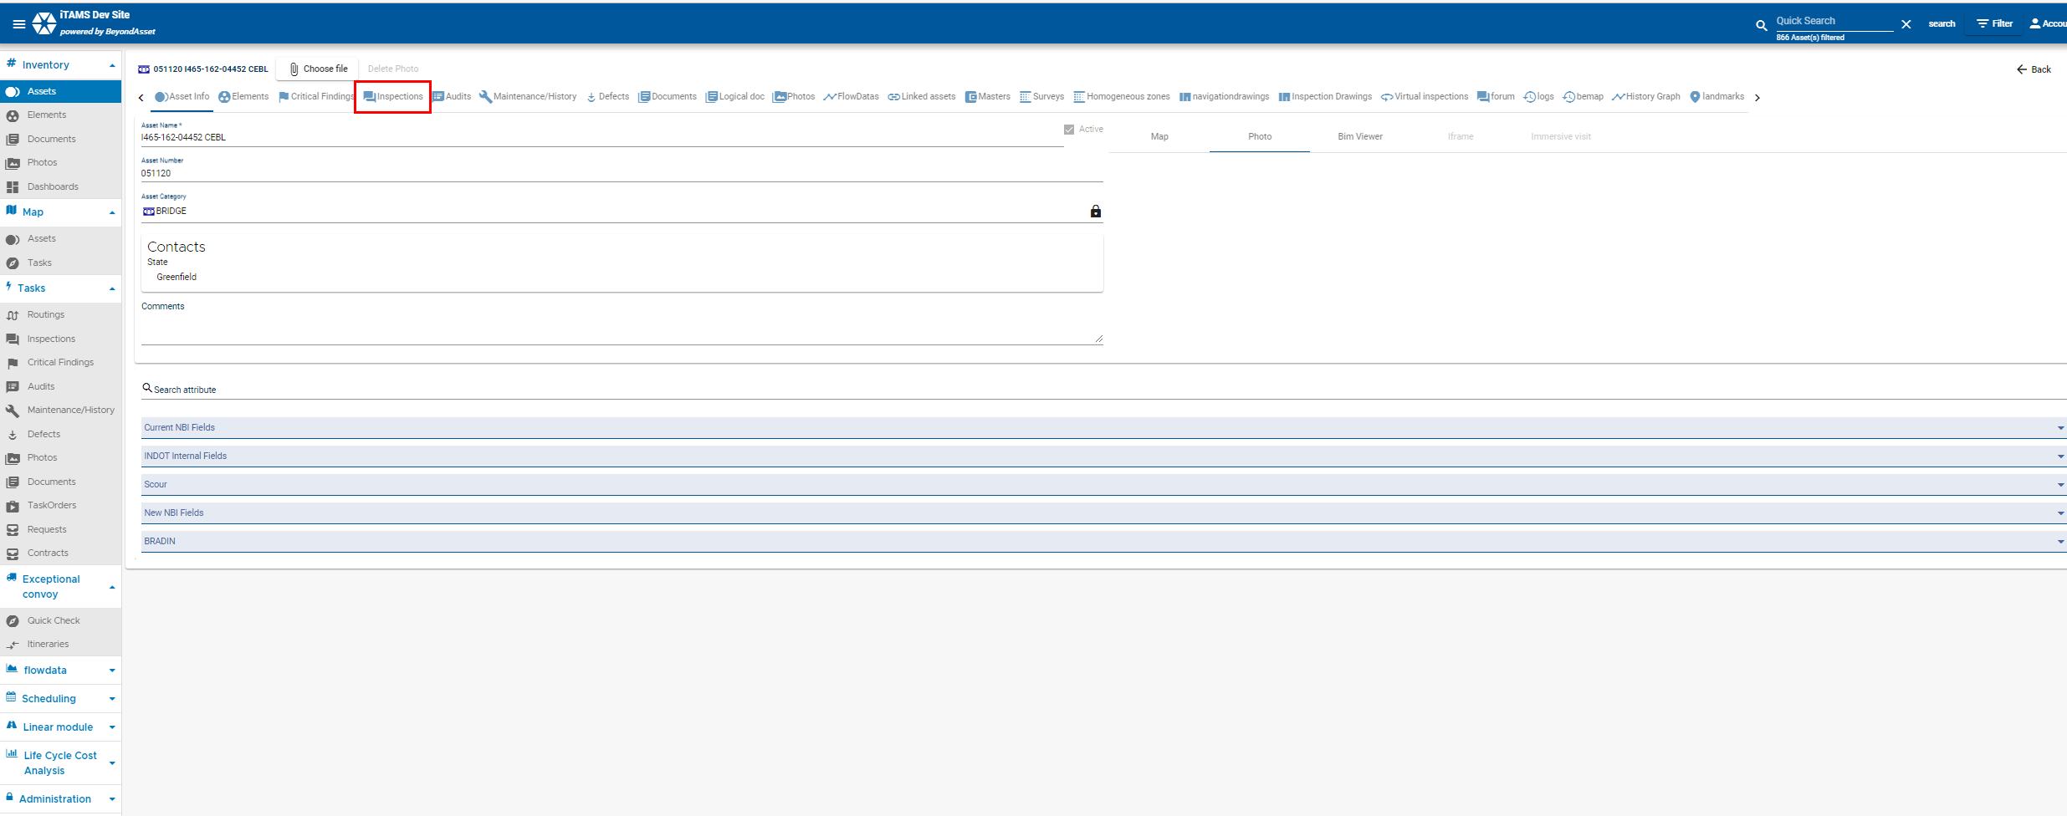
3. | Select the inspection from the list.  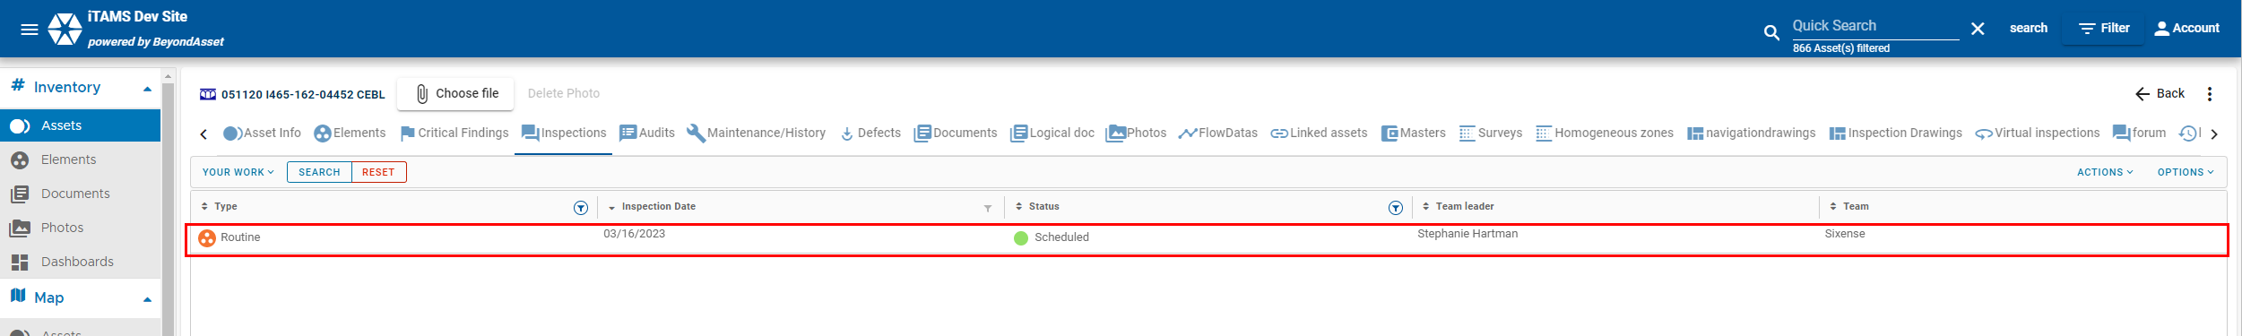

4. | Click on the at the bottom right to edit the inspection.  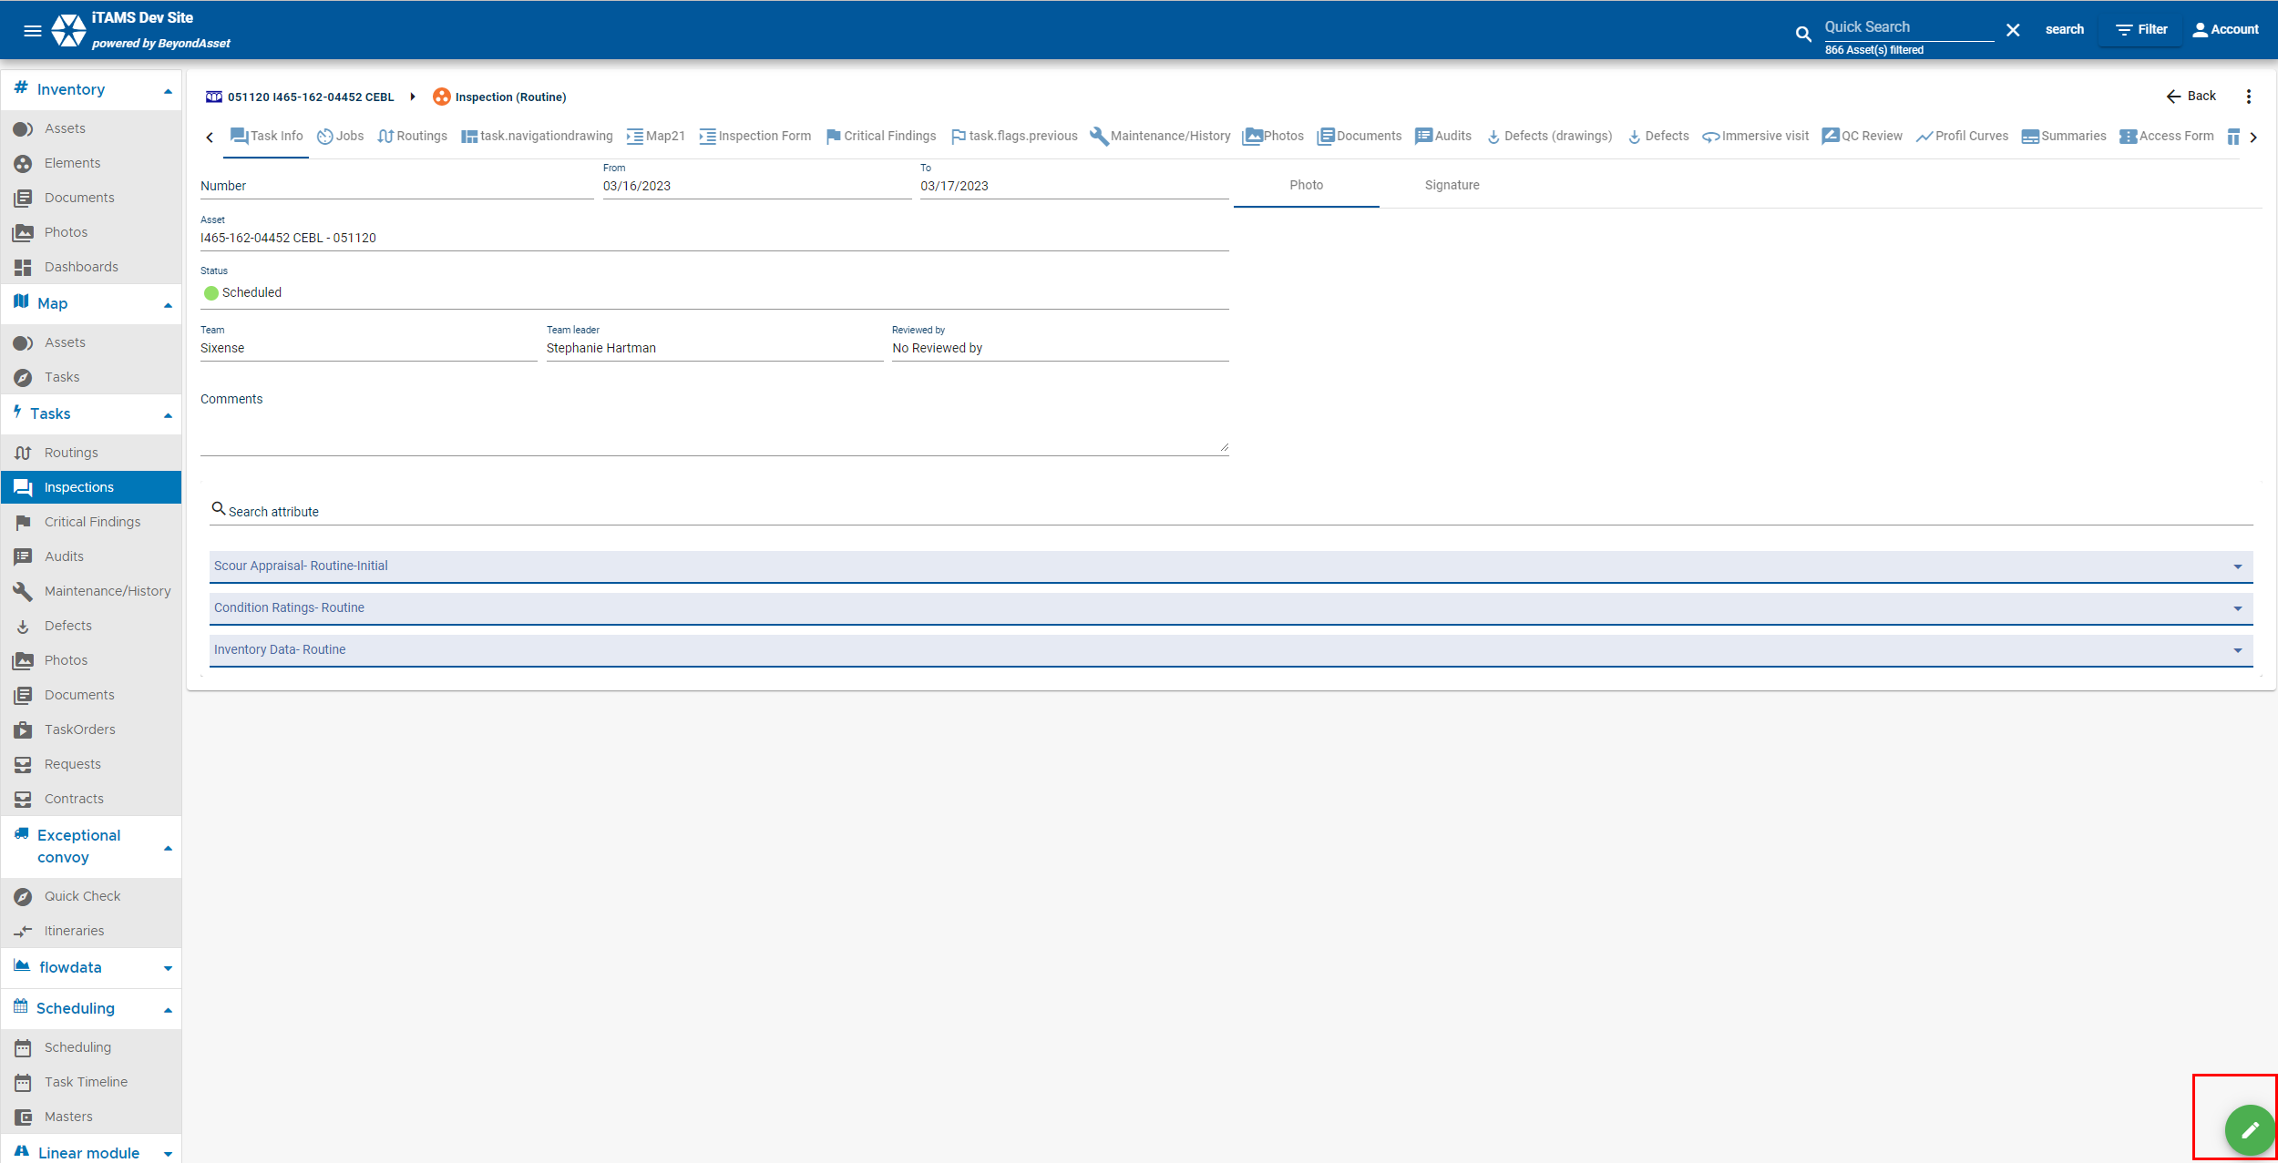
5. | - Update the following tabs and chapters  - Task Info  - Jobs  - Routings  - Elements  - Critical Findings  - Maintenance/History  - Photos  - Documents  - Summaries  - NTSM-Fracture Critical  - Save

