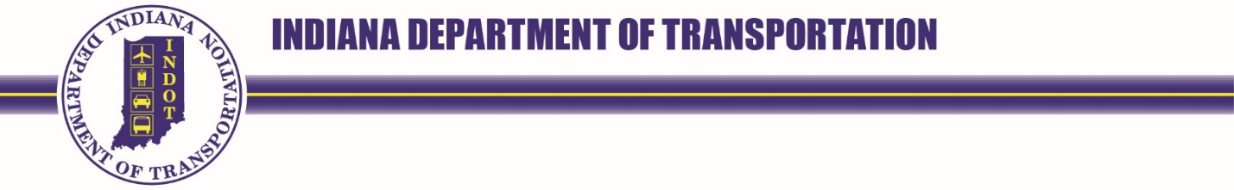
100 North Senate Avenue  Room N758  Indianapolis, Indiana 46204 | PHONE: (855) 463-6848 | Eric Holcomb, Governor  Michael Smith, Commissioner

NOTICE OF OPEN SESSION OF THE
PREQUALIFICATION COMMITTEE
THURSDAY, FEBURARY 15, 2024, 9:00 AM (Executive); 9:45 A.M. ET (Public)
IDOA CONFERENCE CENTER- HARRISON HALL CONFERENCE ROOM 29 (IGC South)

AGENDA
- Executive Session (9:00 AM to 9:45 AM)
THE PREQUALIFICATION COMMITTEE WILL MEET IN EXECUTIVE SESSION TO REVIEW CONFIDENTIAL INFORMATION PURSUANT TO 105 IAC 11-2-4(d) AND IND. CODE § 5-14-1.5-6(b)

- Call Public Session to Order (Steele)
Inset info here

- Old Business (Steele)
  - Consent Agenda (Steele)
Minutes of October 5, 2023

- New Business
  - Adopt Executive Session Recommendations (Committee)
Insert info here

  - Prequalification Division Update (Sutton)
Insert info here

- Public Comment (Open)
  - Insert info here
    - Insert info here

- Next PQC Meeting (Steele)
March 7, 2024 @ 9 A.M- IDOA Conference Center, Room 18

- Adjourn
Insert info here

