How to Schedule an Inspection

This function is located in Scheduling

Description
This “HOW TO” manual describes how to Schedule an inspection.

Steps

# | Description
1. | - Search for an Asset. Example I465-162-04452 CEBL. After a Master is created you can schedule an inspection.  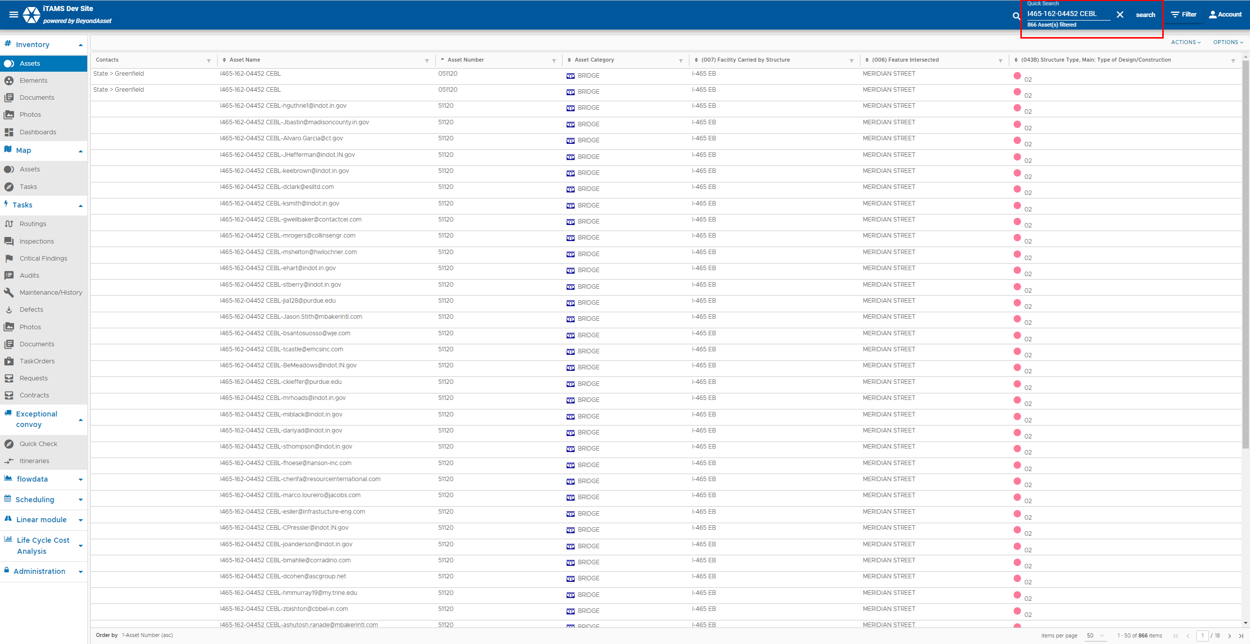  - Select an Asset. Click on the Masters tab to see what Master exist if any.  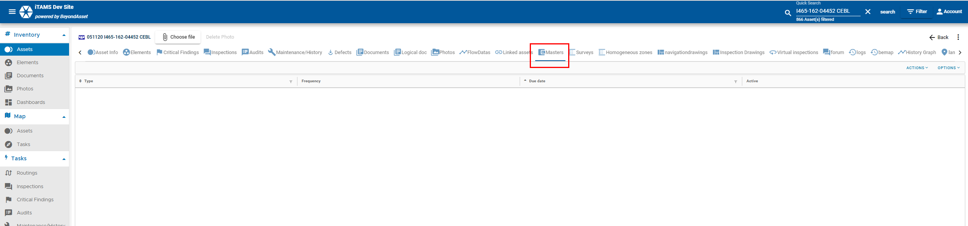  - If no Master exist, then you will have to create one in order to schedule an inspection. Once you create a Master for a particular inspection type, you will be continuously allowed to schedule inspections for that inspection type. You only create a Master once for each type of inspection.  - To create a Master, select the Masters tab. Go to Actions +Add.  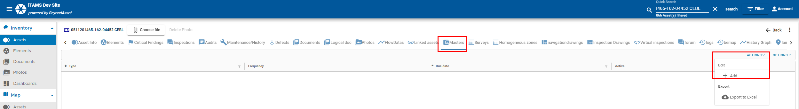  - Select the Type, Enter in the Frequency for the Type of Inspection, the Due date will automatically populate to the current date (you can change it if necessary), enter any comments, then click save (green checkmark in the bottom righthand corner).  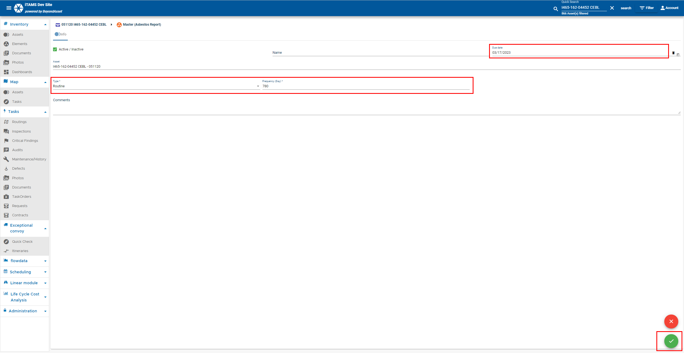
- Click on Scheduling. Select Masters.
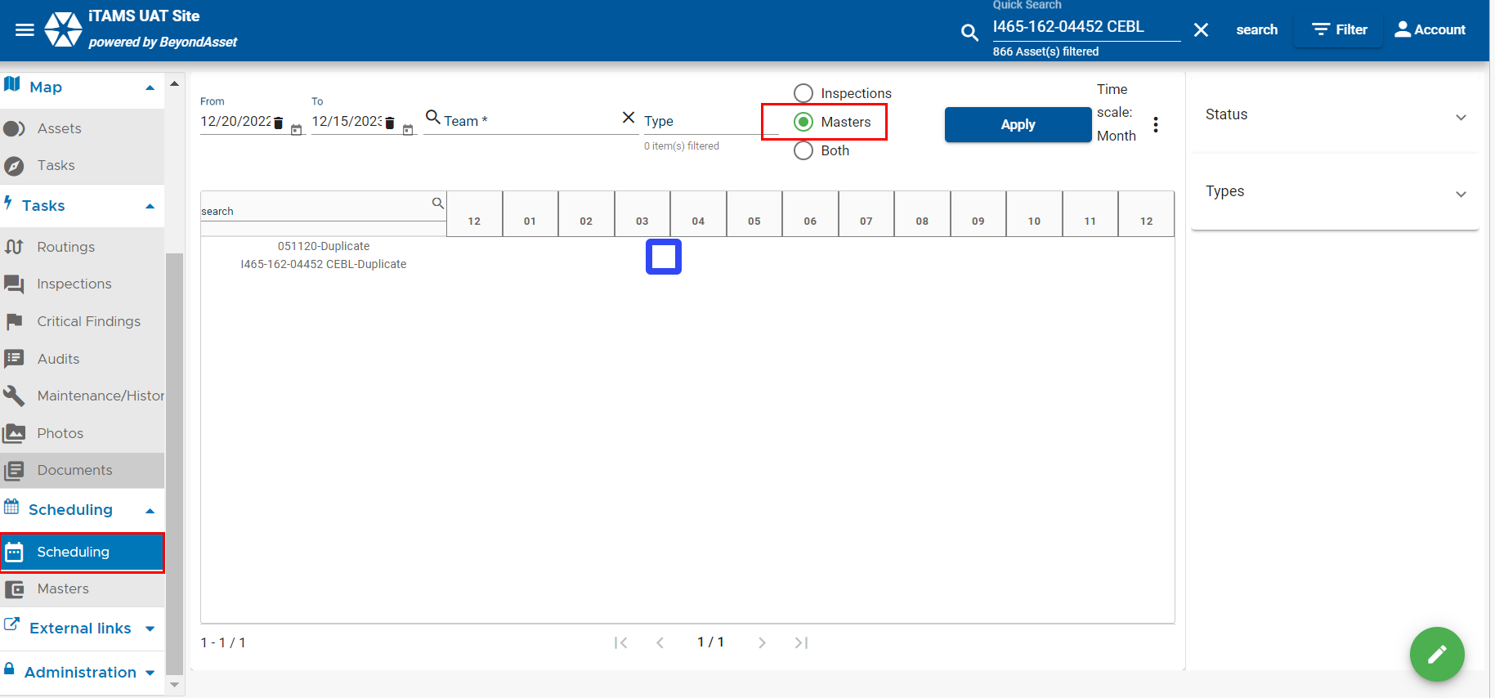
- Click Edit
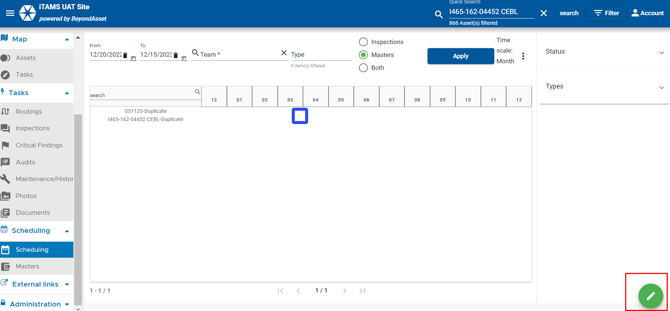
- Select Asset, select tools, change status to Scheduled, select a Team, select a Team Leader, click Save.
