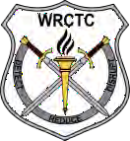
Western Regional Counterdrug Training Center

The New Money Trail: Decoding & Seizing Cryptocurrency
This class provides solid groundwork for law enforcement officers to understand how and why criminals use cryptocurrency to move and hide their proceeds from narcotics trafficking and sales. Students will learn about the history of criminal usage of virtual currencies, changes in government regulation, and how to follow the money using a blockchain explorer. By the end of class, officers will be able to identify users of cryptocurrency, establish an agency wallet, and properly seize
suspect’s funds through proper procedures and exercise.

Course Goals
- Understand cryptocurrencies, how they are procured and used by criminal elements.
- Understand how to trace cryptocurrencies from wallets to an exchange .
- Practice the process of seizing cryptocurrencies from a suspect’s wallet.

Course Overview
When:
5 May 1300-1700
6 May 1300-1700
Where:
NILEA
4500 Montdale Park Drive Valparaiso, IN 46383
History of Virtual Currency and FinCEN Regulation Features and Characteristics of Cryptocurrencies Criminal Procurement Methods
Threat Finance Implications Cryptocurrency Wallets
Blockchain Analysis and Wallet Tracing
Cryptocurrency Seizure Process & Exercises



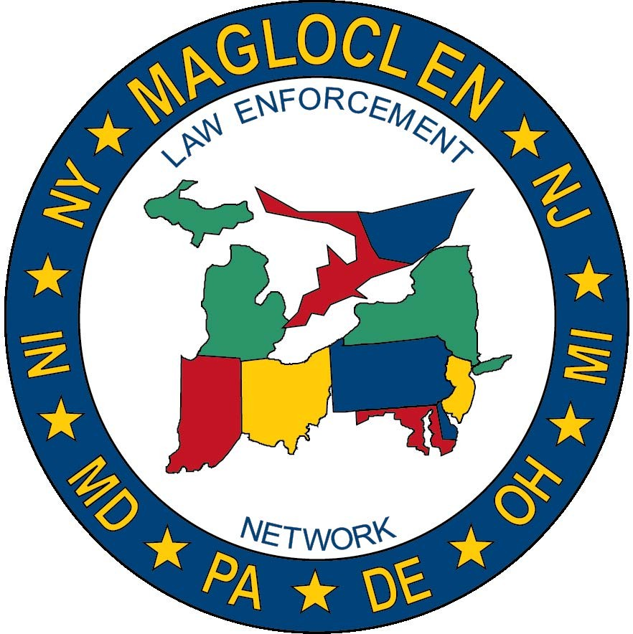

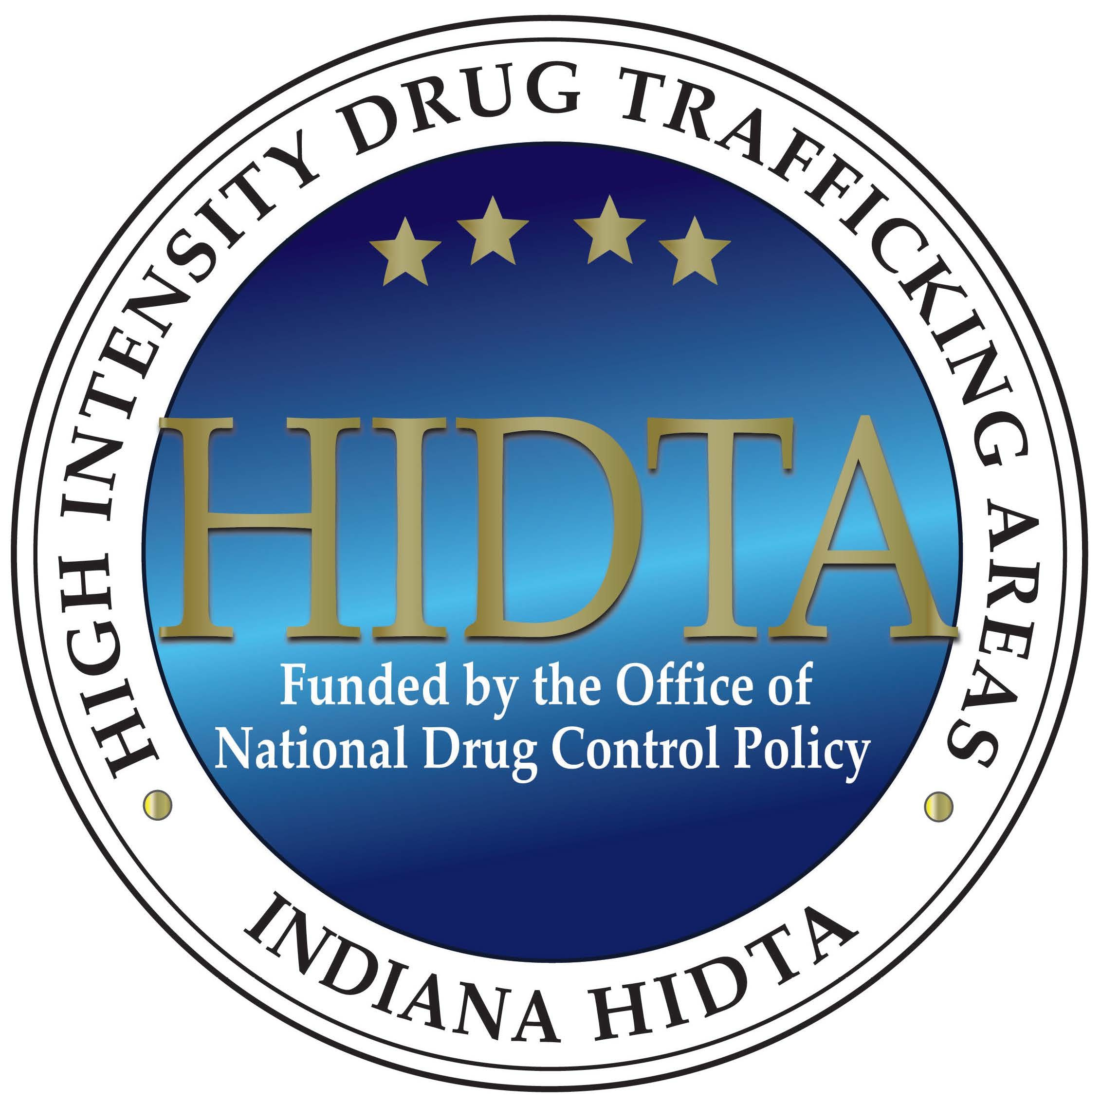


To Register: www.wrctc.org Cost: Zero Cost
5 May 6 May

