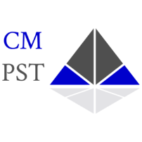

First Line Supervision and Leadership

CM Public Safety Training, LLC

Course Information

Course: First Line Supervision and Leadership

Course Dates: March 12-13, 2025, 0800-1700

Location: Speedway Police Department 5300 Crawfordsville Road, Indianapolis, Indiana 46224

Cost: $400

Instructor: Michael DeHart -(317) 403-8840, mddehart08@gmail.com

Student Registration Information

Name: Click here to enter text. Phone:Click here to enter text.
Email Address:Click here to enter text.

Agency:Click here to enter text.
Agency Address:Click here to enter text.

Contact at Agency: Click here to enter text. Phone:Click here to enter text.
Email Address:Click here to enter text.

Payment

Method of Payment:Click here to enter text.

The agency will be invoiced.

