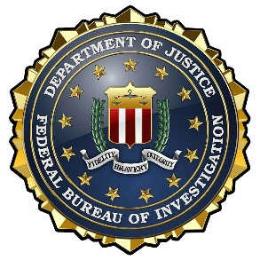
FEDERAL BUREAU OF INVESTIGATION
CRISIS NEGOTIATION TEAM
INDIANAPOLIS DIVISION

Senior Team Leader, Special Agent Matt Zmich
Email: MZMICH@FBI.GOV
Phone: 312-590-8964
MEMORANDUM
FROM: FBI Indianapolis Crisis/Hostage Negotiation Team
DATE: January 2026
RE: Upcoming Basic Negotiation 40-Hour Courses in 2026
The Indianapolis FBI will host two (2) Regional Crisis Negotiation Course (RCNC) in 2026 to address the training needs of law enforcement with responsibilities for hostage and/or crisis negotiations and critical incident management. This course is designed for law enforcement first responders and negotiation team members who have little or no prior negotiation training. Officers should be members of an active negotiation team, SWAT operators on an active team, and/or senior leaders responsible for the management/oversight of a tactical team.
Training will include fundamentals of crisis negotiation, responsibilities of personnel at such incidents, negotiation techniques and policies, role playing exercises and case studies. Instructors are negotiators from the Federal Bureau of Investigation and other law enforcement partners.
There is no fee for this course, however, enrollment will be limited to forty (40) students. Training will be held on the following dates and locations (subject to change):
• March 23rd – March 27th, 2026 (hosted at Carmel Police Department)
• October 19th – October 23rd, 2026 (hosted at Franklin Police Department)
If interested, please e-mail a request to the FBI Indianapolis Crisis Negotiation Senior Team Leader Matt Zmich with your supervisor cc’ed on the email (denoting approval for attendance). Include contact information for all attendees from your department (name, rank, work number, cell number, e-mail address). We will try to accommodate as many requests for slots as possible, given limited course space. Questions can be directed to Special Agent Matt Zmich via email: MZMICH@FBI.GOV

