INDIANA LAW ENFORCEMENT TRAINING BOARD
Retired Officer’s Handgun Qualification Course of Fire
30 Round Qualification Pistol Course

Stage 1 - 3 yard line – 10 rounds in 2 magazines of 5 rounds (Two-handed, strong-handed firing)

The shooter will start with one (1) magazine of 5 rounds loaded and holstered. When the target faces, the shooter will fire 3 rounds in 5 seconds. The shooter will then scan and go to the low ready position. When the target faces a second time, the shooter will fire 2 rounds, conduct a combat magazine exchange, and then fire 2 rounds in a total of 12 seconds. The shooter will scan and go to the low ready. When the target faces a third time, the shooter will fire 3 rounds in 3 seconds. When the stage of fire is completed, the command to cease fire, clear and holster all weapons will be given.

Stage 2 - 5 yard line – 10 rounds in 2 magazines of 5 rounds (One-handed ONLY firing)

The shooter will start with one (1) magazine of 5 rounds loaded and holstered. When the target faces, the shooter will fire 5 rounds (strong-handed only), conduct a 2-handed combat reload, then fire 5 rounds (support-handed only) in 17 seconds. When the stage of fire is completed, the command to cease fire, clear and holster all weapons will be given.

Stage 3 - 7 yard line – 10 rounds in 2 magazines of 5 rounds (Two-handed, strong-handed firing)

The shooter will start with one (1) magazine of 5 rounds loaded and holstered. When the target faces, the shooter will take one (1) step to the left, draw and fire 10 rounds in 20 seconds. Shooters must conduct a combat reload after 5 rounds. When the stage of fire is completed, the command to cease fire, clear and holster all weapons will be given.

- This qualification course of fire will be completed using a G-17 target (see attached).

- The maximum possible score is 60. Retired officers are required to complete the course of fire ONE time only, on an annual basis, with a minimum score of 60 (100% round accountability).

- Speed loaders may be used with revolvers during the course of fire.

- A completed course of fire AND qualifying score is required for each type (revolver or semi-automatic pistol) of handgun that the retiree wishes to carry under LEOSA.

*Approved ILEA Executive Director 10/2017
INDIANA LAW ENFORCEMENT TRAINING BOARD
Retired Officer’s Handgun Qualification Course of Fire
30 Round Qualification Pistol Course
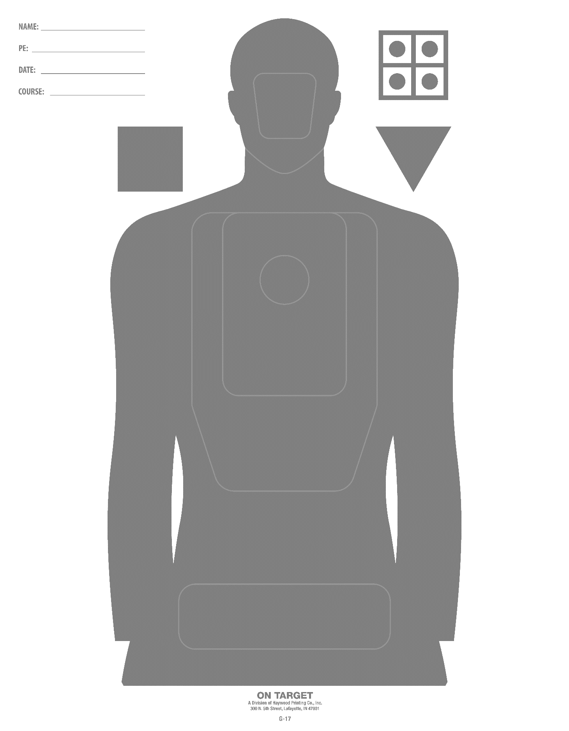

ALL fired rounds must be inside of the large center trapezoid

