Balanced Shield
April 30th, 2025
Martinsville IN – Morgan County
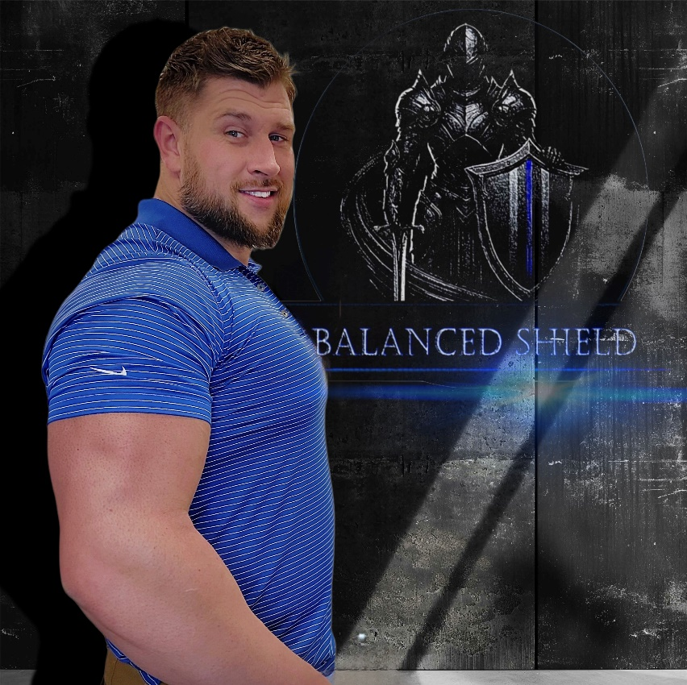
Presented by: Levi App
balancedshield.com

APRIL 30, 2025
REGISTRATION:

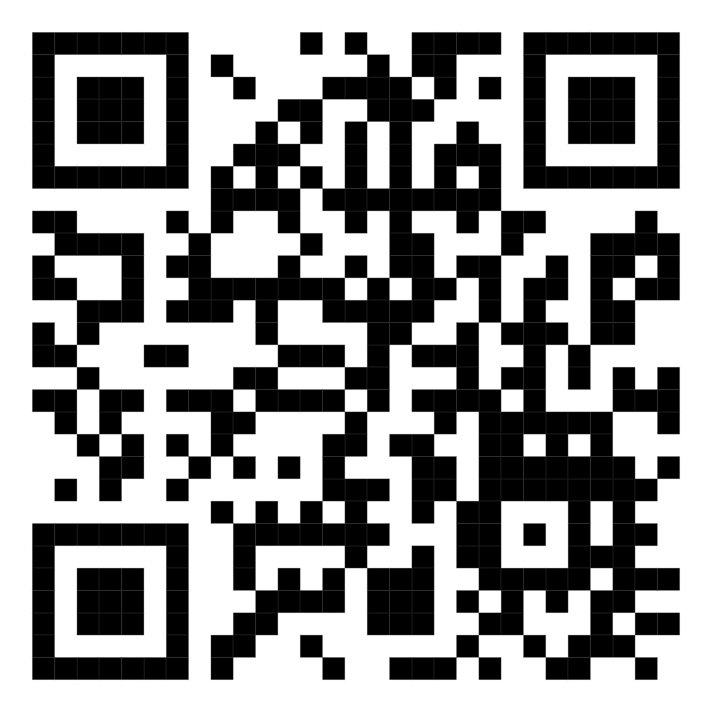

Course Description
Balanced Shield is an insightful course presented by Levi App, a US Navy Veteran and current Law Enforcement Professional with extensive experience in high-stress career fields. Throughout the course, App delves into the intricate connections between mental health and physical well-being, drawing from his personal journey. He candidly shares the perils he faced as the stressors from both his professional and personal life threatened to overwhelm him, ultimately leading him down a treacherous path. However, App's story also highlights how he regained control and learned the transformative power of "Balance" in his life.
The Balanced Shield course not only fosters resilience but also emphasizes the importance of mindfulness. With a strong focus on recognizing the symptoms of mental distress and overcoming the associated stigma, the program equips participants with the tools to cultivate a healthier, more balanced lifestyle.

Hosted By:
Martinsville Police Department
Location:
Martinsville Police Dept
110 W Morgan St
Martinsville, IN 46151

