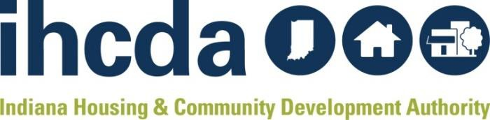

HOPWA

Annual Close-Out Form

Organization Info
Name of Project Sponsor:
Report completed by:
Contact Information
(Email & Phone Number):

Date Submitted:
Grant Information
IHCDA Award Number:
Total Award Amount:
Total Amount Unspent:

Questions:
Please respond to the following questions:

- Summarize your agency’s major achievements completed during the HOPWA program year. Did those achievements also meet your agency’s programmatic impact goals?

- Describe any barriers (regulatory and non-regulatory) encountered in the administration or implementation of your HOPWA program. Explain how these barriers affected your program’s ability to achieve the objectives and outcomes discussed above and what actions were taken in response to these barriers. If your program is administered in multiple regions, please specify whether the barriers encountered are region-specific.

- Identify any HOPWA technical assistance needs that IHCDA may help alleviate. If appliable, describe any potential impact the technical assistance would have on program beneficiary outcomes.

- If your agency receives multiple public and private sources of funding, explain how you’ve leveraged those funds to address the housing and health needs of HOPWA beneficiaries.

