Whitewater Region - Regional Meeting
Wednesday, April 15, 2026, 10:00-11:30am
John H. Miller Community Center, 2900 Park Road, Connersville IN 47331
The Whitewater Region includes Delaware, Randolph, Henry, Wayne, Fayette, Union counties but open to all drinking water and wastewater utilities and elected officials who wish to participate. The IFA has applied for Certified Operator CEU hours.
There is no cost to attend but registration is appreciated. Register here.
Agenda
- Introductions and housekeeping (15 min)
  - New/ongoing capital projects in 2026?

- 811 Updates, Mason Hubner, Indiana 811 (20 min)

- Round Table – potential topics (45 min)
  - IFA updates – Ohio River and Southeast Indiana Regional Water Study and Southeast I-74 Regional Water Study
  - IFA/DNR updates – statewide water stakeholder workshops (May virtual)
  - Asset Management Plan work – Richmond Utilities
  - Open mic

- Next meeting (10 min)
  - When and where to meet next?
  - Suggestions for future topics of discussion?

- Adjourn

The purpose of the meetings is to build on the benefits that come from neighboring utilities collaborating to solve similar issues. These meetings are for utility personnel, board members, and elected officials, and only these individuals can meet the attendance requirement. Consultants and contractors are welcome to attend when they attend at the invitation of a utility who is also attending. Utilities may attend a regional meeting outside of their region, but the intention is that they attend one in their region to get the benefits of interacting with their neighbors.

As a reminder, utilities are required to attend at least one regional meeting a year and attending is required for funding assistance from the IFA (IC 5-1.2-11.5-5). The IFA tracks attendance on a 12-month rolling basis. For example, if your utility attended on April 2, 2025, your utility meets the requirement of the rule until April 2, 2026. The list of utilities who have attended a regional meeting is available on the IFA website. https://www.in.gov/ifa/regional-planning-meetings

Ohio River and Southeast Indiana Regional Water Study
https://www.in.gov/ifa/regional-water-studies/ohio-river-and-southeast-indiana-regional-water-study/
The primary goal of the IFA's Water Study is to improve the understanding of estimated future groundwater and surface water demand and availability within the public water utility sector so that a gap analysis can be conducted. The questions the study is looking to answer include: How much water is currently available? Will there be enough water to meet the 50-year Public Water Supply needs?
The Study will examine the 50-year demand and supply availability in southeastern and southern Indiana watersheds, which are primarily located in Clark, Crawford, Dearborn, Fayette, Floyd, Franklin, Gibson, Harrison, Jefferson, Ohio, Orange, Perry, Posey, Ripley, Scott, Spencer, Switzerland, Union, Vanderburgh, Warrick, Washington, and Wayne counties.
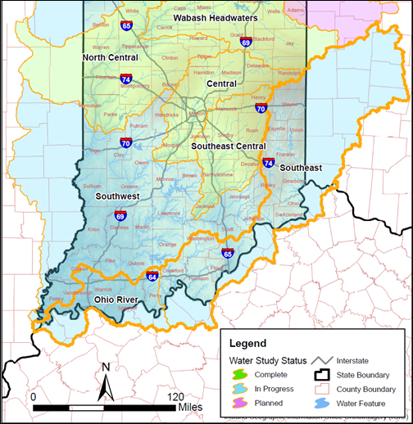

Southeast I-74 Water Study
https://www.in.gov/ifa/regional-water-studies/southeast-I74-water-study/

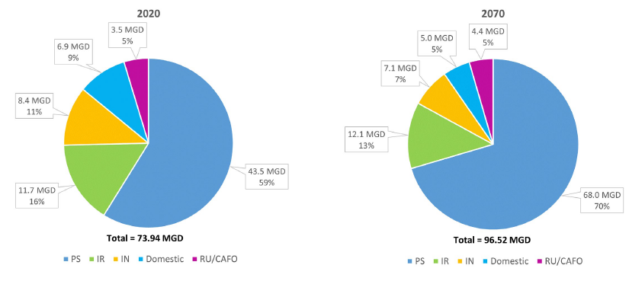

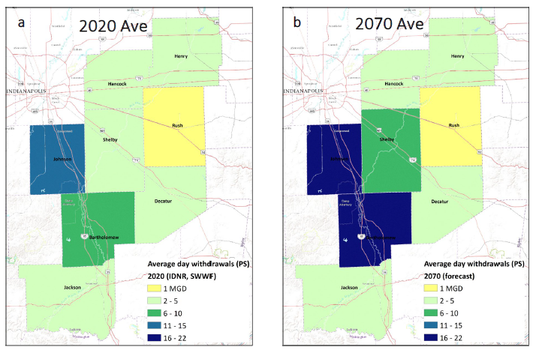

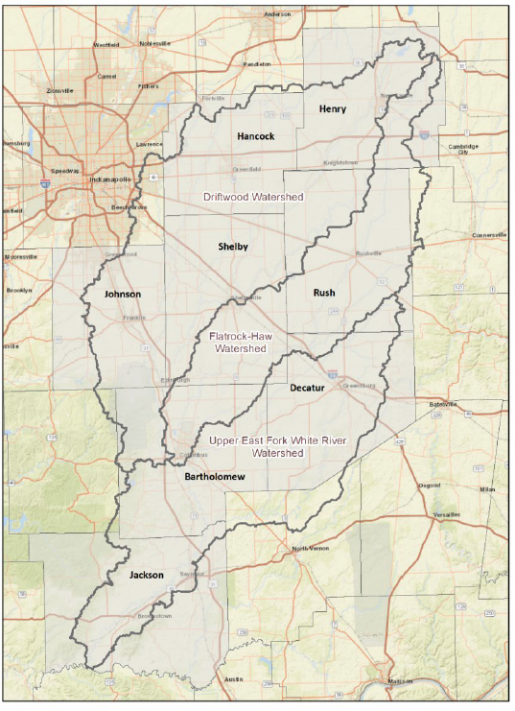
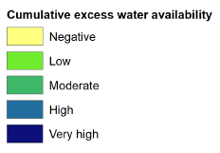
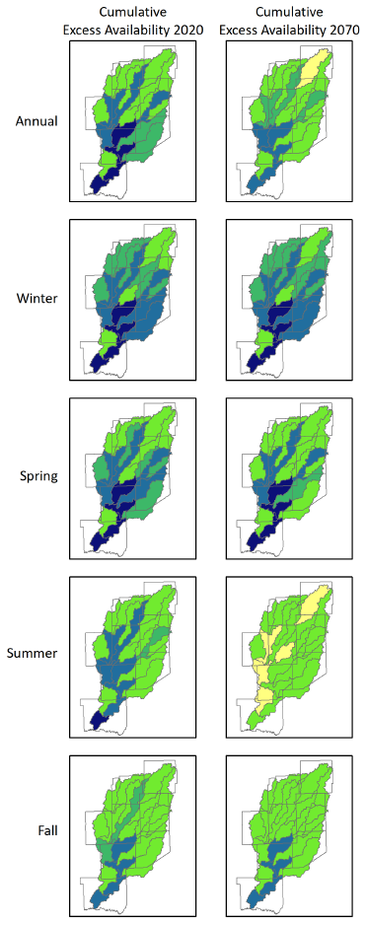

Asset Management Program Reporting for Water and Wastewater Utilities
https://www.in.gov/iurc/water-and-wastewater-division/asset-management-program-reporting-for-water-and-wastewater-utilities/
This webpage is designed to assist water and wastewater utilities in complying with the asset management program reporting requirements under Ind. Code § 8-1-2-128, as established by House Enrolled Act 1459 (2025). The law requires water and wastewater utilities that are not under the Indiana Utility Regulatory Commission’s jurisdiction for rates and charges to submit a report to the Commission on the status of their asset management program every four years. This law applies to all types of utilities (with the exception of regional wastewater districts):
- Public utilities
- Municipally-owned utilities
- Not-for-profit utilities
- Cooperatively-owned corporations
- Conservancy districts
- Regional water districts

Guidance
The Commission adopted a General Administrative Order 2025-03 that provides guidance, filing requirements, and due dates for utilities to comply with the law. Please review the order at the link below. Read GAO 2025-03
Reporting Requirements & Phased Compliance
The law requires compliance in stages on a four-year (quadrennial) basis. The first reporting cycle is from 2026-2029 and will focus on the status of each utility’s asset management program at the time of the report. Subsequent four-year cycles will look for improvements in plans, implementation over time, maintenance of the program, and management training.
The Commission is currently in the process of developing an online questionnaire that will serve as the report to be completed by each applicable water and wastewater by the due dates listed below. The online questionnaire should be made available in the first quarter of 2026.
Please note: The only deficiency in the first four-year cycle will be failure to submit a report – a utility asset management plan is NOT required to meet compliance.

First Reporting Cycle (2026-2029) – Due Dates
Water Utilities | Due Date
Legal names beginning with A - L | July 1, 2026
Legal names beginning with M - Z | July 1, 2027

Wastewater Utilities | Due Date
Legal names beginning with A - L | July 1, 2028
Legal names beginning with M - Z | July 1, 2029
Questions?
For questions, please review General Administrative Order 2025-03 or contact the Commission’s Water/Wastewater Division at 317-232-2785.

