Southwest Central Regional Meeting
The Southwest Central Region includes Brown, Clay, Greene, Putnam, Monroe, Owen, Sullivan, Vigo counties but open to all drinking water and wastewater utilities and elected officials who wish to participate. The IFA has applied for Certified Operator CEU hours.
When: Thursday, April 30, 2026, 1:00-2:30pm
Location: Reelsville Volunteer Fire Department, 7748 S County Rd 625 W, Reelsville, IN 46171
There is no cost to attend but registration is appreciated. Register here.
Agenda:
- Welcome from hosts, Reelsville Water Company
- Introductions (10 min.)
  - 2026 projects?
- Water Audits, Chad Reynolds, Alliance of Indiana Rural Water (20 min.)
- A Case Study: Salt Creek Services, Utility Asset Management Plan, Adam Hershberger, Alliance of Indiana Rural Water, Carl Bauer, Salt Creek Services Board Member (20 min.)
- Round Table – potential topics (30 min.)
  - IFA updates – Southwest Indiana Regional Water Study
  - IFA/DNR updates – statewide water stakeholder workshops (May virtual)
  - Open mic
- Next Meeting (10 min.)
- When, where?
- Suggestions on future topics
- Adjourn – optional tour of Reelsville Water’s office/treatment plant updates
The purpose of the meetings is to build on the benefits that come from neighboring utilities collaborating to solve similar issues. These meetings are for utility personnel, board members, and elected officials, and only these individuals can meet the attendance requirement. Consultants and contractors are welcome to attend when they attend at the invitation of a utility who is also attending. Utilities may attend a regional meeting outside of their region, but the intention is that they attend one in their region to get the benefits of interacting with their neighbors.

As a reminder, utilities are required to attend at least one regional meeting a year and attending is required for funding assistance from the IFA (IC 5-1.2-11.5-5). The IFA tracks attendance on a 12-month rolling basis. For example, if your utility attended on April 2, 2026, your utility meets the requirement of the rule until April 2, 2027. The list of utilities who have attended a regional meeting is available on the IFA website. https://www.in.gov/ifa/regional-planning-meetings

Southwest Indiana Regional Water Study
https://www.in.gov/ifa/regional-water-studies/southwest-indiana-regional-water-study/

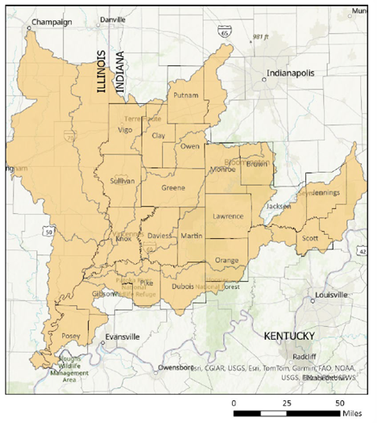

DNR Stakeholder Meetings
https://events.in.gov/event/statewide-water-stakeholder-input-workshops-to-support-development-of-statewide-water-plan

