Northeast Regional Meeting
Wednesday, April 22, 2026, 1:00-2:30 pm
Rieke Park Lodge, 1600 N Indiana Avenue, Auburn, IN 46706

The Northeast Region includes LaGrange, Steuben, Noble, DeKalb, Whitley, Allen counties but open to all drinking water and wastewater utilities and elected officials who wish to participate. The IFA has applied for Certified Operator CEU hours.

There is no cost to attend, but registration is appreciated. Register here.

Agenda
- Introductions (5 min)
  - Name, utility, title, professional experience, what projects are you doing in 2026?

- An Update on Northeast Water Study and IDNR’s Stakeholder State-wide Water Planning, Sarah Hudson IFA (10 min)

- Great Lakes Compact in Indiana – Overview and background, Kay Nelson and Michele Murday Pariso, Northwest Indiana Forum (20 min)

- Update on Funding for Source Water Protection, Amanda Trakas, Alliance of Indiana Rural Water (20 min)

- Round Table - possible discussion topics (30 min)
  - Water quality in the Great Lakes basin – what are your concerns?
  - AMPs – how you do manage them?
  - Water audits due 8/1
  - Spring flooding? Emergency response planning?
  - Succession planning?
  - List of resources to share?
  - Success story to share?
  - Open mic

- Next meeting (5 min)
  - Next meeting, Fall 2026 – Alliance Conference? Spring 2027?
  - Utilities who might want to host: Angola, Ashley, Butler, Steuben Lakes RWD, Huntertown, LaGrange, New Haven
  - Suggestions for future topics of discussion?

- Adjourn

Northeast Indiana Regional Water Study
https://www.in.gov/ifa/regional-water-studies/northeast-indiana-regional-water-study/

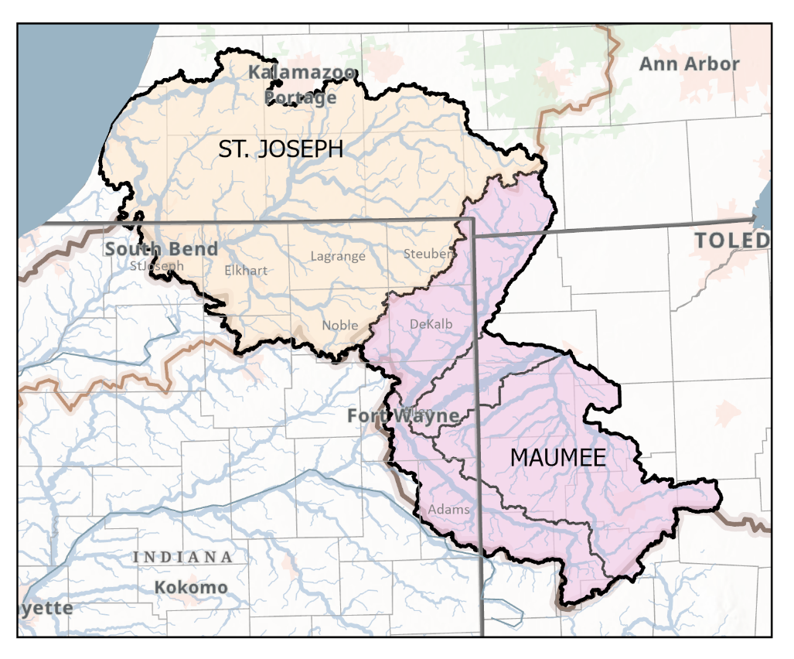

DNR Stakeholder Meetings
https://events.in.gov/event/statewide-water-stakeholder-input-workshops-to-support-development-of-statewide-water-plan

The purpose of the IFA Utility Regional Meetings is to build on the benefits that come from neighboring utilities collaborating to solve similar issues. These meetings are for utility personnel, board members, and elected officials, and only these individuals can meet the attendance requirement. Consultants and contractors are welcome to attend when they attend at the invitation of a utility who is also attending. Utilities may attend a regional meeting outside of their region, but the intention is that they attend one in their region to get the benefits of interacting with their neighbors.

As a reminder, utilities are required to attend at least one IFA Utility Regional Meeting a year and attending is required for funding assistance from the IFA (IC 5-1.2-11.5-5). The IFA tracks attendance on a 12-month rolling basis. For example, if your utility attended on April 2, 2026, your utility meets the requirement of the rule until April 2, 2027. The list of utilities who have attended a regional meeting is available on the IFA website. https://www.in.gov/ifa/regional-planning-meetings

