INCIDENT REPORTING GATEWAY INSTRUCTIONS

To log in to the Gateway the Facility needs to create an account at Access Indiana

- Open Web Browser, key in the web address below and press Enter.
https://www.in.gov/access/
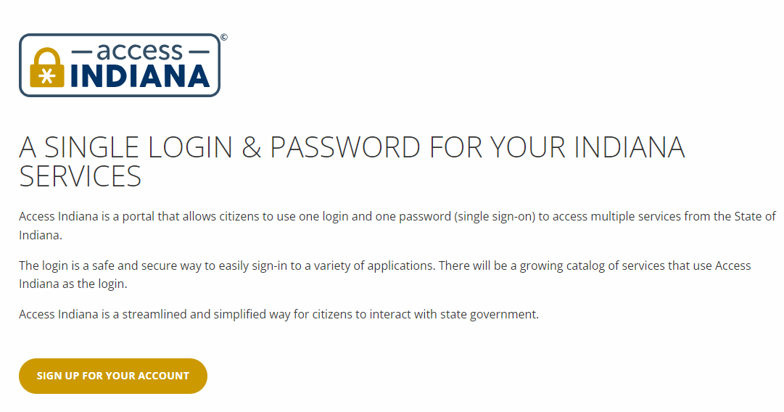
- Click on Sign Up for Your Account
The screen below will come up.
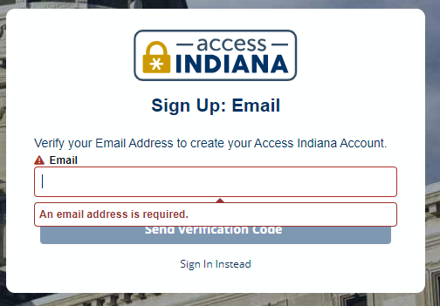

- Put your Email ID for which you want to create an account.
- Click on the Send Verification Code.
- You will receive an email from Access Indiana with the Code.
- Put the Verification Code received in the email and click on Continue.
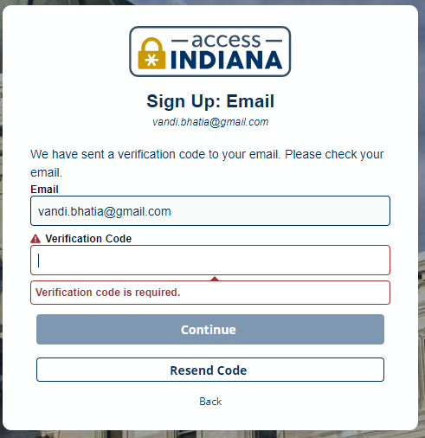
- Create the password following the given instructions.
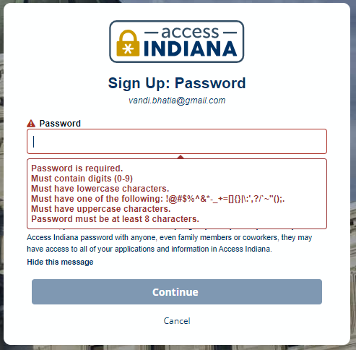

- Confirm the password and click on Continue.

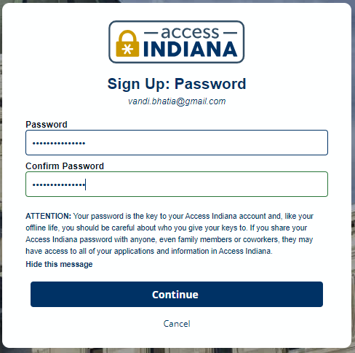
- Enter your Profile Information and Phone Number to create the Profile and click on Create Account.
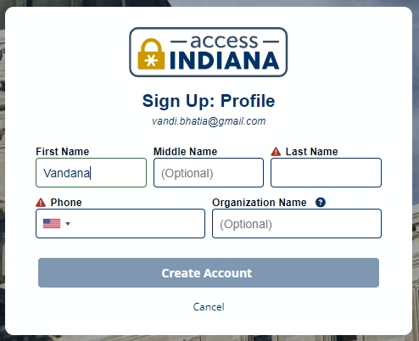

- You can select a Two-Step Verification setup to your account.
- You can use Microsoft Authenticator app and link the account.
- You can set up your Phone number to get a code every time you log in.

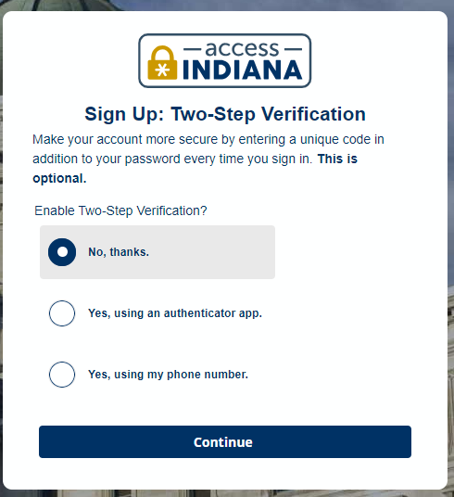
- Set up your recovery email account.
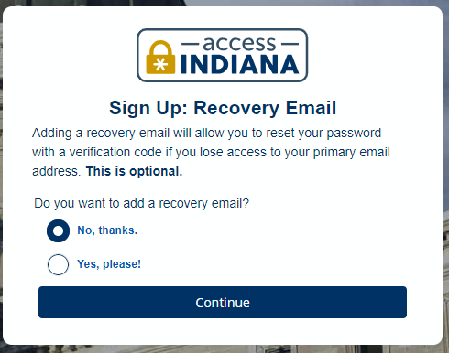
NOTE: User can set up the recovery email. In case of forgotten email ID a recovery email is send to the recovery email Id provided by the user.
- The user will be taken to the New User Request Access form.
Please select Request Type as
- (New User Request for the Gateway Access) in case of new user registration.
- (Existing User Requesting for New Application) in an existing user wants to apply for another application.

- Enter your First Name, Last Name, Organization Name mandatory Fields.

- Select Application SURVEY REPORT SYSTEM

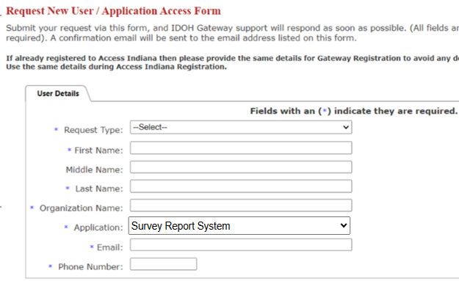
- For Phone Number Double Click on the text box and enter 10-digit phone number.

- Click on Request Access

- The below message will be displayed for successful completion of the registration process.
- Once the admin approves the registration, the user will receive an email notification for the approval.

- After the approval the user can Open Web Browser, key in the web address below and press Enter.
https://access.in.gov/signin/

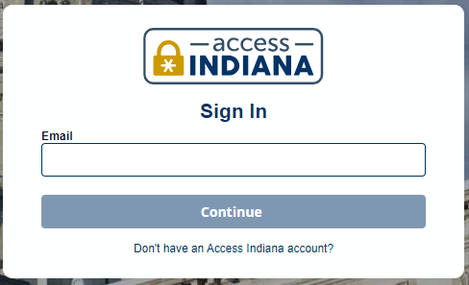
- Enter the email id registered for Access Indiana and click on Continue.
- On services search for Gateway.
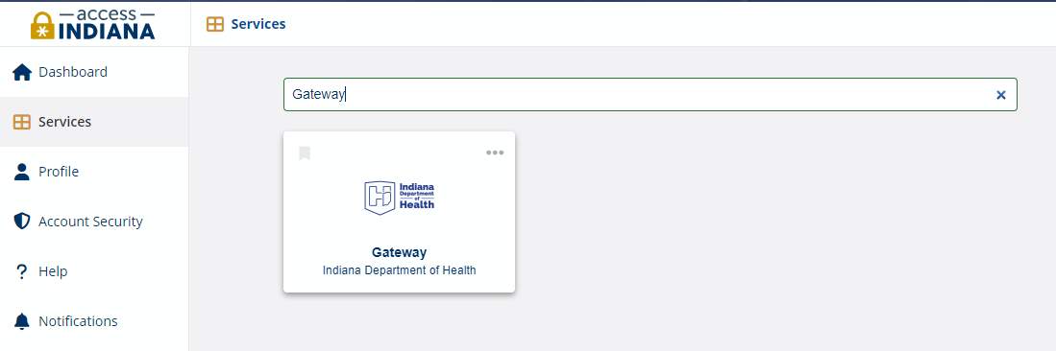

- Select Indiana Department of Health Gateway tile.
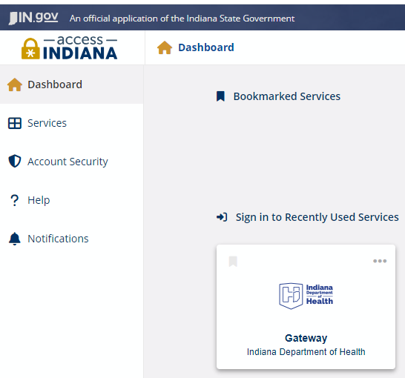
- The user is registered on Access Indiana
- Enter the given link in Web Browser and sign in with the registered ID.
https://gateway.isdh.in.gov/Gateway/SignIn.aspx
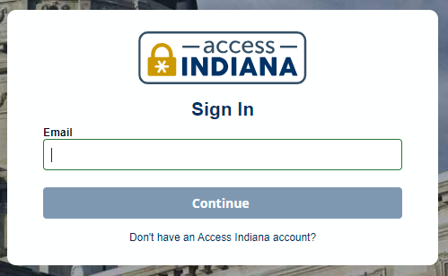
- Users will be taken to the Gateway main page, displaying Survey Report System Tab.
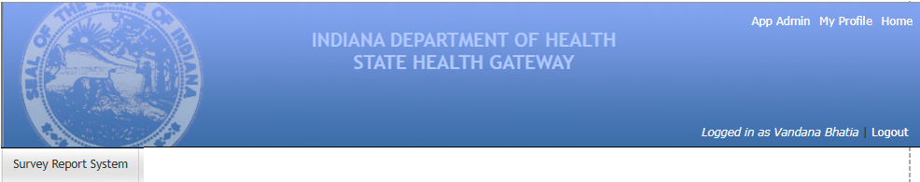

- Click on Survey Report System and select your agency.
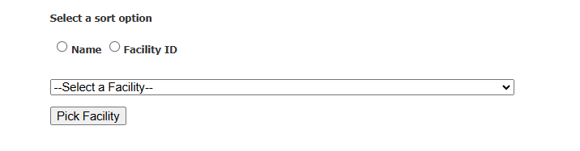
- Once the agency selection is done: Click on Incident Reporting and file the Incident.
