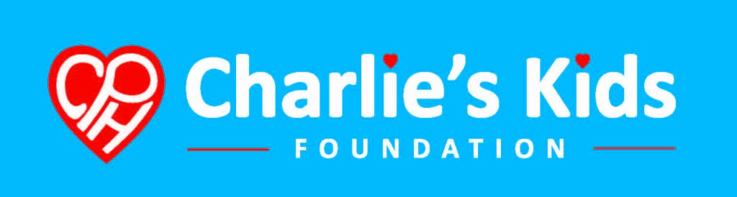Safe Sleep Order Form

Contact Name Date
Click here to enter a date.

Organization Contact E-mail

SHIPPING DETAILS

First Name Last Name Phone Number

Street Address Street Address Line 2

City State Zip Code

Billing Address (if different from shipping)

Are there other important shipping or billing requirements? PO # (If applicable)

Plan for Distribution

Choosing YES, I agree to use Sleep Baby Safe and Snug for educational and advocacy purposes ONLY, and will not resell.

[ ] Yes [ ] No

Bulk pricing of Sleep Baby Safe and Snug book come in cases of 60 books. Shipping via USPS runs around $12.50 per case.

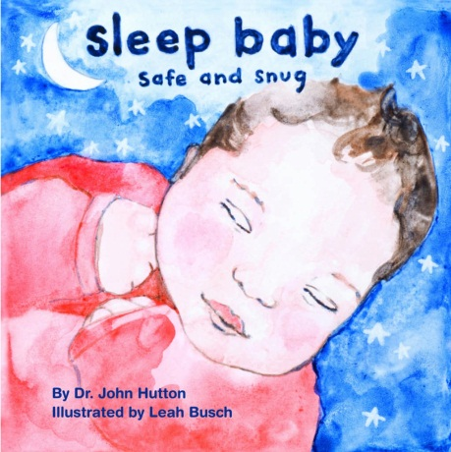
Sleep Baby Safe and Sung
Board Book

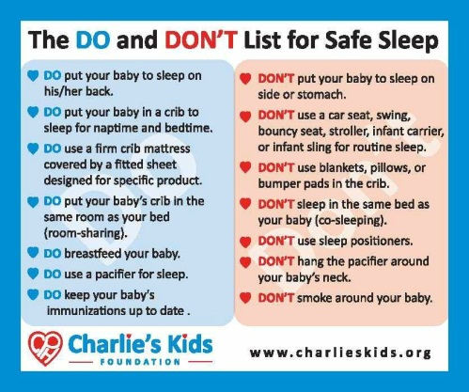
Safe Sleep Do's and Don'ts

Magnet

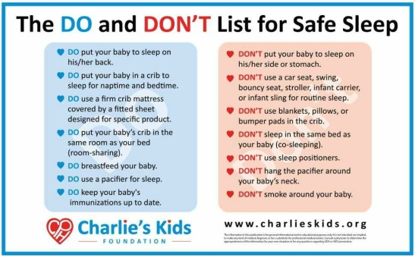
Safe Sleep Do's and Don'ts

Poster

Price

$ 2.00/book

Price

$ 0.25

$ 0.25

Price

$0.50

Quantity

Bulk pricing of book come in cases of 60 books

Quantity (English)

Quantity (Spanish)

Quantity (English)

Quantity (Spanish)

$ 0.50

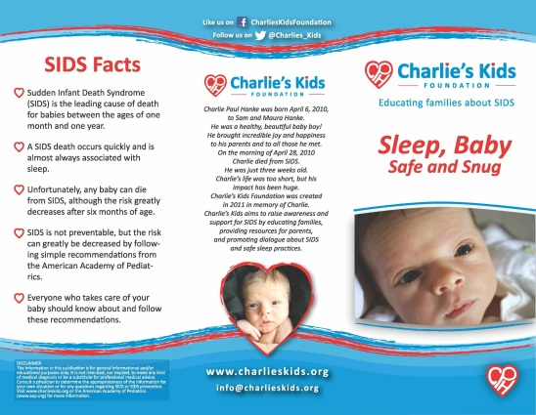
Charlie's Kids Brochure
Price

On request
Quantity (English)
Quantity (Spanish)

On request

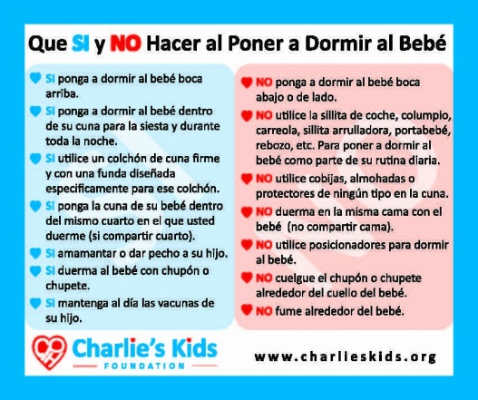
Safe Sleep Do's and Don'ts
Sticker (Spanish Only)

These Spanish stickers replace the English sticker on the back cover of the book
(Full Spanish version is currently in development)
Price

On Request

Quantity

A Charlie's Kids representative will contact you shortly after completion of this form.
Completed ordered forms can be returned to:
Gary.hanke@charlieskids.org
Fax: 502-212-0601
Mail
Charlie’s Kids
PO Box 1571
Jeffersonville, IN 47131

Your final total will be calculated after your order has been shipped.
All major Credit cards and Checks are welcome.

For any questions or concerns e-mail info@charlieskids.org or call (312) 600-SIDS

