Early Hearing Detection and Intervention Direct Referral Form
for Diagnostic Audiology Evaluation

Communicating Did Not Pass Results
Congratulations on the birth of your baby. We just finished screening your baby’s hearing. Your baby did not pass two hearing screenings. This does not necessarily mean that your baby has a hearing loss, but without additional testing we can’t be sure. Funding for follow-up testing can be found through private insurance, Medicaid, Children’s with Special Healthcare Services (CSHCS), or private pay. We will help you make the follow-up appointment before you leave the hospital. If you are interested in applying for CSHCS, we will assist you in getting the appropriate paperwork. If this form is being provided after hours or on the weekend, the hospital staff will be contacting you at home with the time and date of the appointment.

Indiana Locations for Follow-up Testing
(Please mark the location chosen for follow-up)

Please cut and paste appropriate and current Level 1 Centers

Appointment: Scheduled Needs to be Scheduled Interpreter-Type Needed: _________________

Date: Time:
LOCATION: _____________________________________________ Phone: __________________________
Newborn Information

Name: Date of Birth:

Birthing Facility: Screening Facility:

Hearing Screening Date: MRN:
Hearing Screening Results: Right Pass Refer Left Pass Refer
Microtia/Atresia Microtia/Atresia
Down Syndrome: Yes No
Funding for follow-up: Medicaid Self Pay Private Insurance

Parent/Guardian Contact Information

Name: Language Spoken at Home: _________________________

Address:

Phone #: Alternate Phone #:
Email: _____________________________
Alternate Contact (Friend/Relative)

Name: Alternate Phone #:

Primary Care Provider (physician)

Name: Phone #:

Diagnosis: Failed newborn hearing screen (Possible) Diagnosis Code: Z01.118 and/or Z01-110
This order is valid for six (6) months from the date ordered.

Physician Authorizing Diagnostic Audiology Evaluation As the Primary Care Provider, you must sign below and fax back to the facility selected above at least 7 days before the above scheduled appointment or it will be cancelled. Signature must be that of the physician. A copied signature is acceptable.

Physician Signature: Date:

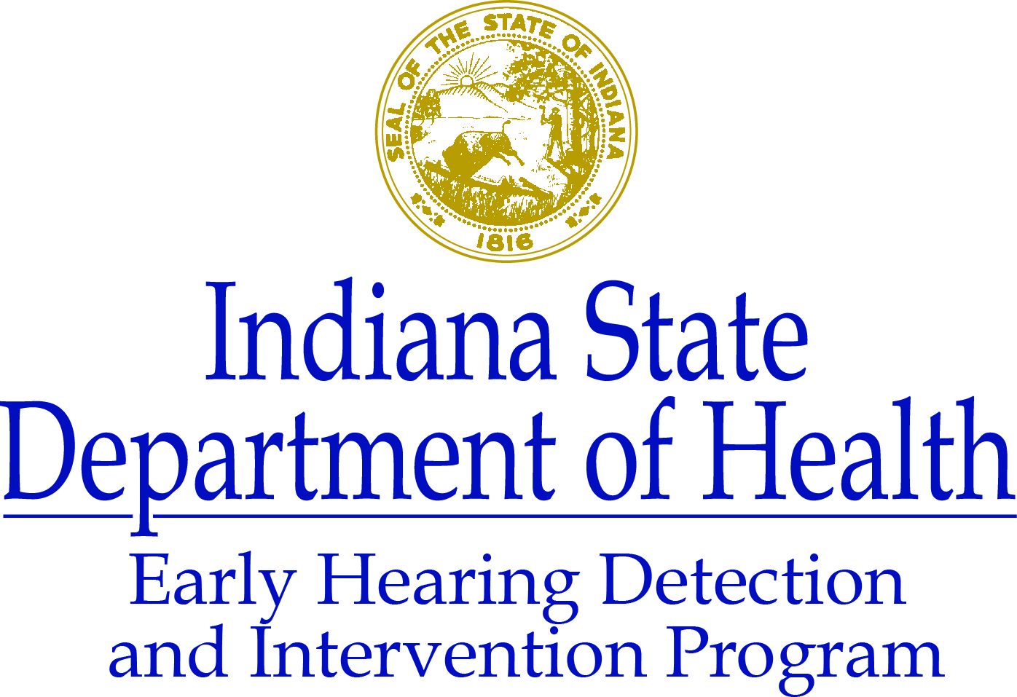
www.hearing.in.gov
317-232-0888 or 317-233-1264

