[INSERT COUNTY NAME] MASS CASUALTY AND FATALITY PLAN

  - Emergency Operations Plan (EOP)
Support-Specific Plan

[INSERT DATE]
Insert County Logo Here

TABLE OF CONTENTS
DISCLAIMER 1
RECORD OF CHANGES 2
RECORD OF DISTRIBUTION 2
PLANNING AGENCIES 3
PRIMARY AGENCIES 3
SUPPORTING COUNTY AND LOCAL AGENCIES 3
NON-GOVERNMENTAL ORGANIZATIONS 3
FEDERAL AGENCIES 3
PURPOSE, SCOPE, SITUATION AND ASSUMPTIONS 5
PURPOSE 5
SCOPE 5
SITUATION 5
PLANNING ASSUMPTIONS 6
CONCEPT OF OPERATIONS 8
GENERAL CONCEPT 8
OPERATIONAL PRIORITIES 9
ACTIVATION AUTHORITY 9
MASS CASUALTY RESPONSE 10
TRIAGE, TREATMENT AND TRANSPORT 10
PATIENT TRACKING AND MOVEMENT 11
MEDICAL SURGE 11
SPECIALTY CARE 11
BEHAVIORAL HEALTH 11
REUNIFICATION 12
MASS FATALITY RESPONSE 12
TRIAGE 14
MORTUARY OPERATIONS 15
REMAINS STORAGE 16
REMAINS REUNIFICATION 16
FATALITY ACCOUNTING 16
DEATH REPORTING 17
SPECIAL CONSIDERATIONS 17
RELIGIOUS, CULTURAL AND SOCIAL BELIEFS 17
CRIME SCENES 17
RADIOLOGICAL INCIDENTS 17
CHEMICAL CONTAMINATION 18
INFECTIOUS DISEASES 18
TRANSPORTATION ACCIDENTS 18
MASS BURIALS 19
PUBLIC INFORMATION 20
ORGANIZATION AND ASSIGNMENT OF RESPONSIBILITIES 21
ORGANIZATION 21
ASSIGNMENT OF RESPONSIBILITIES 21
COUNTY RESPONSIBILITIES 21
NON-GOVERNMENTAL ORGANIZATION (NGO) RESPONSIBILITIES 23
STATE RESPONSIBILITIES 23
FEDERAL AGENCIES AND ORGANIZATIONS 28
COORDINATION 30
LOCAL 30
DISPATCH CENTERS 30
LOCAL HEALTH DEPARTMENTS 30
COUNTY EMERGENCY MANAGEMENT AGENCIES 30
HEALTHCARE COALITIONS 30
INDIANA HOSPITAL EMERGENCY RADIO NETWORK 30
STATE 31
STATE EMERGENCY OPERATIONS CENTER 31
IDOH DEPARTMENT OPERATIONS CENTER 31
INDIANA HEALTH ALERT NETWORK 31
HEALTHCARE INFRASTRUCTURE STATUS INFORMATION SYSTEM 31
WEBEOC 32
STATE EMERGENCY REGISTRY OF VOLUNTEERS FOR INDIANA 32
FEDERAL 32
PLAN DEVELOPMENT AND MAINTENANCE 33
AUTHORITIES 34
APPENDIX A – MAPS 35
APPENDIX B – ACRONYMS 39

DISCLAIMER
This template was created by the Indiana Department of Homeland Security (IDHS) to assist Indiana county emergency management agencies (EMAs) and their stakeholders in the development of a Mass Casualty and Fatality Plan
This template provides SAMPLE language based off the state Mass Casualty and Fatality Plan, but IDHS has tailored it for a more county-specific approach. Included are charts and diagrams to assist county emergency managers with identifying and documenting their specific needs. This template follows Federal Emergency Management Agency (FEMA) Comprehensive Preparedness Guide (CPG) 101 and National Incident Management System (NIMS) guidance.
This template can be scaled up or down and modified to follow each county’s unique organizational structure, activation protocol, threat and hazard assessments and current capability and capacity gaps. This template follows all federal, state and Emergency Management Accreditation Program (EMAP) guidance.
IDHS welcomes feedback on this template. The goal is to provide county stakeholders with best practices and the most comprehensive product for county EMAs and stakeholders in their planning initiatives.

REMOVE THIS PAGE PRIOR TO PUBLISHING THE COUNTY DOCUMENT

RECORD OF CHANGES
Change # | Change Description | Date Posted | Person(s) Responsible

RECORD OF DISTRIBUTION
Date | Agency/Department | Method of Delivery

PLANNING AGENCIES
Within each plan, an agency or organization has been given the designation of primary, supporting, non-governmental or local agencies based on their authorities, resources and capabilities. The primary agency identifies the appropriate support agencies that fall under this plan and collaborates with each entity to determine whether it has the necessary resources, information and capabilities to perform the required tasks and activities within each phase of emergency management, including activations in the [Insert County Name] Emergency Operations Center (EOC) and impacted areas. Though an agency may be listed as a primary agency, it does not control or manage those agencies identified as supporting agencies. The agencies listed below are part of the Whole Community Planning Team for this plan.

PRIMARY AGENCIES
[Insert Name of County Emergency Management Agency] and [Insert County Name] Health Department

SUPPORTING COUNTY AND LOCAL AGENCIES
[Insert County Name] Coroner | [Insert Local Hospitals]
Emergency Medical Services (EMS) | [Insert Local Funeral Homes]
District [X] Healthcare Coalition

NON-GOVERNMENTAL ORGANIZATIONS
American Red Cross (ARC) | Indiana Voluntary Organizations Active in Disaster (INVOAD)

SUPPORTING STATE AGENCIES
Indiana Department of Homeland Security (IDHS) | Indiana Department of Health (IDOH)
Indiana Family and Social Services Administration (FSSA) | Indiana Department of Environmental Management (IDEM)
Indiana National Guard (INNG) | Indiana State Police (ISP)
Indiana Department of Transportation (INDOT)

FEDERAL AGENCIES
Federal Emergency Management Agency (FEMA) | Department of Health and Human Services (HHS)
Centers for Disease Control and Prevention (CDC) | National Transportation Safety Board (NTSB)
United States Department of Veterans Affairs (VA)

PURPOSE, SCOPE, SITUATION AND ASSUMPTIONS

PURPOSE
The [Insert County Name] Mass Casualty and Fatality Plan establishes a coordinated framework between local and state agencies to ensure an effective response and recovery following incidents resulting in significant casualties or fatalities. Its primary objective is to reduce loss of life, mitigate disabling injuries, alleviate human suffering and properly manage fatalities and human remains through timely, organized and collaborative efforts. This plan:
- Identifies threats and hazards resulting in mass casualties and fatalities in [Insert County Name]
- Defines operational priorities for resource allocation
- Provides county-level organizational and operational concepts unique to incidents resulting in medical evacuations, mass casualties, medical surge and fatality management
- Assigns responsibilities to local, state and federal agencies and organizations, as well as non-governmental organizations and private sector partners

SCOPE
Mass casualty incidents, like all disasters, begin and end locally. Given the limited immediate resources available to most local jurisdictions, a structured and collaborative approach with local and state partners is essential to effectively manage such large-scale emergencies. For the purpose of this plan, the [Insert County Name] defines the following:
CASUALTY: A person who is injured or otherwise incapacitated
FATALITY: A death
MASS CASUALTY INCIDENT (MCI): An event with injuries exceeding the normal response capability of an emergency care provider agency. Classification of a mass casualty incident may vary throughout the state based upon the number of patients, severity of injuries, the cause of the incident and available resources.
MASS FATALITY INCIDENT (MFI): An event with fatalities exceeding the normal mortuary resources of a jurisdiction. Classification of a mass fatality may vary throughout the state based upon the number of fatalities, the cause of the incident and available resources.

SITUATION
[Insert County Name] is exposed to many threats and hazards having the potential for causing mass casualties and/or fatalities. The county uses several plans and preparedness assessments to identify and evaluate local threats, hazards, risks, capabilities and gaps. Based on the most recent county assessments, the following have been identified as the top hazards and threats that pose a risk for mass casualties and/or fatalities:
Table 1. [Insert County Name]’s TOP HAZARDS AND THREATS TO HUMAN LIFE
HAZARDS AND THREATS

Impacts that may result from these incidents include, but are not limited to:
- Disruptions to health and lifesaving systems
- Significant human casualties or fatalities
- Significant impacts on transportation infrastructure and routes
- Significant impacts on communication infrastructure and systems
- Significant impacts on information technology infrastructure and systems
- Significant numbers of human radiation exposures and/or radioactive contaminations
- Increases in the response time of public safety, critical resources and services
- Significant impacts to the supply chain, including food and potable water

PLANNING ASSUMPTIONS
- Mass casualty-producing incidents may have the potential to generate mass fatalities, medical surge and medical evacuations (patients in facilities and in their homes).
- Events may occur with little to no notice and may quickly overwhelm local, regional and state resources, thereby requiring state and/or federal emergency support.
- Significant events may render an entire local health jurisdiction or medical system inoperable.
- Events may produce an initial and long-term need for psychological first aid and/or behavioral health services for response personnel, as well as disaster victims.
- Events may overwhelm both the ability of hospitals and other healthcare facilities to address medical surge capacity related to the number of resulting casualties and the number and complexity of surgical procedures that may be potentially necessary to complete.
- Events may overwhelm fatality management processes including recovery, identification, storage, examination, release and disposition of remains.
- Temporary morgue facilities or refrigeration sites may be established if permanent facilities are insufficient.
- Both casualty and fatality management operations must preserve the dignity of the injured or deceased and respect cultural, religious and family considerations.
- The existing standard of care may be adjusted to provide a level of care appropriate for the circumstances given the resources available, as authorized by clinical leadership.
- Healthcare entities will report situations that compromise their ability to continue normal operations, such as extremely large volumes of immediate patients and high staff absenteeism.
- [Insert County Name] has a limited capability to treat an excessively large number of severe trauma injuries and/or severe burn cases.
- Authority and responsibility for managing mass casualty or fatality incidents remains with the local entities unless it falls within the purview of state or federal jurisdiction.
- Management and coordination of all medical resources, personnel, equipment, procedures and communication will take place through the National Incident Management System (NIMS) and Incident Command System (ICS).

CONCEPT OF OPERATIONS

GENERAL CONCEPT
The initial response to a mass casualty or mass fatality incident is handled by local first responders. Once local resources are overwhelmed, mutual aid is requested from nearby jurisdictions to assist through 9-1-1 dispatch. District resources can be requested once local resources are exhausted, which prompts the activation of healthcare coalition support. If state support is needed, Indiana Department of Homeland Security (IDHS) District Liaisons and Emergency Medical Services (EMS) District Managers work jointly with county emergency management and first responders to provide support and supply information to the State Emergency Operations Center (SEOC) regarding unmet needs. If resource coordination is needed from the state level, the SEOC and the Indiana Department of Health (IDOH) Department Operations Center (DOC) may activate. These entities coordinate medical resource response and recovery activities across the state and have the authority to request federal resources if necessary.
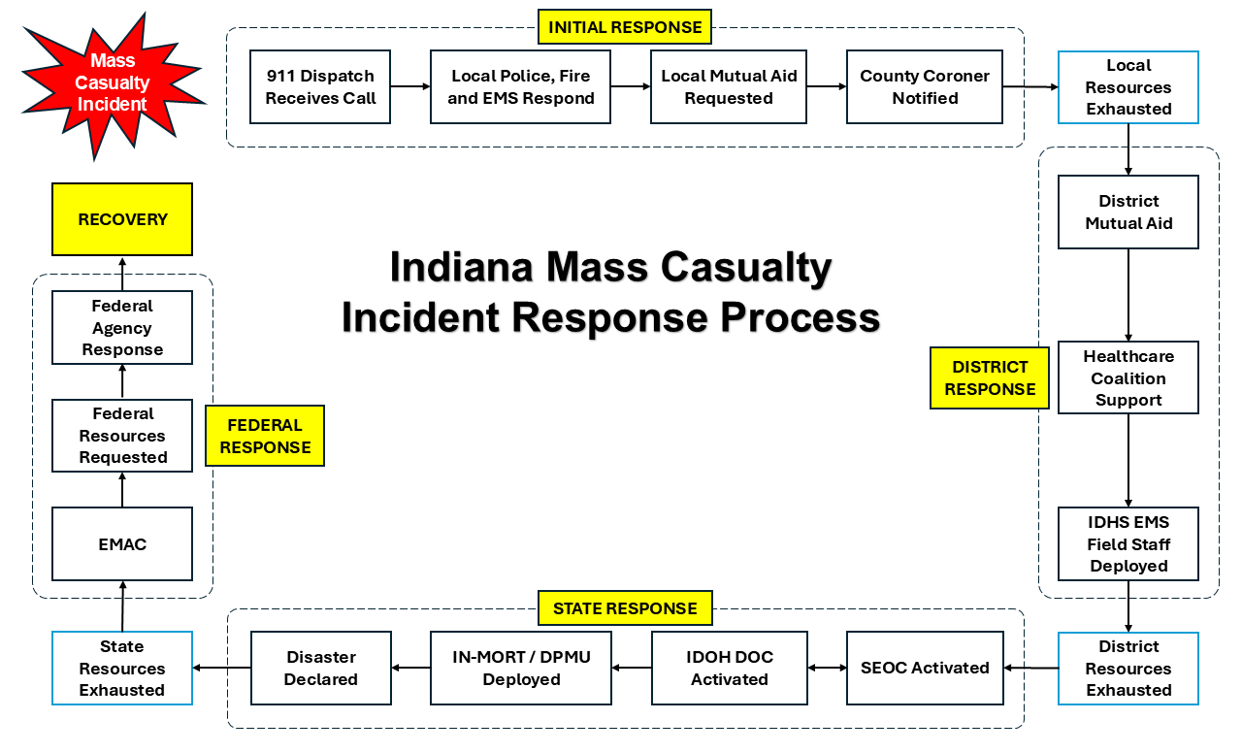
Figure 1. MASS CASUALTY INCIDENT RESPONSE PROCESS

Operational Priorities
Operational priorities during response and recovery operations are:
- Life safety and health (highest priority)
- Incident stabilization
- Protection of property, economy and the environment
- Restoration of essential infrastructure, utilities, functions and services
- Unity of effort and coordination among appropriate stakeholders

ACTIVATION AUTHORITY
The county Emergency Operations Center (EOC) is the primary hub for [Insert County Name]’s emergency support and coordination efforts to gather and disseminate event information, respond to requests for assistance from counties, tribes and local jurisdictions, identify and coordinate priority actions and allocate resources.
The activation of the EOC begins with the activation of the [Insert County Name] Emergency Operations Plan (EOP) [or CEMP] Base Plan when directed by [insert positions with this authority]. The activation of the EOP establishes the emergency operations framework and structure needed to deliver a coordinated emergency response. Following the activation of the EOP, the Mass Casualty and Fatality Plan may be activated when a mass casualty incident has occurred or has the potential to occur. Activation is necessary when:
- Local health and medical resources are overwhelmed or exhausted.
- Mobilization of county, state and/or federal health and medical resources is required.
- Managing the situation requires urgent, non-routine coordination among multiple jurisdictions, departments or other external agencies.

MASS CASUALTY RESPONSE
A mass casualty incident (MCI) occurs when the number of injuries exceeds the normal response capability of a jurisdiction or an emergency care provider. Classification of a mass casualty incident may vary based upon the number of patients, severity of injuries, the cause of the incident and available resources. Regardless of the patient number, mass casualty responses follow the same operational processes as described below.

Triage, Treatment and Transport

Triage
Local first responders perform immediate victim triage, treatment and transportation in the field following a mass casualty incident. There are two (2) primary methods for accomplishing this:
- START – Simple Triage and Rapid Treatment
  - JumpSTART – START for children
- SALT – Sort, Assess, Lifesaving Interventions, Treatment/Transport

Utilizing either the START or SALT method, responders classify and sort victims into the following categories:

Table 2. TRIAGE CATEGORIES
CATEGORY | DESCRIPTION
Immediate | Life-threatening injuries requiring immediate care
Delayed | Serious injuries but not immediately life-threatening
Last Priority | Minor injuries, “walking wounded”
Expectant | Not likely to survive given current resources
No Signs of Life | Injuries are fatal even with treatment or the victim is already deceased

Victim categories can change as their condition evolves and additional assessments are completed. Triage may be dynamic, multi-step process including immediate life-saving interventions.

Treatment
Once victims are sorted at the incident site, first responders reassess and stabilize patients so they can be transported to a higher level of care. Treatment is limited at the incident site, therefore prioritizing getting patients to the right areas rather than providing comprehensive care is key.

Transport
Transportation of patients from the incident site is based on the triage category. Red-tagged patients are moved first, followed by yellow, then green. Transportation to a higher level of care may be accomplished through means of ground, air and non-transport providers designated as Basic Life Support (BLS) and Advanced Life Support (ALS).

Patient Tracking and Movement
Triage tags are used by first responders and other medical personnel to effectively and efficiently distribute limited medical resources and collect vital patient information. This initial information is utilized to track patients through the transportation process until arrival at a medical facility. Once assessed and triaged in a receiving medical facility, patients may be moved to obtain specialized medical, surgical and dental care or treatment. Tracking of patients within and between medical facilities occurs between the transferring and receiving facilities. Each facility maintains its own patient tracking methods. Patient tracking ceases at discharge from field care or a medical facility.

Medical Surge
In the event of a mass casualty incident, it is important for first responders and local health departments to understand the medical surge capabilities and capacities of nearby facilities. Medical surge capacity refers to the ability to evaluate and care for a markedly increased volume of patients, one that challenges or exceeds normal operating capacity. The surge requirements may extend beyond direct patient care to include such tasks as extensive laboratory studies or epidemiological investigations. Medical surge capability refers to the ability to manage patients requiring unusual or very specialized medical evaluation and care. Surge requirements span the range of specialized medical services (expertise, information, procedures, equipment or personnel) that are not normally available at the location where they are needed (e.g., pediatric care provided at non-pediatric facilities). Surge capability also includes patient problems that require special intervention to protect medical providers, other patients and the integrity of the healthcare organization.

Specialty Care
On-scene responders will coordinate the transport of patients to facilities with the appropriate level of care. Medical facilities may then transport patients to specialty facilities, including but not limited to pediatric, burn and trauma care.

Behavioral Health
Behavioral health is a critical component of mass casualty response, addressing the immediate and long-term psychological impact on survivors, responders and the community. This includes providing services such as mental health support, stress management and substance abuse care in the aftermath of an incident. Common immediate reactions include fear and sleep disruption, while long-term effects can include post-traumatic stress disorder, chronic anxiety and depression.

Telemedicine
Telemedicine is an effective and valuable tool for the "worried well," a term for healthy people who have persistent concerns about their health. Telemedicine includes the remote diagnosis and treatment of patients by means of technology (phone or video calls).

Critical Incident Stress Management
Critical Incident Stress Management (CISM) is a comprehensive set of programs and interventions designed to help emergency responders and others manage and recover from the stress of traumatic events. It includes a wide range of strategies, such as pre-incident education, peer support groups and crisis management briefings to help individuals and groups build resilience and cope with acute stress reactions. The goal is to reduce the impact of the incident, prevent long-term psychological problems and promote recovery. CISM support for local responders and survivors is coordinated locally through medical facilities or the district healthcare coalition.

Reunification
Reunification occurs may be managed by the local health department, hospitals, voluntary organizations or county emergency management. This may occur within a Family Assistance Center (FAC). [Expand with local information regarding reunification plans and processes]

MASS FATALITY RESPONSE
A mass casualty incident (MCI) may develop into a mass fatality incident (MFI) when the number of fatalities exceeds the normal mortuary resources of a jurisdiction. One or more of the following criteria may prompt the designation of a mass fatality incident:
- Prolonged or complex decedent recovery operations
- Remains are contaminated by chemical, biological, radiological, nuclear or explosive (CBRNE) agents or materials
- There are more decedents than can be recovered and examined by the local coroner and their associated resources
- Any circumstance requiring multi-agency or regional response to support mass fatality management operations

The county coroner has authority over local fatality management. The following mass fatality management process remains relatively consistent, though the order of steps may vary depending on the incident:

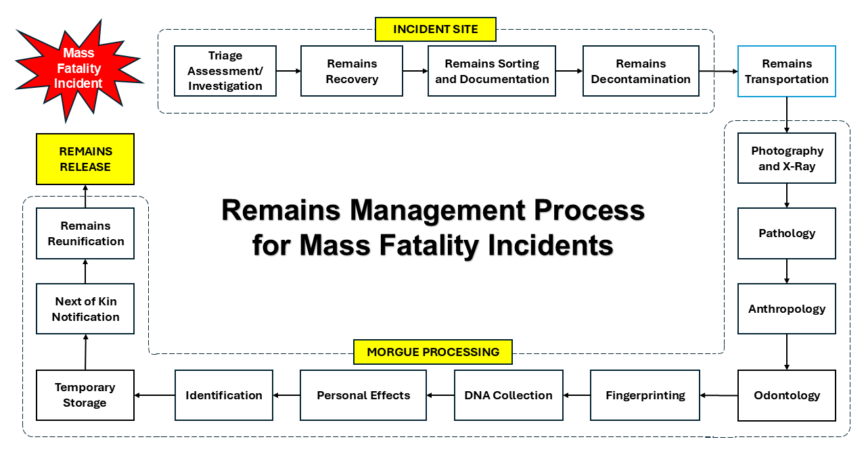
Figure 2. REMAINS MANAGEMENT PROCESS

Response and recovery activities associated with mass fatality incidents may occur over a protracted timeline depending on the incident type; condition, location and amount of remains; and associated investigations.

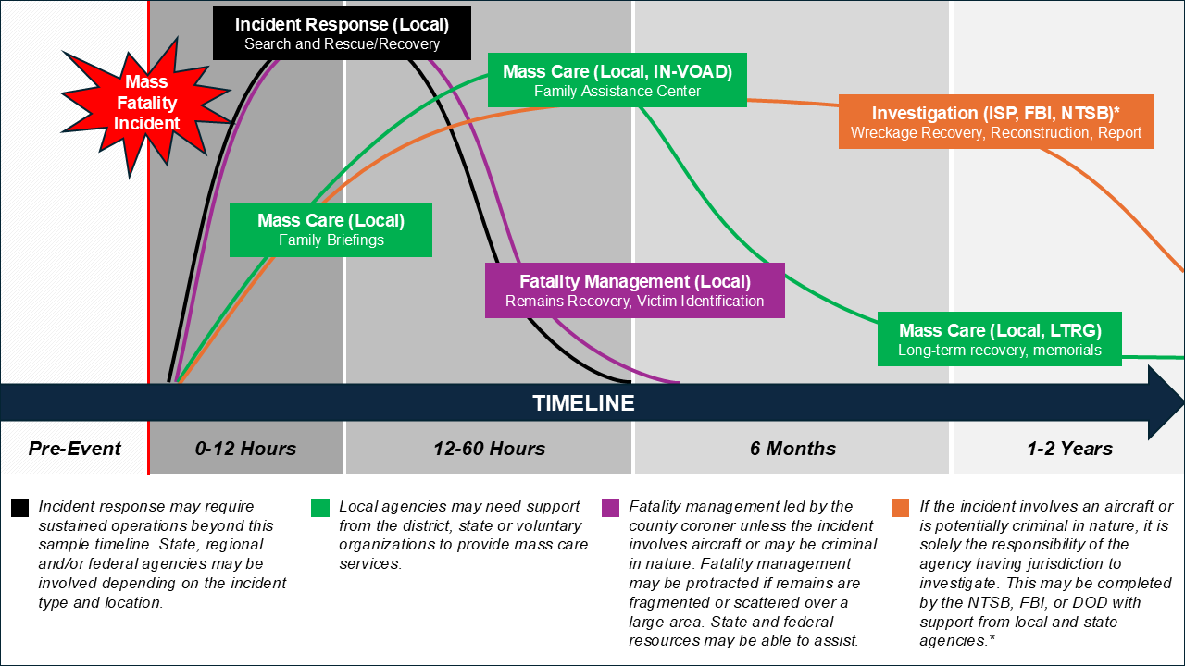
Figure 3. MASS FATALITY INCIDENT MANAGEMENT TIMELINE

Triage
Mass fatality incident triage consists of assessing the incident site for the following:
- Number of potential or actual fatalities
- Condition of the human remains
- Size and accessibility of the incident site
- Level of difficulty in recovery
- Identification of possible CBRNE hazards

Based on the incident site assessment, local responders will determine the following:
- Type and number of personnel and equipment needed for human remains search, recovery and transportation
- Location of a temporary morgue, if needed
- Type and number of personnel and equipment needed for processing and identification of human remains
- Location for a Family Assistance Center or reunification center and an estimate of personnel needs

Mortuary Operations

Remains Recovery
At the direction of the county coroner, human remains may be removed from an incident site in a controlled manner by law enforcement officers, investigators, forensic personnel or specialized recovery teams. Body collection points (BCPs) may need to be established if the remains are scattered over a vast area. Human remains must be handled in an efficient, yet meticulous and respectful manner. Contaminated remains must be decontaminated before they are released for transport. Personal effects will be collected during remains recovery and the coroner will assume responsibility for the items. Any personal effects having potential value as evidence will be collected by law enforcement.

Remains Tracking and Movement
The county coroner is responsible for establishing a human remains tracking system at the incident site, which may consist of tagging remains individually and/or in body bags. Care must be taken when determining the numbering format, as the unique numbers must provide a competent means for tracking each set of human remains to its site location, through the identification process, during storage and until final disposition.
Transportation logs with a chain of custody are highly recommended when moving human remains from the incident site. Transportation logs are required if the incident site is a potential crime scene. The logs should include the following:
- Assigned scene recovery number
- Number of remains being transported
- License number of the transporting vehicle
- Name of the driver of the vehicle
- Signature of the driver accepting responsibility for the remains
- Date and time the vehicle leaves the incident site for the incident morgue

The process of transporting remains should be carefully monitored and regulated to maintain dignity for the deceased and safety for the responders. Transportation of human remains should only occur once a driver is assigned a transportation route. Transportation should only occur by a professional funeral vehicle or refrigerated trailer with an appropriately licensed driver. A police escort may be assigned.

Morgue Processing
Morgue processing describes systematic operations for examining, identifying, storing and releasing human remains in the event of a mass fatality incident. Morgue processing also includes providing security for the human remains and associated records.

Morgue Forensics
Forensic scientists process human remains at several stations:
- Photography
- Radiology
- Pathology (examination)
- Anthropology (bones)
- Odontology (teeth)
- Fingerprinting (ink and card, not digital)
- DNA

Victim Identification
A Victim Identification Center (VIC) is typically established away from the incident site. The VIC focuses on obtaining antemortem data, gathering information from family members and others to assist in the identification of a person’s remains. The VIC may also have samples of personal effects.

Morgue Information
At a Morgue Information Center (MIC), postmortem data gathered by the forensic scientists is compiled. The MIC works with the VIC to establish matches between the collected human remains and personally identifying information. This may involve the use of computer technology, but the requesting coroner retains the authority to make all final determinations.

Remains Storage
While human remains are typically stored in hospital morgues or funeral home mortuaries, mass fatality incidents may quickly overwhelm the capacities of these facilities, requiring the need for temporary storage. Temporary storage can range from temperature-controlled rooms at the coroner’s office to portable units and refrigerated trailers or modular structures. In rare cases, receiving vaults in cemeteries can also serve as a temporary storage site for remains. Remains must be stored properly to delay decomposition before reunification with the next of kin and final disposition.

Remains Reunification
Following the identification of human remains, the coroner notifies the next of kin. Their wishes for disposition are documented, and the remains are transferred from the coroner’s control. Common tissue that is not associated with any victim, remains that are not identified and remains that are identified but not claimed are retained under the control of the coroner until final disposition decisions are reached.

Fatality Accounting
Fatality accounting is the coordinated process of identifying and documenting the deceased, managing their remains and reconciling these records with lists of unaccounted-for persons. It is imperative fatalities are accurately reported, especially when serving civil and criminal legal needs such as death certification and criminal investigation. In some cases, a person’s injury may not become fatal for several days or weeks following an incident. If this occurs, the death will retroactively be managed as part of the multi-fatality incident. Initial fatality accounting will be relayed from the county coroner and/or local health department to the county Emergency Management Agency (EMA), then to the State Emergency Operations Center (SEOC).

Death Reporting
In mass fatality incidents, the county coroner is charged with determining the cause and manner of death and with filing the death certificate with the local health department. Local health departments use death certificates to keep a legal record of deaths, release copies to the public for legal purposes and provide data to the state vital records office to be compiled into state and national statistics.

SPECIAL CONSIDERATIONS

Religious, Cultural and Social Beliefs
Mass fatalities may present difficulties in acknowledging and complying with religious or cultural rituals. Reasonable care should be taken to accommodate religious, cultural and societal expectations and beliefs and the wishes of the family. The effects of disrupting normal rituals and the unresolved mourning of a society are traumatic and debilitating to individual mourners and the public.

Crime Scenes
Law enforcement is responsible for investigating and securing any incident that is suspected of being the result of criminal activity. If the incident is suspected to be criminal or terroristic in nature, the incident site becomes the jurisdiction of the overseeing law enforcement agency. This may be local, state or federal law enforcement. There may be additional requirements for evidence collection during mortuary operations. If the incident is criminal in nature, it may take longer for remains and personal effects to be released.

Radiological Incidents
Human remains exposed to, but not contaminated by, radiation may be managed with no radiation-specific precautions. For those who are considered contaminated, directional probes are preferred to help ensure the measured radiation is from the surface being checked. Subject matter expertise from a health physicist may be required. If the incident is a nuclear weapon detonation, consider delaying recovery of remains for one to two days to allow decay of fission products. A “dirty bomb” explosion does not require a delay in recovering remains.
All personnel handling the deceased following a radiation incident must wear appropriate personal protective equipment (PPE) and a personal dosimeter. As bodies are recovered and brought to the field morgue, each must be surveyed. Those without evidence of external contamination may be moved to the uncontaminated field morgue. Those with measurable levels of contamination must be decontaminated based upon advice of the health physicist prior to transport. Cremation is not permitted after a radiological incident.

Chemical Contamination
Several chemicals may cause mass fatalities. It is important for first responders and other emergency personnel to be aware of the possibility of contamination prior to victim rescue or remains recovery. Appropriate PPE and decontamination processes are necessary. Decontamination of the deceased, regardless of the chemical, can be accomplished by using soap and water and adding bleach if desired. Additional detergent is required for mustard agent decontamination.

Infectious Diseases
Infectious diseases may result in many deaths over a period of several weeks. While not classified as a specific “incident”, the consequences of a severe epidemic or pandemic may result in a situation requiring the management of mass fatalities.
In addition to the challenges presented by any mass fatality event, severe infectious disease outbreaks may result in many of the people who normally respond to mass fatality situations being patients themselves. Funeral homes may be at or above capacity for a long duration. Cemetery workers may be unavailable to dig graves and prepare funeral services. Fewer people may be available to retrieve the deceased from hospitals and homes.
It may be wise to postpone funerals and memorial services during epidemics and pandemics to avoid the gathering of large numbers of people during an outbreak of a contagious disease. It may be necessary to inter the bodies at the time of death and conduct services later. The use of a traditional Family Assistance Center may not be appropriate. If one is needed, a virtual center may be established.

Transportation Accidents
The Aviation Disaster Family Assistance Act of 1996 mandates essential services are provided for family members of aviation disaster victims in a timely manner and designates the National Transportation and Safety Board (NTSB) as the coordinating federal agency. Subsequent acts such as the Foreign Air Carrier Family Support Act of 1997 and the Rail Passenger Disaster Family Assistance Act of 2008 allow for the NTSB to have the responsibility for coordinating resources to assist victims and their families after all United States aviation accidents (except military/intelligence agencies) and selected rail accidents, highway accidents, marine accidents, pipeline accidents and hazardous materials (hazmat) accidents.
It is a local responsibility to begin the delivery of family support by securing a facility and providing temporary services until the arrival of federal authorities. While the NTSB oversees all airplane incidents, it is still the responsibility of the local coroner to sign death certificates. Therefore, extensive local involvement in the situation continues after the arrival of federal resources.

Mass Burials
Mass burials are implemented only as a last resort. If mass burial must occur, proper identification must be affixed to the body with a waterproof tag prior to burial. Unidentified bodies are marked with a reference number corresponding to documents containing detailed descriptions of the deceased and any personal effects. The personal effects are not buried with the body but secured with the coroner, funeral director or law enforcement. Circumstances requiring mass burial include:
- The number of remains cannot be disposed of in the traditional manner and their prolonged presence could present a public health concern.
- The remains cannot be adequately refrigerated or embalmed.
- The remains cannot be properly identified or processed in an acceptable manner.

If local cemeteries do not have sufficient capacity to contain bodies for mass burial, alternate sites must be identified. This requires significant coordination from local, county and state officials:
- Cemetery Managers
- County Attorney
- County Coroner
- County Surveyor
- Department of Public Works
- Emergency Management
- Funeral Directors
- Indiana Department of Environmental Management
- Local Clergy
- Local Health Department

The following must be considered when identifying alternate burial sites:
- Soil conditions
- Highest water table level available
- Distance from the affected community
- Clearly marked location surrounded by a buffer zone to allow the planting of deep-rooted vegetation and to separate the site from inhabited areas
- At least 225 yards from water sources such as streams, lakes, springs, waterfalls, beaches and shorelines
- Required distance of graves from drinking water wells
  - Up to four bodies: 200 yards
  - 5-60 bodies: 275 yards
  - 60 or more bodies: 400 yards

Once alternate burial sites are identified, the following should be considered:
- Bodies should be buried in clearly marked, individual graves.
- Prevailing religious practices may indicate a preference for the orientation of the bodies (e.g., head facing east).
- There are no standard recommendations for grave depth, but it is suggested graves should be between 5-10 feet deep.
- An earth cover of at least two (2) feet is required at the shallowest point over the outer receptacle in which the body is placed.
- If a mass burial is needed, it should consist of a trench holding a single row of bodies each placed parallel to the other, 1.5 feet apart with at least seven (7) feet between the bottom of the grave and the water table. Distances may need to be increased depending on soil conditions.

PUBLIC INFORMATION
In mass casualty and fatality incidents, it is imperative public information and messaging be timely, accurate and regularly updated. Public information and messaging at the local and state levels should include:
- Verified details of the incident
- Expectations for search and recovery efforts
- Contact information to report missing persons
- Family Assistance Center information
- Volunteer opportunities
- Donations management

Critical information such as investigative details, progress of recovery efforts and identification of victims should be shared first with fatality management personnel, then victim family members and friends at family briefings and lastly with the public and media. It is essential that families receive verified information from responders prior to the media.

ORGANIZATION AND ASSIGNMENT OF RESPONSIBILITIES

ORGANIZATION
Response and initial recovery activities for a significant mass casualty or fatality incident require all levels of government, the private sector and non-governmental organizations to ensure an effective and coordinated effort. The [Insert County Name] Emergency Management Agency and the [Insert County Name] Health Department jointly serve as the primary agencies for such incidents. Together, they work to ensure the public health and emergency medical needs of the county are met before, during and after emergency or disaster events.
When the county Emergency Operations Center (EOC) is activated at a higher level, Emergency Support Functions (ESFs) 6, 8 and Emergency Medical Services (EMS) are responsible for this coordination and resource prioritization. These entities are supported by several other agencies and organizations with subject matter-specific responsibilities and functional capabilities.

ASSIGNMENT OF RESPONSIBILITIES [ADD, CHANGE or REMOVE TO COUNTY PROTOCOL]

County Responsibilities
All county departments and agencies should develop and maintain an external communications plan. The plan should identify procedures for communicating with the media, public, elected officials, local entities and partner agencies.

Emergency Management Agency
- Maintain situational awareness of the incident.
- Activate the county emergency operations center, if necessary.
- Assist in the coordination of resources.
- Request resources from the State Emergency Operations Center (SEOC), if local and district resources are overwhelmed, exhausted or expected to be.

County Coroner
- Investigate and determine the cause of death, particularly in cases of violence, accidents, suspicious deaths or when a person dies without a physician.
- Investigate and determine the manner of death (homicide, suicide, accident, natural or undetermined).
- Identify the deceased.
- Enlist the assistance of forensic experts, if necessary.
- File death certificates with the county health department.

County Health Department
- Certify death certificates submitted by the county coroner.
- Provide public health guidance, if needed.
- Provide subject matter expertise on required decontamination procedures.
- Collect and disseminate antemortem and postmortem data.
- Support the operation of victim identification, morgue information and Family Assistance Centers.
- Conduct water and soil sampling if the event has environmental contamination.
- Support the provision of behavioral health services to survivors, families and first responders.

Healthcare Coalition
- Serve as the communication and coordination hub for member organizations, including hospitals, public and private health agencies and facilities, emergency medical services and emergency management agencies.
- Manage, prioritize and deploy critical district resources such as personal protective equipment, medical evacuation sleds, portable decontamination equipment, medical equipment and other non-clinical supplies such as tents, cache radios and trailers.
- Coordinate the delivery of medical care, enhance surge capacity and assist with the recovery process as requested.
- Assist medical facilities with updating Indiana’s healthcare infrastructure status information system and relay information to the SEOC and/or Indiana Department of Health.
- If requested, support county emergency operations centers (EOCs) and/or incident command as subject matter experts.
- Provide education and training to healthcare facilities.
- Support healthcare facilities with emergency preparedness initiatives.

Emergency Medical Services
- Establish on-scene incident command or unified command.
- Provide triage, stabilization and life-saving measures at the incident site.
- Transport victims to necessary medical facilities.

Hospitals
- Activate the facility-specific mass casualty and/or medical surge plan.
- Call in additional staff.
- Direct incoming patients from ambulances and self-transport to designated areas based on triage severity.
- Triage incoming patients based on severity, ensuring the most critical receive care first.
- Deliver immediate medical treatment and coordinate specialty services as required.
- Communicate regularly with the local health department, other hospitals, emergency medical services and other supporting entities as necessary.
- Determine and implement an effective and efficient means for patient movement and tracking.
- Provide emotional and psychological support for staff.

Funeral Directors
- Assist with the removal, transportation and temporary storage of remains once released from the custody of the county coroner.
- Assist in managing temporary morgue facilities and ensure the proper handling and security of remains throughout the identification process.
- Ensure accurate and meticulous documentation of all procedures, including processing death certificates and other legal documents.
- Provide available fatality management resources to support other funeral directors, coroners and local governments as initial resources become overwhelmed or exhausted.
- Assist with the coordination of community-wide or temporary memorial services.
- Coordinate the overwhelming demand for funeral services and supplies.
- Oversee the preparation, processing and final disposition of remains, respecting the wishes of the next of kin.
- Recommend immediate and long-term emotional support services such as counseling or support groups.

Non-governmental Organization (NGO) Responsibilities

American Red Cross
- Support local governments in opening emergency shelters, providing food and first aid.
- Collect, receive and support information about the status of victims.
- Assist with family reunification and assistance.
- Provide first aid and other related health services within capabilities at temporary treatment centers.
- Provide food for emergency medical workers, volunteers and patients if necessary.

Indiana Voluntary Organizations Active in Disaster
If requested, Indiana Voluntary Organizations Active in Disaster (INVOAD) may coordinate the provision of the following services by activating agreements with local voluntary organizations:
- Emotional and spiritual care
- Volunteer and donations management
- Family Assistance Center staffing

State Responsibilities

Indiana Department of Homeland Security
- Activate the State Emergency Operations Center (SEOC), when necessary.
- Coordinate statewide resources during emergency response and recovery operations.
- Support local jurisdictions with resources and expertise, when requested.

Indiana Mortuary Operational Response Team
The Indiana Mortuary Operational Response Team (IN-MORT) can support mass fatality incidents when the resources of the local coroner or morgue are overwhelmed. IN-MORT is requested by the county coroner through the county emergency management agency (EMA). The EMA relays the request to the SEOC for processing. IN-MORT can provide the following specialty teams:
- Disaster Portable Mortuary Unit (DPMU)
- Remains Recovery Team
- Morgue Processing Team
- Morgue Forensics Team
- Victim Identification Center (VIC) Team
- Morgue Information Center (MIC) Team

District Liaisons
A District Liaison staffed at the state level is assigned to cover all or part of each IDHS district to ensure that all 92 counties have representation. District Liaisons are considered a routine and emergency resource for individual counties and districts, as they can provide insight, consultation and support when critical decisions are made, as well as assessing each county’s level of preparedness and awareness. A District Liaison may act as a direct link to the SEOC to relay incident-specific information and critical resource needs.

Indiana Department of Health
The Indiana Department of Health (IDOH) is responsible for licensing and regulating healthcare facilities, maintaining vital records such as birth and death certificates, overseeing public health programs to reduce disparities and improve population health and supporting the state's public health laboratory services for testing and disease detection. IDOH also manages state certifications for certain healthcare professionals. In a mass casualty or fatality incident, IDOH has the specific responsibility to:
- Activate and staff the IDOH Department Operations Center (DOC), if necessary.
- In conjunction with local healthcare and jurisdictional authorities, coordinate access to health and medical care for the affected population and responders.
- Coordinate among various health and medical organizations affected by the incident.
- Develop a common operating picture with District Healthcare Coalitions, the Indiana Hospital Association and other agencies supporting public health activities.
- Assist hospitals in surge planning and response efforts, including providing licensure approval for surge.
- During mass casualty, medical surge or medical evacuation incidents requiring inter-regional, intra-state or inter-state response, ensure that patients affected by the disaster are transported to acute care facilities with available beds, including those for trauma and burn care.
- Issue temporary certifications to certain healthcare professionals in short supply who are out-of-state or hold inactive certifications, if needed.
- Assist in monitoring patient movement and provide information on available bed space.
- If necessary, request additional assets from the federal strategic national stockpile (SNS).
- If necessary and in conjunction with IDHS, submit requests for necessary medical assistance (e.g., DMAT, DMORT).
- If necessary and in conjunction with IDHS, assist in coordinating the evacuation of hospitals, long-term care facilities and affected community populations.
- Coordinate communication of medical information to the public, including where and when to seek treatment.

Emergency Preparedness Field Staff
Emergency preparedness field staff are assigned to cover all or part of each of the ten (10) Public Health Preparedness Districts to promote overall preparedness, readiness and resilience for public health and healthcare across the state. Staff work closely with local health departments, hospitals, healthcare coalitions and other public health and healthcare partners to ensure effective and efficient coordination and outreach.

Family and Social Services Administration
The Family and Social Services Administration (FSSA) is the state’s primary health and human services agency, responsible for administering programs and services that aim to improve the emotional, mental and physical well-being of citizens.

Division of Mental Health and Addiction
The FSSA Division of Mental Health and Addiction (DMHA) sets care standards for the provision of mental health and addiction services in the state. DMHA will:
- Assess mental health and addiction service provider systems’ ability to respond to a disaster or emergency.
- Monitor short and long-term mental health needs following a disaster or emergency.
- Provide technical assistance and guidance to local health departments and certified community behavioral health clinics.
- Provide crisis counseling to victims and first responders.
- Coordinate psychological first aid resources.

DMHA maintains three (3) pillars for emergency mental and behavior health services for individuals which are listed on 988indiana.org and can be utilized before, during or after incidents:
Figure 6. DMHA EMERGENCY RESPONSE RESOURCES
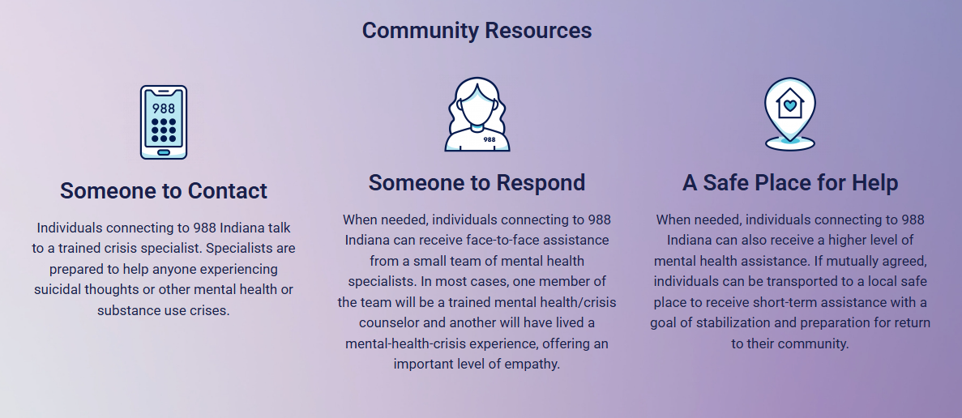
In the event of a larger-scale incident, DMHA supports the deployment of Resilience and Emotional Support Teams (REST) from local communities. REST teams are voluntarily staffed in each of the ten (10) Indiana districts to provide short-term emotional support to survivors, responders and the broader community. REST utilizes psychological first aid and skills for psychological recovery to help survivors navigate their emotions and decisions required after a disaster.

Indiana 2-1-1
FSSA hosts Indiana 2-1-1, a free and confidential service that connects individuals and families within Indiana’s communities to health and human service agencies and resources locally. Services can be requested through means of phone calls, text or online.

Indiana Department of Transportation
- Increase staffing at the INDOT Traffic Management Center (TMC).
- In coordination with the SEOC, the TMC will monitor and coordinate the need for route clearance and debris removal.
- Manage ingress and egress to protect transportation infrastructure across the state.
- Coordinate transportation routes for emergency medical personnel and assist in the delivery of medical supplies.
- Provide heavy equipment for debris removal to gain access to incident sites and medical facilities.

Indiana State Police
- Major of Field Enforcement Bureau or designee coordinates all uniformed response in conjunction with local law enforcement.
  - Provide traffic control.
  - Provide site security of permanent and temporary medical facilities.
  - Cordon off media control areas at appropriate distances from staging or patient care areas.
  - Assist with family reunification and notification offsite .
- Major of Investigations Bureau or designee coordinates all investigative proceedings with local law enforcement.
  - Identify evidence in the aftermath of known or suspected criminal activity, or in the case of accidents requiring National Transportation Safety Board (NTSB) investigations.
- Major of Forensic Services or designee coordinates scene processing with local law enforcement and coroner.
  - Collect and secure evidence.
  - Provide subject matter expertise for morgue processing.
- Support next of kin notifications with volunteer police chaplains.
- Support critical incident stress management by coordinating the deployment of volunteer police chaplains.
- Provide public information statements.

Indiana Department of Natural Resources
- Coordinate rescue and recovery operations in rural areas and water environments.
- Provide heavy equipment for debris removal to gain access to incident sites and medical facilities.
- Support next of kin notifications with the DNR chaplain team.
- Support critical incident stress management with DNR peer support teams.
- Supplement site security of permanent and temporary medical facilities.
- Supplement traffic control.

Indiana Department of Environmental Management
- Work with local officials to identify and approve alternate burial sites, if needed.
- Dispatch appropriate teams to assess water and air quality to protect the health and safety of first responders and the public.

Indiana National Guard
- Assess current capabilities to activate a Medical Immunization/Vaccination Force Package or Medical Support Company to support temporary medical facilities or mobile response operations.
- Assist in providing support transportation (air and ground) for patient evacuation (sick and injured) and health and medical-related materials and personnel.
- Assist in fatality search and recovery efforts.
- Assist local law enforcement with site security for temporary medical facilities and incident sites, if requested.

Federal Agencies and Organizations

Federal Emergency Management Agency
The Federal Emergency Management Agency (FEMA) serves as the primary point of contact for all requested federal agencies and jointly coordinates their response and recovery activities from the State Emergency Operations Center (SEOC). The SEOC must submit all requests for federal assistance.

Department of Health and Human Services
The U.S. Department of Health and Human Services (HHS) is responsible for enhancing the health and well-being of all Americans, by providing for effective health and human services and by fostering sound, sustained advances in the sciences underlying medicine, public health and social services. Several HHS programs and services have specific mass casualty and fatality incident responsibilities:

Administration for Strategic Preparedness and Response
The Administration for Strategic Preparedness and Response (ASPR) collaborates with hospitals, healthcare coalitions, biotech firms, community members, state, local, tribal and territorial governments and other partners across the country to improve readiness and response capabilities. ASPR can provide:
- Regional Emergency Coordinators in the SEOC or IDOH DOC
- Technical assistance
- Emergency prescription assistance
- Fatality management support
- State medical shelter support
- Medical surge support in mobile hospitals
- Waivers and modifications of requirements for Medicaid and Medicare

National Disaster Medical System
The National Disaster Medical System (NDMS) provides personnel, equipment, supplies and a system of partner hospitals that work together with state and local personnel to provide care when requested at the state level. NDMS can provide the following:
- Disaster Medical Assistance Teams (DMATs)
- Trauma and Critical Care Teams
- Disaster Mortuary Operations Response Teams (DMORTs)
- Victim Identification Center (VIC) Teams
- National Veterinary Response Teams (NVRTs)

Disaster Medical Assistance Team
Disaster Medical Assistance Teams (DMATs) provide high-quality rapid-response medical care when public health and medical emergencies overwhelm state, local, tribal or territorial resources. DMATs can perform the following patient-care functions:
- Triage and pre-hospital care
- General emergency medical care
- General medical care
- Hospital decompression
- Support of patient movement (assessing, stabilizing and preparing)
- Mass prophylaxis (vaccination and disease control)

Disaster Mortuary Operational Response Team
Disaster Mortuary Operational Response Teams (DMORTs) support local mortuary services on location, working to quickly and accurately identify victims and reunite victims with their loved ones in a dignified, respectful manner. DMORT members provide technical assistance and consultation on fatality management and mortuary affairs. DMORTs may be called on to provide a wide range of services, including but not limited to:
- Tracking and documenting human remains and personal effects
- Establishing temporary morgue facilities
- Assisting in the determination of cause and manner of death
- Collecting ante-mortem data
- Collection of medical records, dental records or DNA of victims from next of kin to assist in victim identification
- Performing postmortem data collection
- Documentation during field retrieval and morgue operations
- Performing forensic dental pathology and forensic anthropology methods
- Preparing, processing and returning human remains and/or personal effects to appropriate recipients
- Processing and re-interment of disinterred remains
- Providing technical assistance and consultation on fatality management and mortuary affairs

U.S Department of Veterans Affairs
The U.S Department of Veterans Affairs (VA) runs the nation’s largest healthcare system and can provide several resources to assist with mass casualty incidents and other disasters:
- Maintain the 24/7 Veterans Crisis Line.
- Provide immediate post-disaster housing assistance through the National Call Center for Homeless Veterans.
- Deploy emergency pharmacy services in self-contained vehicles to the affected area within a few hours.
- Coordinate prescription and medical equipment needs with mobile clinics, home health teams and community care providers.
- Deploy Public Contact Teams at local shelters or in Disaster Recovery Centers (DRCs).

COORDINATION

LOCAL

Dispatch Centers
Local 911 dispatch centers field calls for emergency services personnel and direct the appropriate fire, law enforcement and emergency medical resources to incident sites. When local emergency services are overwhelmed, the dispatch center coordinates with nearby jurisdictions and requests mutual aid support. Information is tracked in the computer aided dispatch (CAD) system.

Local Health Departments
Local health departments (LHDs) coordinate resource needs and allocation with the county Emergency Management Agency (EMA) and their supporting district healthcare coalition.

County Emergency Management Agencies
The county Emergency Management Agency (EMA) coordinates all response and recovery activities from the county Emergency Operations Center (EOC) during an emergency or disaster within its jurisdiction. When local resources are exhausted, the county EMA coordinates with the State Emergency Operations Center (SEOC) to request supplemental resources. This may be facilitated through the IDHS District Liaisons.

Healthcare Coalitions
Each of the ten (10) Indiana districts maintains a healthcare coalition (HCC) which supports the development of cooperative partnerships between emergency management agencies, health departments hospital networks, municipal and private emergency medical and transport services and the like. The healthcare coalitions promote and enhance the well-being of the community’s healthcare system through coordinated disaster preparedness, education, public information, response/recovery activities and sharing of resources.
Coordination of information and resources occurs primarily between county emergency management and the healthcare coalitions at the local level. Healthcare coalitions relay this information upward to the SEOC and Indiana Department of Health (IDOH) as needed or requested.

Indiana Hospital Emergency Radio Network
The coordination of emergency medical services within local jurisdictions primarily occurs through 911 dispatch radio channels. In the event primary 800 MHz communications are unavailable, coordination occurs through the Indiana Hospital Emergency Radio Network (IHERN). This interoperable network helps ensure EMS providers can communicate with each other and with hospitals during routine operations and emergencies, particularly when other communication systems are down due to local conditions or disasters.

STATE

State Emergency Operations Center
Coordination between state agencies, state-level supporting entities and other state emergency management programs assisting in response or recovery operations for an emergency or disaster situation occurs within the State Emergency Operations Center (SEOC). This is facilitated through the Emergency Support Functions (ESFs). Each ESF has a primary agency representative who receives, processes and fulfills requests for assistance and resource support within the SEOC. ESF-8, Public Health and Medical, coordinates with personnel from supporting agencies regarding subject matter expertise, capabilities and limitations and developing strategies to perform assigned tasks.

IDOH Department Operations Center
The Indiana Department of Health (IDOH) Department Operations Center (DOC) coordinates medical resources for public health and medical responses to a disaster or emergency. The DOC brings together representatives from divisions of IDOH and its health and medical partners for more effective and efficient problem-solving and use of resources. DOC staff acts as accessible subject matter experts for their assigned roles and acts in conjunction with other DOC team members to achieve a quality response to public health and medical needs. The DOC works in conjunction with the SEOC to achieve these goals.

Indiana Health Alert Network
The Indiana Health Alert Network (IHAN-IN) is a mass notification protocol intended to distribute health alerts to healthcare providers and public health professionals across the state of Indiana. Messages are disseminated by the Indiana Department of Health. Health alert messages fall into the following categories:
- Health Alert: Conveys the highest level of importance and warrants immediate action or attention.
- Health Advisory: Provides important information for a specific incident or situation and may not require immediate action or attention.
- Health Update: Provides updated information regarding an incident or situation and is unlikely to require immediate action.
- Health Information: Provides general health information which is not considered to be of an emergent nature.

Healthcare Infrastructure Status Information System
Indiana’s healthcare infrastructure status information system is an internet-based emergency resource management system that provides real-time communication and situational awareness for healthcare, public health and first responders during emergencies. The system tracks resource availability, such as hospital beds and ambulance diversion status, allowing agencies to better manage and coordinate responses by directing patients to appropriate facilities and sharing critical updates on healthcare capabilities and needs.

WebEOC
Indiana utilizes a web-based, crisis information management system known as WebEOC. The primary objective of WebEOC is to provide key personnel with a platform to share, analyze and manage emergency management and homeland security information throughout the state. The system provides resource management capabilities to share information, track critical missions and tasks and coordinate resources across multiple jurisdictions and levels of government. Stakeholders, local emergency management agencies and Emergency Support Functions (ESF) organizations, for example, are requested to update WebEOC with situational updates.

State Emergency Registry of Volunteers for Indiana
The State Emergency Registry of Volunteers for Indiana (SERV-IN) is an electronic registration system and database of local, regional and statewide medical and non-medical volunteers who have agreed to assist public health and healthcare systems during an emergency or disaster. The program is managed by the Indiana Department of Health who collects information on volunteers such as contact information, licensure, credentials, training history, response experience and skills and can activate and deploy volunteers as required. The system can also be utilized for internal communications for registered personnel.

FEDERAL
If the Federal Emergency Management Agency (FEMA) is not activated in the SEOC, federal agency coordination occurs through the Liaison Officer with SEOC management. If FEMA is activated, it serves as the primary point of contact for all requested federal agencies and jointly coordinates their response and recovery activities.

PLAN DEVELOPMENT AND MAINTENANCE

PLAN DEVELOPMENT
The [Insert County Name] Emergency Management Agency (EMA) is the primary agency responsible for the program and technical content of this plan. The designated agency personnel are the primary points of contact for planning collaboration with internal and external stakeholders.
The primary agency identifies required planning team members and provides contact information and expectations of planning needs. [Insert County Name] EMA approves all program and technical content changes during the development, review and scheduled updates of the plan. The plan is updated on a three-year cycle.

PLAN MAINTENANCE
The [Insert County Name] EMA oversees plan maintenance, formatting and grammatical editing of the plan. The EMA is responsible for ensuring the planning schedule is accurately published and timelines followed. The EMA also is responsible for scheduling planning meetings, arranging logistics and creating and distributing planning meeting agendas and subsequent meeting minutes. Additionally, the EMA is responsible for facilitating planning meeting group discussion, as needed to achieve meeting objectives. A hard copy or electronic version of this plan is provided to all county department heads, local municipalities and key stakeholders. Distribution is intentionally limited as this document is designated as For Official Use Only (FOUO).

AUTHORITIES

FEDERAL AUTHORITY
- 29 CFR – 1910.1030, Bloodborne Pathogens
- 45 CFR Part 164, HIPAA Privacy Regulations
- Foreign Air Carrier Family Support Act, 1997
- Homeland Security Act, 2002
- Homeland Security Presidential Directive 5, 2003
- Homeland Security Presidential Directive 7, 2003
- Homeland Security Presidential Directive 8, 2003
- Homeland Security Presidential Directive 10, 2004
- Homeland Security Presidential Directive 18, 2007
- Homeland Security Presidential Directive 21, 2007
- Public Health Security and Bioterrorism Preparedness and Response Act, 2002
- Public Health Service Act, 1944
- Rail Passenger Disaster Family Assistance Act, 2008
- Robert T. Stafford Disaster Relief and Emergency Assistance Act, 1988

STATE AUTHORITY
- 410 Indiana Administrative Code 18, Vital Records
- Indiana Code 4-23-6.5, Establishing the Indiana Coroners Training Board
- Indiana Code 9-26-4, Duties of Coroners Related to Traffic Accidents
- Indiana Code 10-14-3, Emergency Management and Disaster Law
- Indiana Code 10-14-5, Emergency Management Assistance Compact
- Indiana Code 10-19-2, Establishing the Indiana Department of Homeland Security
- Indiana Code 16-19-3, Protecting the Health and Lives of the Citizens of Indiana
- Indiana Code 16-37, Vital Statistics
- Indiana Code 23-14, General Cemetery Law
- Indiana Code 23-14-54, Disposition of Dead Human Bodies
- Indiana Code 36-2-14, County Coroner
- State of Indiana Emergency Operations Plan, 2025

LOCAL AUTHORITY [INSERT AS APPLICABLE]
- Local Emergency Management Ordinances
- Local Emergency Operations Plans/Comprehensive Emergency Management Plans
- Local Health Department Plans

appendix a – maps

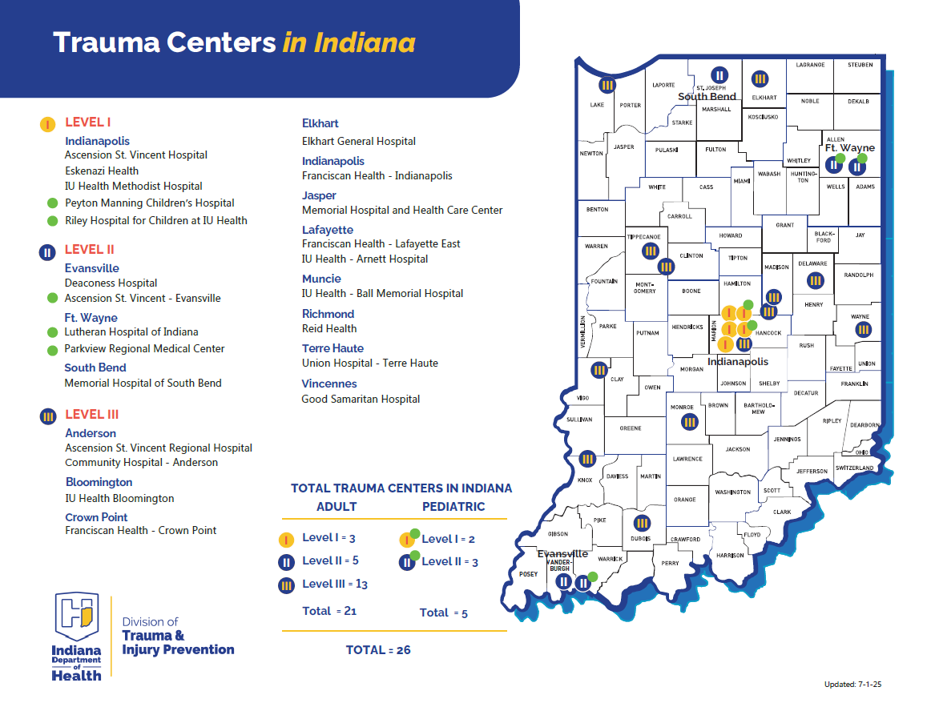
Figure 7. ADULT AND PEDIATRIC TRAUMA CENTERS

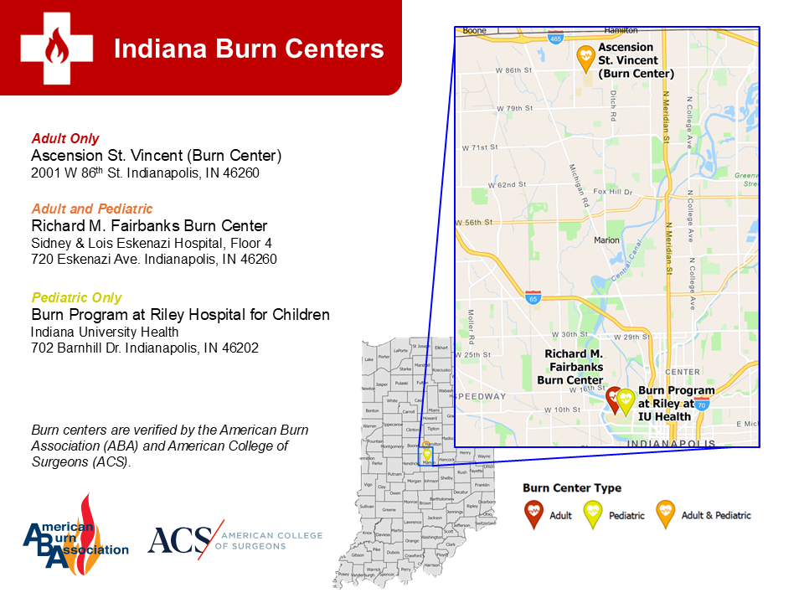
Figure 8. ADULT AND PEDIATRIC BURN CENTERS

Figure 9. INDIANA HOSPITALS
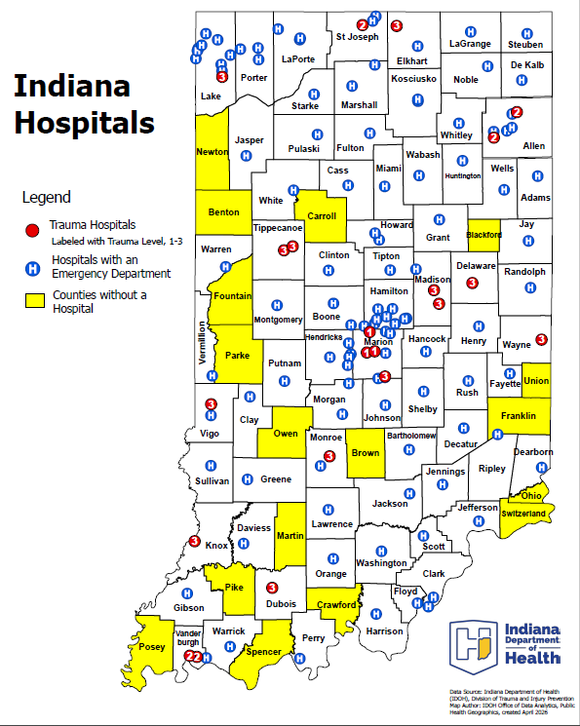
Figure 10. MENTAL HEALTH AND ADDICTION RESOURCES
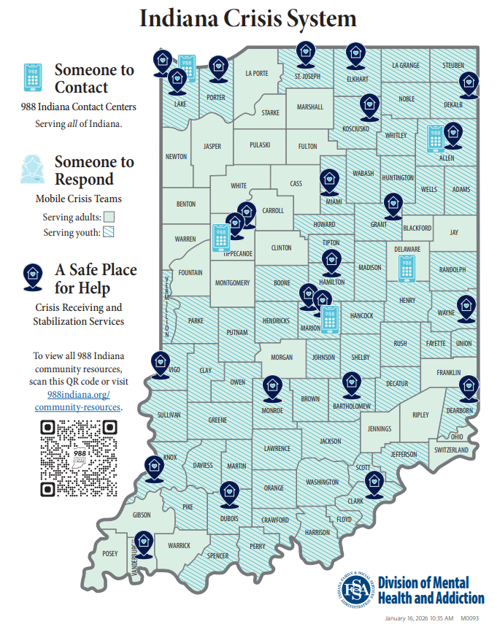

Appendix b – acronyms
ACRONYM | FULL DESCRIPTION
ALS | Advanced Life Support
ARC | American Red Cross
ASPR | Administration for Strategic Preparedness and Response
BCP | Body Collection Point
BLS | Basic Life Support
CAD | Computer-Aided Dispatch
CBRNE | Chemical, Biological, Radiological, Nuclear or Explosive
CDC | Centers for Disease Control and Prevention
CFR | Code of Federal Regulations
CISM | Critical Incident Stress Management
DMAT | Disaster Medical Assistance Team
DMHA | Division of Mental Health and Addiction
DMORT | Disaster Mortuary Operations Response Team
DNR | Indiana Department of Natural Resources
DOC | Department Operations Center
DPMU | Disaster Portable Mortuary Unit
DRC | Disaster Recovery Center
EMA | Emergency Management Agency
EMS | Emergency Medical Services
EOC | Emergency Operations Center
EOP | Emergency Operations Plan
ESF | Emergency Support Function
FAC | Family Assistance Center
FEMA | Federal Emergency Management Agency
FSSA | Family and Social Services Administration
HAZMAT | Hazardous Materials
HCC | Healthcare Coalition
HHS | U.S. Department of Health and Human Services
HIPAA | Health Insurance Portability and Accountability Act
HSEEP | Homeland Security Exercise and Evaluation Program
IC | Indiana Code
ICS | Incident Command System
IDEM | Indiana Department of Environmental Management
IDHS | Indiana Department of Homeland Security
IDOH | Indiana Department of Health
IHAN-IN | Indiana Health Alert Network
IHERN | Indiana Hospital Emergency Radio Network
IN-MORT | Indiana Mortuary Operational Response Team
INVOAD | Indiana Voluntary Organizations Active in Disaster
INDOT | Indiana Department of Transportation
INNG | Indiana National Guard
ISP | Indiana State Police
LHD | Local Health Department
MCI | Mass Casualty Incident
MFI | Mass Fatality Incident
MIC | Morgue Information Center
NDMS | National Disaster Medical System
NIMS | National Incident Management System
NTSB | National Transportation Safety Board
NVRT | National Veterinary Response Team
PPE | Personal Protective Equipment
REST | Resilience and Emotional Support Team
SALT | Sort, Assess, Lifesaving Interventions, Treatment/Transport
SEOC | State Emergency Operations Center
SERV-IN | State Emergency Registry of Volunteers for Indiana
SNS | Strategic National Stockpile
SONAR | SOund Navigation and Ranging
START | Simple Triage and Rapid Treatment
TMC | Traffic Management Center
VA | United States Department of Veterans Affairs
VIC | Victim Identification Center
WebEOC | Web Emergency Operations Center

