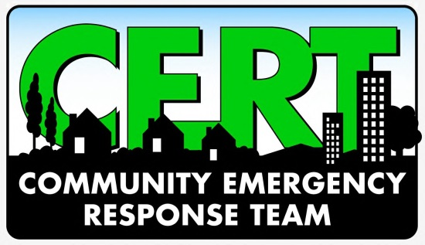
NEWS RELEASE
(INSERT NAME) Community Emergency Response Team

(INSERT NAME) CERT to Join / Participate / Help / Host (EVENT/EXERCISE)
The (INSERT NAME) Community Emergency Response Team (CERT) hosted/joined/participated/helped at (INSERT EVENT OR RESPONSE). CERT provided (DESCRIBE FUNCTIONS OR ACTIVITIES).
(CERT LEADER QUOTE)
(MORE DETAILS ABOUT EVENT/RESPONSE)
(LOCAL FIRST RESPONDER LEADER QUOTE)
(INFORMATION ABOUT CERT’S NEXT PLANNED ACTIVITY/EXERCISE/OUTREACH)

-30-
About CERT
The Community Emergency Response Team (CERT) program develops and trains teams in neighborhoods, workplaces and schools in basic disaster response skills, including fire suppression, urban search and rescue and medical operations. Administered by FEMA and the Indiana Department of Homeland Security, the CERT program provides an opportunity for citizens to take an active role in local emergency preparedness.

