January 31st, 2023

TO: Charlene Blackmore, MSW
Administration for Children and Families
FROM: Director Terry J. Stigdon, MSN, RN
SUBJECT: CFSR Round 4-Statewide Assessment

Please find Indiana’s Statewide Assessment attached. This document is comprised of all four sections outlined in the SWA Guide provided by ACF, including 36 items with analysis and ratings. Justifications are outlined, and attachments referenced are in the second document attached.

Please let Indiana Department of Child Services know if you have any questions.

Sincerely,

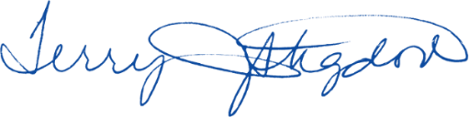

Terry Stigdon, MSN, RN
Agency Head/Director
Indiana Department of Child Services

