Indiana Family Preservation Services
Agenda and Questions
September 30, 2022
- Concrete supports reminder—Please complete this form for any concrete spend, and send to Bridget McIntyre (Bridget.McIntyre@dcs.in.gov) or the Child Welfare Plan (ChildWelfarePlan@dcs.in.gov):
https://www.in.gov/dcs/files/Expense-Tracking-Agencies.xlsx

- DCS received formal approval of our 5-year Title IV-E Prevention Plan on June 30. While the specific models that were approved include the following, providers delivering INFPS should continue to deliver this service as they have been with no change needed…
  - Motivational Interviewing
  - Parents as Teachers
  - Functional Family Therapy
  - Healthy Families America/Indiana
  - TF-CBT

- Current case information: (as of 9/29/22)
Regions | Family Pres Case Count
1 | 122
2 | 56
3 | 78
4 | 92
5 | 36
6 | 35
7 | 120
8 | 117
9 | 48
10 | 162
11 | 73
12 | 60
13 | 60
14 | 45
15 | 70
16 | 102
17 | 60
18 | 89
Grand Total | 1425
Up 4 from last meeting.

- Updated DCS data on case numbers…

Current number of kids in out-of-home care: 9,662 (Lowest since December 2013)

Number of kids in out-of-home care down 25.4% since launch on 6/1/20, from 12,956 to 9,662

In-home cases down 35.7% since launch, from 7,776 to 4,997.

Absence of Repeat Maltreatment above federal standard (94.6%) 7 months in a row, and over 95% for 6 months in a row—first time we’ve done that since December 2010 – May 2011.

Absence of Repeat Maltreatment was at 93.6% at launch…now it is 95.03%.

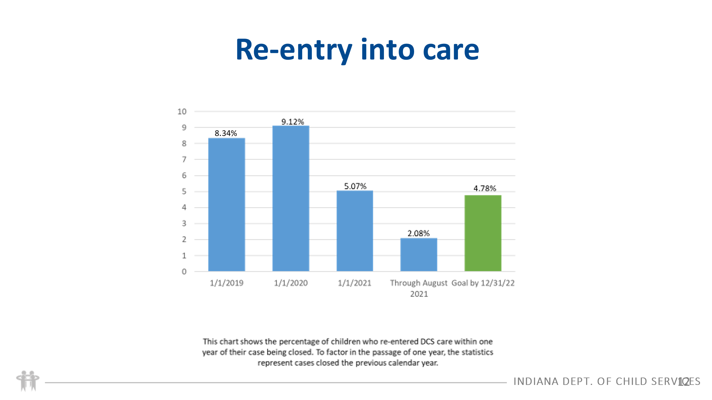

- Questions received:

There were NO questions received for this meeting

Anything else?

Referral was Family Pres with another agency, and now our agency has a referral for in home services. Should our referral be for Family Pres?
If there is no family preservation provider in place and there was no removal, then your referral should be Family Pres. Please talk to the FCM and feel free to include referral@dcs.in.gov

What is the email for the Services Hub?
serviceshub@dcs.in.gov

Can we do Family Preservation with a dual status case?
Yes! Currently cannot do family pres for JD/JS cases, but dual status is ok.

What do we do if we need an updated referral?
First reach out to the FCM/local office. If they are not responsive, please email referral@dcs.in.gov and cc the FCM. We can assist with those!

Our agency is not found in KidTraks for a particular county in Family Preservation – what do we do?
Ask the FCM to email referral@dcs.in.gov for assistance

Next meeting: We are moving this to Monthly meetings going forward, with the meeting to be held on the 3rd Friday of each month. Next meeting: 10/21/22 @ 1:00 Eastern
THANK YOU!

