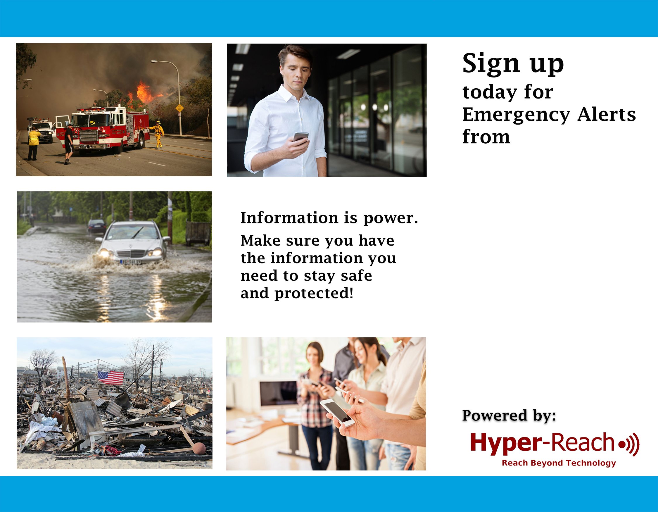
Randolph County
9-1-1
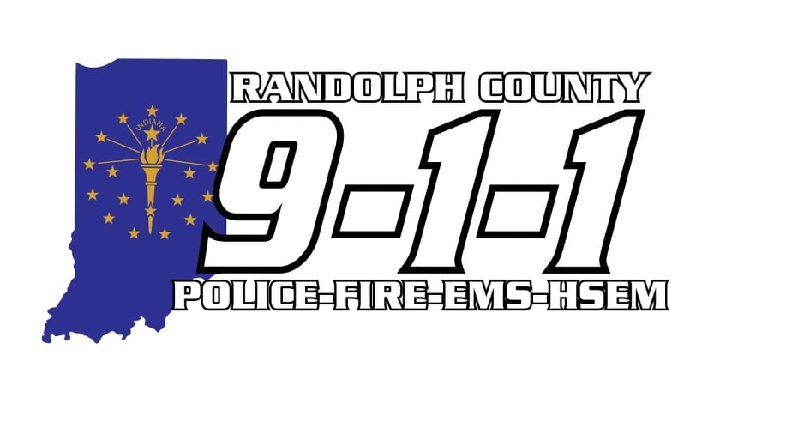

5 Ways to Sign Up:

- Scan QR Code:
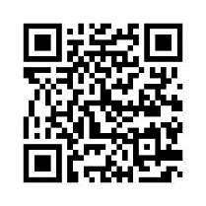

- Go to:

http://hyper-reach.com/inrandolphsignup.html

- Call:

765-305-4100

- Text “alerts” to

765-305-4100

- Tell your Alexa unit, “Alexa, enable Hyper-Reach”

