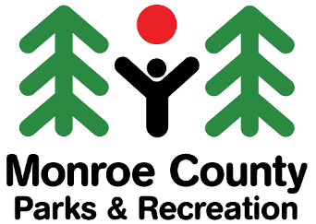

FLATWOODS DRONE ZONE
mcparksandrec.org
812-349-2800
Hours of Operation
- The Drone Zone is open during normal park hours.
- The Drone Zone is closed during field maintenance.
Drone Zone Regulations
- Youth under 12 years old must be supervised by someone who is at least 16 years old.
- All drones must weigh under 5 pounds.
- Operate within the flying site boundaries, which are indicated by the red flags at each corner of the field.
- Maintain your drone within visual line of sight at all times.
- Obey all FAA drone/unmanned aircraft system (UAS) regulations.
- Always yield right of way to other drones.
- Do not fly directly over people, animals, vehicles, or structures.
- Do not fly in a careless or reckless manner.
- Do not fly higher than 400 feet.
- Do not fly in bad weather.
- Do not fly under the influence of alcohol or drugs.
- No smoking or tobacco products.
Drone Pilot’s Responsibility While Using the Drone Zone
- Pilot operates drone at their own risk.
- Pilot is responsible for any bodily injury or property damage.
- Pilot is responsible for damage to own drone.
Federal Aviation Administration’s (FAA) Rules for Recreation Flyers
- Take The Recreational UAS Safety Test (TRUST) and carry proof of test passage when flying.
- Have a current FAA registration, mark your drones on the outside with the registration number, and carry proof of registration with you when flying.
- Do not operate your drone in a manner that endangers the safety of the national airspace system.
1-18-2023

