ICJI: Behavioral Health’s LCC Resources
In Whatever web browser you are comfortable with using: Look for the ICJI website by entering https://www.in.gov/cji/ or Google Search ICJI.
Below is the homepage example. There are several agencies within ICJI- you will want to click on Behavioral Health (circled in green)

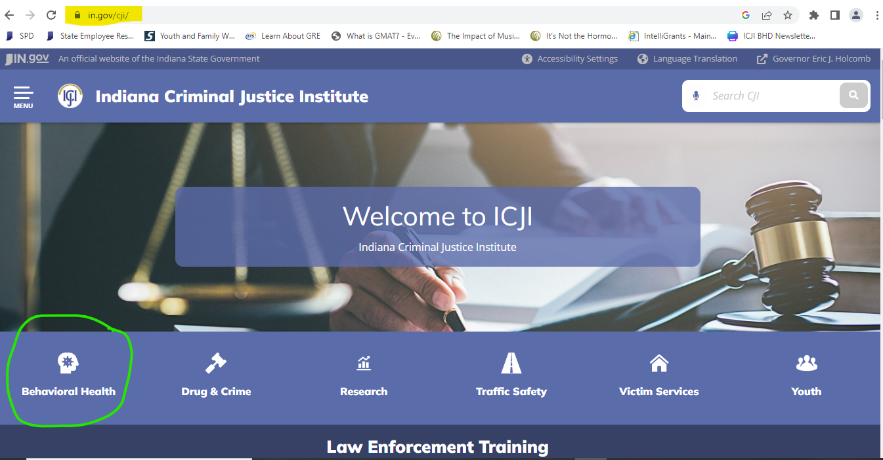

The Behavioral Health Division oversees 2 different sub-divisions: Youth Involvement and the Local Coordinating Councils (LCCs). From here, you will want to click on the LCC Resource link.
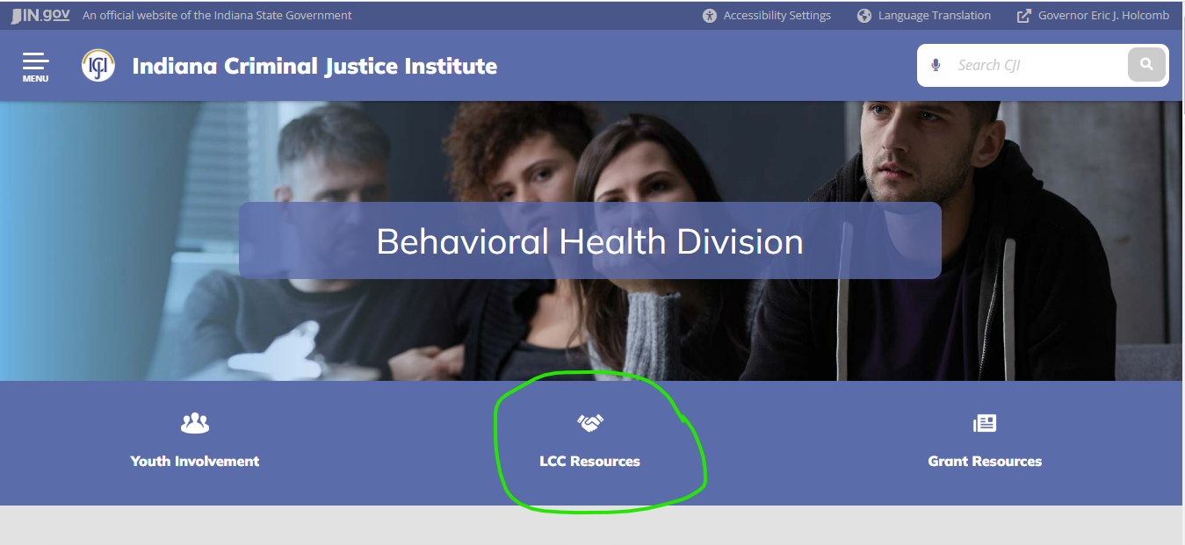

On the LCC Page, you will have a menu bar that will lead you to:
- The Policies and Procedures Manual
- Comprehensive Community Plan and Certification Letter with a video tutorial and templates
- Reporting Requirements for Quarterly Reports, End of Year Report, and Meeting Minutes
- And an LCC Map of Active LCCs, their CCPs and Contacts. (We encourage you to reach out to similar LCCs for inspiration and networking!)
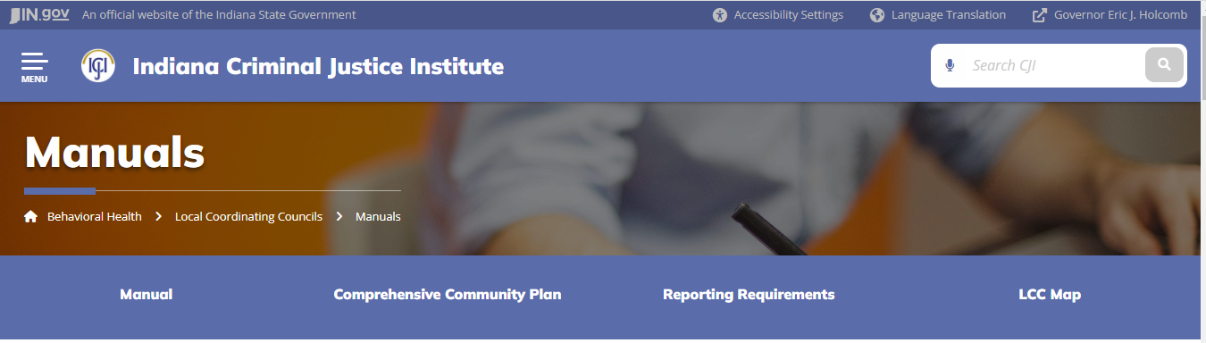

At the bottom of the page, you’ll find 3 separate toolbars:
- LCC Toolbox
- LCC Surveys
- Webinars
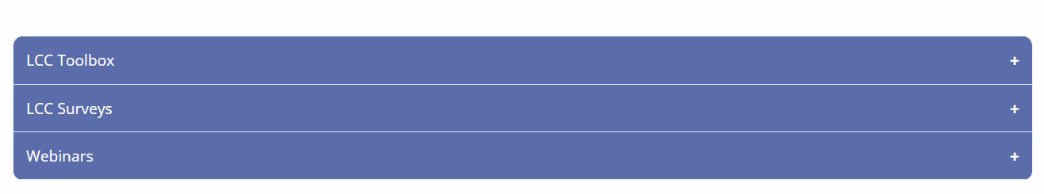
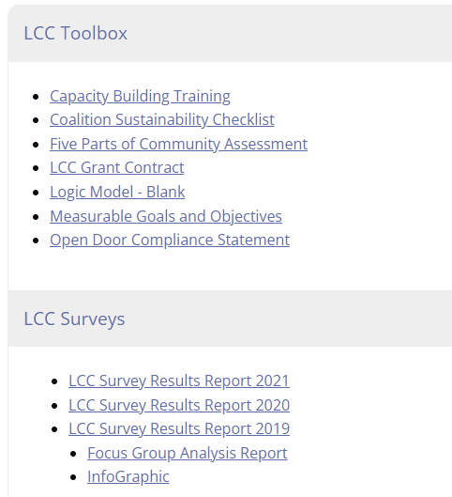
All of these resources are useful and should be explored- but one thing I want to point out to you is in the WEBINAR Section Data to Action Training. SAMHSA’s Strategic Prevention Framework.
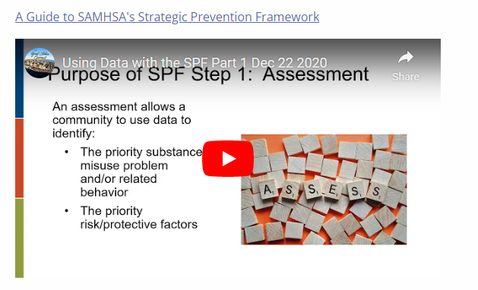
This is a similar course that I took to fully understand what the CCP is and how it is utilized by the LCCs. I encourage you to take some time and review this video- I believe this is only Part 1 of a 5-part model, but it’s a great jumping off point to get started!

