DATE
Dear Parent/Guardian,
As of July 1, 2019, Indiana Deaf Education and Assessments of Language (IDEAL) was put into law (IC 20-35-12) and the Center for Deaf and Hard of Hearing Education was tasked to oversee the mandates within this code. The purpose of this law was to encourage closer monitoring of children who are deaf and hard of hearing to improve outcomes for these students.
One mandate in IDEAL is reporting results of language and literacy assessment measures for all deaf and hard of hearing children in Indiana from birth through age 10 years. As your child’s school, we are seeking your permission to include your child’s personal information in our reporting (e.g., name, date of birth, and STN) along with those required scores.
The reason to report personal information is for tracking over time. The Center for Deaf and Hard of Hearing Education was created to assist local schools and providers as experts in deaf education. The data IDEAL provides to the Center allows them to know when and where assistance is needed – for your child, and other individual children- as well as what groups of children may benefit from additional support. On the flip side, the data will also help the Center know when deaf and hard of hearing children are developing language and literacy on par with their peers and learn from their programming and services to help others.
The IDEAL legislation also includes creation of a Parent Document- specifically designed for you! This valuable resource includes information about how language develops, how you can support that development, laws and policies related to your child and their education as well as language milestones in English, American Sign Language and Spanish from birth through age 10 years. Take the time to check these out- and bring questions and ideas to your child’s teachers and service providers.

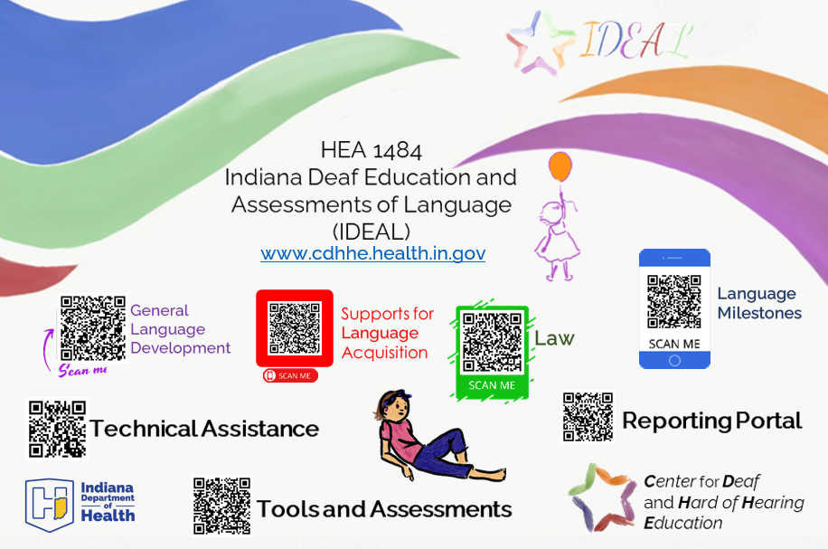
As your child’s parent/guardian, the decision to sign this form is completely voluntary. By signing and returning this form, you are allowing [ENTER SCHOOL DISTRICT NAME] to share language and literacy assessment results with the Center for Deaf and Hard of Hearing Education as part of the IDEAL legislation. This consent will be effective across time unless you indicate a specific end date or event. You may revoke your consent at any time by notifying [ENTER SCHOOL DISTRICT NAME] in writing.

_________________________
Child’s First Name Middle Name Last Name
_________________________
Date of Birth Phone Number Email Address
_________________________
Street Address/Post Office Box City/Town State Zip Code

I, _______________________________________, give consent for my child’s school, _________________________________________, to share the following personal identifiable information along with language and literacy assessment records with Indiana Department of Health’s Center for Deaf and Hard of Hearing Education.
- First Name
- Last Name
- Date of Birth
- Sex
- School District
- School
- Student Test Number (STN)
- Programming (IEP, 504 Plan)

I have read and understand the contents of this consent form. Records are subject to the regulations imposed by the Family Education Rights and Privacy Act (FERPA) of 1974 (Public Law 93-380).

This consent is effective from the date of my signature on this form until I ask for this consent to be revoked or until the following date or event ______________. This consent is subject to revocation by me at any time, if done so in writing. However, revocation of this consent will not affect the services provided or information obtained prior to revocation.

I HAVE READ AND UNDERSTAND THE CONDITIONS OF THIS FORM.

____________________________________________ ___________________
Signature of Parent/Legal Guardian Date

____________________________________________ ________________________
Printed Name of Parent/Legal Guardian Relationship to Child

